**A Project Report on**

**GQT OFFICIAL SITE(CLONE)**

**USING HTML & CSS**

submitted by

**V NOSHITHA NAVYA RENUKA - GQT-S0156**

under the mentorship of

**KESHAV MURTHY**



**GLOBAL QUEST TECHNOLOGIES**

[info@gqtech.in](mailto:info@gqtech.in)

Yelahanka Satellite Town,

Bangalore, Karnataka - 560064.

[2023]

**Signature of the mentor Signature**

**Keshav Murthy G.R.Narendra Reddy**

**INTRODUCTION**

**HISTORY OF HTML:**

**HTML** stands for **Hyper Text Markup Language**.

* It is used to share the information over the internet.
* HTML id developed by Tim Berner’s Lee in 1991.But officially in 1993.
* The First version of HTML consists of “18 tags”
* HTML follows certain rules and regulations setup by “**ISO**”.
* International Organization for standardization is set of rules and regulation are present in ‘**SGML**’ document.

**Versions of HTML**

* **HTML-1** version in the year 1993.
* **Html-2** version in the year 1995.
* **HTML-3.02** version in the year 1997.
* **HTML-4.1** version in the year 1999.
* **HTML-5** version in the year 2014.

**Features of HTML**

* It is easy to Learn.
* It is a tag based language.
* HTML is supported by multiple browsers.
* First web browser is Netscape navigation which was developed by the “Mosiac”.
* It is a portable language.
* **WORA** stands for ‘write once run anywhere’

**Limitation of HTML**

* HTML has less designing capabilities.
* It is dependent on other technology such as CSS in order to develop well designed Webpages.
* HTML has no programming capabilities.
* Using HTML and CSS we can develop only static Web page.
* In order to write the HTML code required an editor such as VS Code, Notepad, Eclipse.
* In order to execute the HTML code we required Web browsers.Like Chrome, Firefox, edge, Opera Safari .

**CSS**

* **CSS** stands for **Cascading Style Sheets**.
* It was developed by W3C to add stylings to the HTML elements.
* W3C stands for World Wide Web.com

**Versions of CSS:**

* CSS-1 (level-1) in the year 1996.
* CSS-2 (level-2) in the year 1998.
* CSS-3 (level-3) in the year 1999.

**Why do we required CSS ?**

* Since HTML has less designing capabilities we cannot create well designed or most appealing Websites.
* Using HTML we cannot add style, animation and transitions to the Webpage.
* Therefore we require CSS to create well designed Webpages.

**Advantages of CSS**

* It allows to add styles, animation and variouses effects to the Webpage.
* It allows us to develop the Webpage rapidly. It is also know as RAD ( rapid application Developer).
* It allows us to separate from formatting develop page to the presentation of Webpage.
* It allows to create well designed Websites.

**Limitations of CSS**

* Using CSS we can perform static styles for the Webpages.
* In order to create dynamic styling for the Websites. We must make use of scripting language such as JavaScript and Libraries of JavaScript.

**Types of CSS:**

1. Inline CSS
2. Internal CSS
3. External CSS
4. Default Browser CSS

**Inline CSS:**

Defining all the CSS properties within the style attribute inside the opening of the tag is referred to as Inline CSS.

**Internal CSS:**

Defining all the CSS properties within <style> inside the HTML document is referred to as Internal CSS.

**External CSS:**

Defining all the CSS properties within as external Script or File with an extension CSS is referred to as External CSS.

* In order to link external CSS file within the HTML document we must use of <link>.
* The value for the ‘ref’ attribute should be ‘stylesheet’.

**GQT OFFICIAL SITE(CLONE)**

**Scope of the document**

Global Quest Technologies (GQT) is an online platform dedicated to providing in-depth insights, resources, and services related to cutting-edge technologies and their real-world applications. The scope of the GQT website includes:

**Technology News and Trends:** GQT will offer the latest news, updates, and trends in various fields of technology, such as artificial intelligence, blockchain, cybersecurity, biotechnology, and more.

**Educational Resources:** The website will provide comprehensive educational materials, including articles, tutorials, and video content, to help both beginners and experts understand complex technological concepts.

**Product and Service Reviews:** GQT will feature unbiased reviews and assessments of technology products, software, and services, helping users make informed decisions.

**Industry Insights:** The website will delve into specific industries and examine how technology is transforming them. This includes case studies, interviews with industry experts, and analysis of technology's impact on sectors like healthcare, finance, and manufacturing.

**Community and Collaboration:** GQT will foster a community of tech enthusiasts, professionals, and innovators, allowing them to connect, share ideas, and collaborate on projects.

**Events and Webinars:** The website will promote and host webinars, conferences, and events related to technology, providing a platform for networking and knowledge sharing.

**Technologies Used**

* HTML5
* CSS3

**Our Project**

**Root Structure:**

**GQTCLONE**

**→CODES**

**→HTML_Files**

→GQTclone.html

→CRS.html

→Internships.html

→Placementsgqt.html

→GQTCCNA.html

→GQTCCNP.html

→GQTDevops.html

→GQTAWS.html

→Meanstack.html

**→CSS_Files**

→GQTAws.css

→GQTClone.css

→Meanstack.css

**PROJECT REPORT**

→FRONT END PROJECT 2 GQT_CLONE.DOC

**SCREENSHOTS**

→ALL THE CORRESPONDING SCREENSHOTS OF PAGES.

**CONTROL FLOW DIAGRAM:**

GQTClone.Html

HOME.HTML IS OPENED

HOME LINK

**Click**

CRS.HTML IS OPENED

**Click**

CRS LINK

Internships.HTML IS OPENED

**Click**

Internships LINK

Placementsgqt.HTML IS OPENED

**Click**

Placements LINK

**Click**

AWS.HTML IS OPENED

AWS LINK

**Click**

MeanStack.HTML IS OPENED

MeanStack LINK

**Click**

CCNA.HTML IS OPENED

CCNA LINK

CCNP.HTML IS OPENED

CCNP LINK

**Click**

**Click**

Devops.HTML IS OPENED

Devops LINK

HOME

**Source Code:-**

**Home.html:**

<!DOCTYPE html>

<html lang="en">

<head>

<meta charset="UTF-8">

<meta name="viewport" content="width=device-width, initial-scale=1.0">

<title>Document</title>

<link rel="stylesheet" href="GQT.css">

</head>

<body>

<div style=" height: 65px; background-color: white;position: fixed;width:100%;margin-left: 1px;margin-top: -70px;">

<img src="https://gqtech.in/wp-content/uploads/2022/04/cropped-GQT_Logo_H_.png" alt="">

<nav>

<div id="header">

<select name="" style="width: 8%; border: none;font-size: 16px;color: rgb(96, 92, 92);">

<option value="">Course</option>

<option value="">Unified course-1</option>

<option value="">Unified course-2</option>

<option value="">Unified course-3</option>

<option value="">Data Science</option>

<option value="">Programming Fundamental Course-1</option>

<option value="">Programming Fundamental Course-2</option>

<option value="">Amazon Web Services</option>

<option value="">Microsoft Azure</option>

<option value="">MEAN Stack</option>

<option value="">MERN Stack</option>

<option value="">MBA-HR and Finance</option>

<option value="">DecOps</option>

<option value="">Sales Force</option>

<option value="">CCNA</option>

<option value="">CCNP</option>

<option value="">Ethical Hacking</option>

<option value="">Digital Marketing</option>

</select>

<select name="" id="" style="width: 8%; border: none;font-size: 16px;color: rgb(96, 92, 92);">

<option value="">Corporate</option>

<option value="">Need Corporate Training</option>

<option value="">Want To Hire Our Students</option>

</select>

<a href="" class="class1">CRS</a>

<a href="" class="class1">Internship</a>

<a href="" class="class1">Projects</a>

<a href="" class="class1">Placements</a>

<a href="" class="class1">Branches</a>

<select name="" id=""

style="width: 10%; border: none;font-size: 16px;color:rgb(96, 92, 92);padding-left:20px">

<option value="">Comapny</option>

<option value="">About us</option>

<option value="">Contact us</option>

</select>

</div>

</nav>

<img src="https://www.iconbunny.com/icons/media/catalog/product/cache/2/thumbnail/600x/1b89f2fc96fc819c2a7e15c7e545e8a9/1/6/168.9-phone-icon-iconbunny.jpg"

style="width:43px;height:42px;margin-left: 1220px;margin-top: -32px">

<div id="h1"><img src="search.png" style="margin-left: 10px;"> </div>

<p>94484 03469<br>info@gqttech.in</p>

</div>

<div id="d">

<img id="d1" src="https://gqtech.in/wp-content/uploads/2022/04/hero.png">

</div>

<div id="d2">

<h1>Upskill Your Profile And Increase Your Earning Potential</h1><br>

<div style="width:100%;height:40px;">

<p id="d3">Get hands-on learning from industry experts and amplify your earning potential with skill-based

training and project-certified courses with complete placement assistance.</p>

</div>

</div>

<a href="#blocks"><input id="d4" type="button" value="Get Started"></a>

<div id="d5">

<marquee width="50%" direction="left" height="100px" scrollamount="15"><b>Live Training with the Corporate

Experts|&nbsp;&nbsp;&nbsp;&nbsp;&nbsp;&nbsp;&nbsp;&nbsp;&nbsp;&nbsp;&nbsp;&nbsp;&nbsp;&nbsp;&nbsp;&nbsp;&nbsp;&nbsp;&nbsp;&nbsp;&nbsp;&nbsp;&nbsp;&nbsp;&nbsp;&nbsp;&nbsp;&nbsp;&nbsp;&nbsp;&nbsp;&nbsp;

&nbsp;&nbsp;&nbsp;&nbsp;Frequent Mock Interviews and Tests

|&nbsp;&nbsp;&nbsp;&nbsp;&nbsp;&nbsp;&nbsp;&nbsp;&nbsp;&nbsp;&nbsp;&nbsp;&nbsp;&nbsp;&nbsp;&nbsp;&nbsp;&nbsp;&nbsp;&nbsp;&nbsp;&nbsp;&nbsp;&nbsp;&nbsp;&nbsp;&nbsp;&nbsp;&nbsp;&nbsp;&nbsp;&nbsp;&nbsp;&nbsp;&nbsp;&nbsp;

700+ Hiring Parents

|&nbsp;&nbsp;&nbsp;&nbsp;&nbsp;&nbsp;&nbsp;&nbsp;&nbsp;&nbsp;&nbsp;&nbsp;&nbsp;&nbsp;&nbsp;&nbsp;&nbsp;&nbsp;&nbsp;&nbsp;&nbsp;&nbsp;&nbsp;&nbsp;&nbsp;&nbsp;&nbsp;&nbsp;&nbsp;&nbsp;&nbsp;&nbsp;&nbsp;&nbsp;&nbsp;&nbsp;

Curriculam Designed for Industry Applications |</b></marquee>

</div>

<div id="E">

<h2>Courses in Demand</h2>

<p id="p1">IT and non-IT courses are built with a foundational to application-level approach to provide students

with a well-rounded understanding. Could you take a look at our most popular systems?</p>

</div>

<div id="b">

<a name="blocks">

<img src="https://gqtech.in/wp-content/uploads/2022/04/img1.png"

style="width:50%;height:251px;margin-top: -1px;margin-left: -1px;border-radius: 10px;">

<h2 style="color:rgb(69, 67, 67);margin-left: 300px;margin-top: -230px;">Unified Course 1</h2>

<p style="color:rgb(69, 67, 67);margin-left: 300px;margin-top: -10px;">Learn with our specialisation of

Unified

Course 1 and build the proper foundation required for software development.</p>

<input class="cp" type="button" value="Learn More"><a src="https://gqtech.in/unified-course-1/"></a>

</a>

</div>

<div id="b1">

<img src="https://gqtech.in/wp-content/uploads/2022/04/img2.png"

style="width:50%;height:251px;margin-top: -1px;margin-left: -1px;border-radius:10px ;">

<h2 style="color:rgb(69, 67, 67);margin-left: 300px;margin-top: -230px;">Unified Course 2</h2>

<p style="color:rgb(69, 67, 67);margin-left: 300px;margin-top: -10px;">Acquire hard and soft skills and update

yourself for the software development industry backed up with application-based projects.</p>

<input class="cp" type="button" value="Learn More">

</div>

<div id="b2">

<img src="https://gqtech.in/wp-content/uploads/2022/04/img3.png"

style="width:50%;height:251px;margin-top: -1px;margin-left: -1px;border-radius:10px ;">

<h2 style="color:rgb(69, 67, 67);margin-left: 300px;margin-top: -230px;">Data science</h2>

<p style="color:rgb(69, 67, 67);margin-left: 300px;margin-top: -10px;">Establish yourself and update your skills

as a data scientist with core skills, followed by the relevant programming languages.</p>

<input class="cp" type="button" value="Learn More">

</div>

<div id="b3">

<img src="https://gqtech.in/wp-content/uploads/2022/04/img4.png"

style="width:50%;height:251px;margin-top: -1px;margin-left: -1px;border-radius:10px ;">

<h2 style="color:rgb(69, 67, 67);margin-left: 300px;margin-top: -238px;">Programming Fundamental Course - 1</h2>

<p style="color:rgb(69, 67, 67);margin-left: 300px;margin-top: -12px;">Learn the foundations of programming and

algorithms with Programming Fundamental Course-1 and prepare yourself for hands-on applications of

theoretical learning.</p>

<input class="cp" type="button" value="Learn More">

</div>

<div id="b4">

<img src="https://gqtech.in/wp-content/uploads/2022/04/img5.png"

style="width:50%;height:251px;margin-top: -1px;margin-left: -1px;border-radius:10px ;">

<h2 style="color:rgb(69, 67, 67);margin-left: 300px;margin-top: -230px;">DevOps</h2>

<p style="color:rgb(69, 67, 67);margin-left: 300px;margin-top: -10px;">From the foundational introductions to

the essentials of cloud computing, learn the development and operations of the virtual data.</p>

<input class="cp" type="button" value="Learn More">

</div>

<div id="b5">

<img src="https://gqtech.in/wp-content/uploads/2022/04/img6.png"

style="width:50%;height:251px;margin-top: -1px;margin-left: -1px;border-radius:10px ;">

<h2 style="color:rgb(69, 67, 67);margin-left: 300px;margin-top: -230px;">MBA Training</h2>

<p style="color:rgb(69, 67, 67);margin-left: 300px;margin-top: -10px;">MBA Training for the HR and Finance

industry to prepare yourself for the corporate and acquire the professional training for modern management

principles.</p>

<input class="cp" type="button" value="Learn More">

</div>

<div id="G">

<h2>Global Quest Technologies Advantages</h2>

<div>

<p id="p2">With Global Quest Technologies, you get what is required to stay ahead in the race. You don’t

only learn what is necessary to be an expert but also receive complete guidance throughout the way so

that you know the directions.</p>

</div>

</div>

<div id="n"><img id="n1" src="https://gqtech.in/wp-content/uploads/2022/04/Path-3960-1.png" alt="">

<table cellspacing="0"

style="width:70%;height:350px;padding: 200px;margin-left: 510px;margin-top: -730px;line-height: 40px;font-size: 20px;color:white;">

<tbody>

<tr>

<td><b>Advantages</b></td>

<td><b>GQTech</b></td>

<td><b>Others</b></td>

</tr>

<tr>

<td>Experienced Faculty(SMEs)</td>

<td class="ma">✓</td>

<td class="ma">X</td>

</tr>

<tr>

<td>Comprehensive Curriculum</td>

<td class="ma">✓</td>

<td class="ma">X</td>

</tr>

<tr>

<td>Hands-on Learning Experience</td>

<td class="ma">✓</td>

<td class="ma">X</td>

</tr>

<tr>

<td>Smooth and Student-Friendly Interface</td>

<td class="ma">✓</td>

<td class="ma">X</td>

</tr>

<tr>

<td>100% Placement Assistance</td>

<td class="ma">✓</td>

<td class="ma">X</td>

</tr>

<tr>

<td>Life-Time LMS Access</td>

<td class="ma">✓</td>

<td class="ma">X</td>

</tr>

<tr>

<td>Build real-time Projects</td>

<td class="ma">✓</td>

<td class="ma">X</td>

</tr>

<tr>

<td>Interview cracking skills</td>

<td class="ma">✓</td>

<td class="ma">X</td>

</tr>

<tr>

<td>Course completion certificate</td>

<td class="ma">✓</td>

<td class="ma">X</td>

</tr>

<tr>

<td>Campus to Corporate Etiquettes</td>

<td class="ma">✓</td>

<td class="ma">X</td>

</tr>

</tbody>

</table>

</div>

<div style="margin-top: 20px;"><img id="n3" src="https://gqtech.in/wp-content/uploads/2022/07/business-man.jpg"

alt=""></div>

<div id="n4">

<h2 id="x">Why Global Quest Technologies - GQT?</h2>

<div class="z">

<div

style="width:100%;height: 80px;background-image: linear-gradient(90deg,rgba(33, 162, 222, 0.6),rgba(33, 162, 222, 0.6),white);border-radius: 5px;">

<h2 class="sub">Meet and Mingle with Industry Experts</h2>

<p style="margin-left: 7px;margin-top: 40px;">Interact directly with experts. Get proper training and

answers to all your questions regarding the

industry and its essentials.</p>

</div>

</div>

<div class="z1">

<div

style="width:100%;height: 80px;background-image: linear-gradient(90deg,rgba(33, 162, 222, 0.6),rgba(33, 162, 222, 0.6),white);border-radius: 5px;">

<h2 class="sub">Real-time

Corporate<br> Merge</h2>

<p style="margin-left: 7px;margin-top: 50px;">Build and enhance your profile and get real-time corporate

experience to understand the operations and applications in the industry.

</p>

</div>

</div>

<div class="z2">

<div

style="width:100%;height: 80px;background-image: linear-gradient(90deg,rgba(33, 162, 222, 0.6),rgba(33, 162, 222, 0.6),white);border-radius: 5px;">

<h2 class="sub">Personalised

Mentorship</h2>

<p style="margin-left: 7px;margin-top: 70px;">With a personalised approach to training, we provide our

students with the mentorship for their personal development as an expert.</p>

</div>

</div>

<div class="z3">

<div

style="width:100%;height: 80px;background-image: linear-gradient(90deg,rgba(33, 162, 222, 0.6),rgba(33, 162, 222, 0.6),white);border-radius: 5px;">

<h2 class="sub">360 ° Placement

Assistance</h2>

<p style="margin-left: 7px;margin-top: 60px;">We provide our students with complete assistance with the

placement, from preparing for the interview to finding the right roles until they land a great job.

</p>

</div>

</div>

</div>

<div id="S">

<h2>Just Everything You Need to Enhance Your Career</h2>

<div>

<p id="p3">Just Everything You Need to Enhance Your Career Global Quest Technology provides the skills and

knowledge to help you level up your career and shine bright as an individual in the industry.</p>

</div>

</div>

<div id="n5">

<div id="M">

<h2>Social Responsibility Drive- Motive of the Mission</h2>

</div>

<div class="c1"><img class="c4" src="https://gqtech.in/wp-content/uploads/2022/05/kalam.jpg" alt="">

<p class="c8"><b>Dr.APJ Abdul Kalam Sir

</b></p>

<p class="c9">“All of us do not have equal talent. But, all of us have <br>an equal opportunity to develop

our talents.”</p>

</div>

<div class="c2"><img class="c4" src="https://gqtech.in/wp-content/uploads/2022/05/swamy.jpg" alt="">

<p class="c8"><b>Swami Vivekananda</b></p>

<p class="c9">“Experience is the only teacher we have. We may talk <br>and reason all our lives, but we

shall not<br> understand a word of truth.”</p>

</div>

<div class="c3"><img class="c4" src="https://gqtech.in/wp-content/uploads/2022/05/New-Project.png" alt="">

<P class="c8"><b>Puneeth Rajkumar</b></P>

<p class="c9">“Stop Waiting For The Right Time. Time Isn’t Waiting For You.”</p>

</div>

</div>

<div id="K">

<h2>Placement Partners</h2>

</div>

<img id="c11" src="https://gqtech.in/wp-content/uploads/2022/07/Placements-Logo.jpg">

<div id="ef">

<h1 id="i">Student Testimonials</h1>

<div id="cc1">

<img class="ima" src="https://gqtech.in/wp-content/uploads/2022/05/students4.jpg">

<p class="cv"><b>James</b><br>⭐⭐⭐⭐⭐<br></p><br>

<p class="xc">I enrolled for the Unified Course - 3 and I think that was a right choice that I

made. I

have been able to have a grasp on the course, also I was able to get thorough assistance

with my

placement. They also helped me work on my soft skills and personality development.</p>

</div>

<div id="cc2"><img class="ima" src="https://gqtech.in/wp-content/uploads/2022/05/students3.jpg">

<p class="cv"><b>Priyanka</b><br>⭐⭐⭐⭐⭐</p><br>

<p class="xc">The live sessions have been beneficial for me in understanding the concept. The

instructors are very well thorough with the updated trends of the corporate industry and

they

provided guidance on a very personal level to help me improve my skills</p>

</div>

<a href="#" class="do">

<div id="dot"></div>

</a>

<a href="#" class="do">

<div id="dot1"></div>

</a>

<a href="#" class="do">

<div id="dot2"></div>

</a>

<a href="#" class="do">

<div id="dot3"></div>

</a>

</div>

<div id="or">

<p style="font-family: sans-serif;font-size: 50px;margin-left: 150px;color:white;margin-top: 55px;">Learning

Made Simple and Impactful</p>

<p style="font-family: sans-serif;margin-left: 155px;margin-top: -25px;font-size: 20px;color:white">Acquire

game-changing skills to level up your professional career graph with Global Quest <br>Technologies. Get in

touch with our expert to know more.</p>

<p style="font-family: sans-serif;font-size: 20px;color:white;margin-top: -130px;margin-left: 1100px;">Talk to

Course Manager</p>

<input id="db" type="button" value="080 - 41280009">

</div>

<div id="en">

<img src="https://gqtech.in/wp-content/uploads/2022/04/GQT_Logo_H_@2x.png"

style="width:15%;height: 55px;margin-top: 100px;">

<div style="width:20%;height: 30px;margin-left: 1160px;margin-top: -50px;">

<a src="https://www.facebook.com/GlobalQuestTech"><img class="img1"

src="https://w7.pngwing.com/pngs/477/596/png-transparent-computer-icons-facebook-blog-facebook-logo-desktop-wallpaper-facebook-icon.png"></a>

<img class="img1"

src="https://encrypted-tbn0.gstatic.com/images?q=tbn:ANd9GcQHFaeB-HcUWto9n8MutH7JNk08haKZqWAaJQ&usqp=CAU">

<img class="img1"

src="https://encrypted-tbn0.gstatic.com/images?q=tbn:ANd9GcTf5uv7QTp8TwmP5eDDUk8p3gJAO-Hjswj5fA&usqp=CAU">

<img class="img1" src="https://upload.wikimedia.org/wikipedia/commons/1/1a/Twitter_logo.png">

<img class="img1"

src="https://e7.pngegg.com/pngimages/209/964/png-clipart-youtube-logo-computer-icons-youtube-angle-rectangle.png">

</div>

<div style="width:85%;height: 360px;border: 2px solid rgb(10, 11, 52);margin-left: 180px;margin-top: 20px;">

<p class="li"><b>Quick Links</b><br>

<ul type="none">

<a href="https://gqtech.in/" style="text-decoration: none;">

<li class="lin">Home</li>

</a>

<a href="https://gqtech.in/csr/" style="text-decoration: none;">

<li class="lin">CRS</li>

</a>

<a href="https://gqtech.in/placements/" style="text-decoration: none;">

<li class="lin">Placements</li>

</a>

<a href="https://gqtech.in/internship/" style="text-decoration: none;">

<li class="lin">Internship</li>

</a>

<a href="https://gqtech.in/projects/" style="text-decoration: none;">

<li class="lin">Project</li>

</a>

<a href="https://gqtech.in/about-us/" style="text-decoration: none;">

<li class="lin">About us</li>

</a>

<a href="https://gqtech.in/contact-us/" style="text-decoration: none;">

<li class="lin">Contact us</li>

</a>

</ul>

</p>

<p class="li1"><b>Courses</b><br>

<ul type="none">

<a href="https://gqtech.in/amazon-web-services/" style="text-decoration: none;">

<li class="lin1">AWS</li>

</a>

<a href="https://gqtech.in/ccna/" style="text-decoration: none;">

<li class="lin1">CCNA</li>

</a>

<a href="GQTCCNP.html" style="text-decoration: none;">

<li class="lin1">CCNP</li>

</a>

<a href="GQtdevops.html" style="text-decoration: none;">

<li class="lin1">DevOps</li>

</a>

<a href="https://gqtech.in/amazon-web-services/" style="text-decoration: none;">

<li class="lin1">Digital Marketing</li>

</a>

<a href="https://gqtech.in/amazon-web-services/" style="text-decoration: none;">

<li class="lin1">Ethical Hacking</li>

</a>

<a href="https://gqtech.in/mba-hr-and-finance/" style="text-decoration: none;">

<li class="lin1">MBA-HR and Finance</li>

</a>

<a href="Meanstack.html" style="text-decoration: none;">

<li class="lin1">MEAN Stack</li>

</a>

</ul>

</p>

<p class="li2"><b>Courses</b><br>

<ul type="none">

<a href="https://gqtech.in/mern-stack/" style="text-decoration: none;">

<li class="lin2">MERN Stack</li>

</a>

<a href="https://gqtech.in/microsoft-azure/" style="text-decoration: none;">

<li class="lin2">MS Azure</li>

</a>

<a href="https://gqtech.in/programming-fundamental-course-1/" style="text-decoration: none;">

<li class="lin2">Programming Fundamental-1</li>

</a>

<a href="https://gqtech.in/programming-fundamental-course-2/" style="text-decoration: none;">

<li class="lin2">Programming Fundamental-2</li>

</a>

<a href="https://gqtech.in/sales-force/" style="text-decoration: none;">

<li class="lin2">Sales Forces</li>

</a>

<a href="https://gqtech.in/unified-course-1/" style="text-decoration: none;">

<li class="lin2">UFC-1 Course</li>

</a>

<a href="https://gqtech.in/unified-course-2/" style="text-decoration: none;">

<li class="lin2">UFC-2 Course</li>

</a>

<a href="https://gqtech.in/unified-course-3/" style="text-decoration: none;">

<li class="lin2">UFC-3 Course</li>

</a>

</ul>

</p>

<p class="li3"><b>Contacts</b><br>

<ul type="none">

<a href="https://gqtech.in/#" style="text-decoration: none;">

<li class="lin3">#324,2nd Floor,3 A Cross, Near Seshadripuram First Grade College, Above City Union

Bank, Yelahanka New Town, Bengaluru-560064.</li>

</a>

<a href="" style="text-decoration: none;">

<li class="lin3">+91 94484 03469</li>

</a>

<a href="" style="text-decoration: none;">

<li class="lin3">080-41280009</li>

</a>

<a href="" style="text-decoration: none;">

<li class="lin3">info@gqtech.in</li>

</a>

</ul>

</p>

<hr>

<p style="margin-left: 240px;margin-top: 20px;color:white;">GQT | Copyright © 2022 Global Quest

Technologies, Training & Placements. All Rights Reserved.</p>

</div>

</div>

</body>

</html>

**Home.css:**

body {

width: 100%;

box-sizing: border-box;

margin: 0px;

padding: 0px;

}

img {

width: 11%;

height: 42px;

margin-top: 15px;

margin-left: 170px;

}

#header{

margin-left: 370px;

margin-top: -35px;

}

nav:hover{

color: rgb(45, 154, 218);

}

.class1:hover{

color: rgb(45, 154, 218);

}

#h1 {

width: 24%;

height: 100px;

margin-top: -64px;

margin-left: 1140px;

}

p {

margin-left: 1280px;

color: rgb(108, 103, 103);

margin-top: -84px;

font-size: 15px;

font-family: sans-serif;

}

#d{

height: 410px;

background-color: rgb(52, 194, 241);

margin-top: 70px;

}

.class1{

width: 7%;

font-size: 17px;

color: rgb(96, 92, 92);

margin-left: 20px;

text-decoration: none;

font-family: sans-serif;

}

#d1 {

width: 33%;

height: 410px;

margin-top: -1px;

margin-left: 850px;

}

#d2 {

color: white;

width: 40%;

height: 100px;

font-family: sans-serif;

margin-top: -350px;

margin-left: 260px;

}

td{

border-bottom: 1px solid white ;

padding-top: 3px;

padding-bottom: 3px;

}

.ma{

text-align: center;

}

#d3 {

/*137 167 36 0.966*/

margin-left: 3px;

margin-top: -6px;

font-family: sans-serif;

color: white;

font-size: 20px;

}

#d4 {

border-radius: 40px;

width: 10%;

height: 45px;

background-color: orange;

margin-top: 110px;

margin-left: 260px;

color: white;

font-size: larger;

border: none;

}

#d5 {

width: 50%;

height: 60px;

border: none;

margin-top: 40px;

border-radius: 0px 0px 200px 0px;

background-color: rgb(255, 213, 60);

}

marquee {

width: 60%;

height: 30px;

font-size: x-large;

margin-left: 200px;

margin-top: 15px;

}

#E {

width: 60%;

height: 200px;

border: none;

margin-left: 280px;

margin-top: 55px;

font-family: sans-serif;

font-size: 22px;

text-align: center;

color: rgb(69, 67, 67);

}

#p1{

color: rgb(135, 133, 133);

margin-top: 20px;

margin-left: 20px;

word-spacing: 3px;

font-size: 18px;

line-height: 24px;

font-family: sans-serif;

}

#b {

width: 38%;

height: 250px;

border: 2px solid gray;

margin-left: 170px;

border-radius: 10px;

margin-top: -55px;

}

#b1 {

width: 38%;

height: 250px;

border: 2px solid gray;

margin-left: 770px;

margin-top: -253px;

border-radius: 10px;

}

#b3 {

width: 38%;

height: 250px;

border: 2px solid gray;

margin-left: 170px;

margin-top: 15px;

border-radius: 10px;

}

#b2 {

width: 38%;

height: 250px;

border: 2px solid gray;

margin-left: 170px;

margin-top: 15px;

border-radius: 10px;

}

#b4 {

width: 38%;

height: 250px;

border: 2px solid gray;

margin-left: 770px;

margin-top: -520px;

border-radius: 10px;

}

#b5 {

width: 38%;

height: 250px;

border: 2px solid gray;

margin-left: 770px;

margin-top: 15px;

border-radius: 10px;

}

#G {

width: 60%;

height: 200px;

border: none;

margin-left: 280px;

margin-top: 55px;

font-family: sans-serif;

font-size: 22px;

text-align: center;

color: rgb(69, 67, 67);

}

#p2 {

color: rgb(135, 133, 133);

margin-top: 20px;

margin-left: -60px;

word-spacing: 3px;

font-size: 17px;

font-family: sans-serif;

width: 120%;

height: 200px;

}

#n {

height: 570px;

background-color: rgb(52, 194, 241);

border: 2px;

margin-top: -60px;

}

#n1 {

width: 35%;

height: 540px;

margin-left: 100px;

}

#n3 {

width: 39%;

height: 500px;

margin-left: 850px;

margin-top: 40px;

}

.sub{

font-family: sans-serif;

font-size: 20px;

margin-left: 20px;

padding-top: 20px;

}

#n4 {

width: 50%;

height: 500px;

border: none;

margin-top: -500px;

margin-left: 30px;

}

#S {

width: 60%;

height: 200px;

border: none;

margin-left: 280px;

margin-top: 55px;

font-family: sans-serif;

font-size: 22px;

text-align: center;

color: rgb(69, 67, 67);

}

#p3 {

color: rgb(135, 133, 133);

margin-top: 20px;

margin-left: -60px;

word-spacing: 3px;

font-size: 17px;

font-family: sans-serif;

width: 120%;

height: 200px;

}

#n5 {

height: 630px;

border: 2px solid rgb(249, 244, 244);

background-color: rgb(249, 244, 244);

}

#M {

width: 60%;

height: 200px;

border: none;

margin-left: 290px;

margin-top: 55px;

font-family: sans-serif;

font-size: 23px;

text-align: center;

color: rgb(69, 67, 67);

}

.c1 {

width: 25%;

height: 400px;

border: 2px solid rgb(244, 240, 240);

margin-left: 180px;

margin-top: -100px;

border-radius: 10px 10px 0px 0px;

background-color: white;

}

.c2 {

width: 25%;

height: 400px;

border: 2px solid rgb(253, 248, 248);

margin-left: 580px;

margin-top: -403px;

border-radius: 10px 10px 0px 0px;

background-color: white;

}

.c3 {

width: 25%;

height: 400px;

border: 2px solid rgb(246, 241, 241);

margin-left: 980px;

margin-top: -403px;

border-radius: 1opx;

background-color: white;

}

.c4 {

width: 100%;

height: 250px;

margin-left: 1px;

margin-top: -4px;

border-radius: 10px 10px 0px 0px;

}

.c8 {

text-align: center;

margin-left: -20px;

margin-top: 20px;

color: rgb(69, 67, 67);

font-size: 20px;

}

.c9 {

text-align: center;

margin-left: -9px;

margin-top: 20px;

color: rgb(69, 67, 67);

font-size: 15px;

}

#K {

width: 60%;

height: 200px;

border: none;

margin-left: 290px;

margin-top: 55px;

font-family: sans-serif;

font-size: 23px;

text-align: center;

color: rgb(69, 67, 67);

}

#c11 {

width: 80%;

height: 1500px;

margin-top: -100px;

}

#x{

margin-left:10px;

margin-top: 20px;

font-family: sans-serif;

font-size: 30px;

text-align: center;

color: rgb(69, 67, 67);

}

.z{

width:38%;

height: 200px;

border: 2px solid white;

margin-left: 100px;

}

.z1{

width:38%;

height: 220px;

border: 2px solid white;

margin-left: 100px;

margin-top: 20px;

}

.z2{

width:38%;

height: 240px;

border: 2px solid white;

margin-left: 400px;

margin-top: -223px;

}

.z3{

width:38%;

height: 220px;

border: 2px solid white;

margin-left: 400px;

margin-top: -465px;

}

.cp{

color:white;

font-size:20px ;

background-color:rgb(52, 194, 241) ;

font-family: sans-serif;

width:25%;

height: 50px;

margin-left: 70%;

margin-top: 3px;

border:none;

border-radius: 5px;

}

#en{

background-color: rgb(10, 11, 52);

height: 590px;

margin-top: -2px;

}

#ef{

background-color:rgb(249, 244, 244) ;

height: 450px;

border: 2px solid rgb(218, 210, 210) ;

margin-top: 80px;

}

#st{

width:30%;

height: 100px;

float:right;

margin-top: -30px;

}

#i{

font-family: sans-serif;

color:rgb(69, 67, 67) ;

font-size: 35px;

text-align: center;

margin-top: 60px;

}

#cc1{

width:35%;

height:230px;

background-color: white;

margin-left: 230px;

border: 2px solid rgb(218, 210, 210);

}

#cc2{

width:35%;

height:230px;

background-color: white;

margin-left: 770px;

margin-top: -233px;

border: 2px solid rgb(218, 210, 210) ;

}

.cv{

margin-left: 80px;

font-family: sans-serif;

color:black;

margin-top: -50px;

}

.xc{

margin-left: 20px;

margin-top: 5px;

}

#or{

border:2px solid orange;

background-color: rgb(255, 115, 0);

height: 250px;

}

#db {

border-radius: 40px;

width: 18%;

height: 46px;

background-color: orange;

margin-top: 10px;

margin-left: 1070px;

color: white;

font-size: larger;

border: none;

}

#db:hover{

border: 2px solid rgb(225, 150, 12);

}

.ima{

width:50px;

height:50px;

border-radius:90px 90px 90px 90px;

margin-left: 20px;

}

.li{

margin-left: 20px;

margin-top: 20px;

font-size: 25px;

color:white;

}

.lin{

margin-left: -20px;

margin-top: 10px;

font-size: 20px;

padding-top: 2px;

line-height: 20px;

color:white;

}

.li1{

margin-left: 300px;

margin-top: -283px;

font-size: 25px;

color:white;

}

.lin1{

margin-left: 260px;

margin-top: 10px;

font-size: 20px;

padding-top: 2px;

line-height: 20px;

color:white;

}

.li2{

margin-left: 630px;

margin-top: -315px;

font-size: 25px;

color:white;

}

.lin2{

margin-left: 590px;

margin-top: 10px;

font-size: 20px;

padding-top: 2px;

line-height: 20px;

color:white;

}

.li3{

margin-left: 1000px;

margin-top: -315px;

font-size: 25px;

color:white;

}

.lin3{

margin-left: 960px;

margin-top: 10px;

font-size: 20px;

padding-top: 2px;

line-height: 20px;

color:white;

}

hr{

margin-top: 190px;

width: 117%;

margin-left: -180px;

}

.img1{

width:20px;

height: 20px;

margin-left: 20px;

}

#dot{

width:8px;

height: 8px;

background-color:gray;

border-radius: 90px 90px 90px 90px;

margin-left: 750px;

margin-top: 5px;

}

#dot1{

width:8px;

height: 8px;

background-color:gray;

border-radius: 90px 90px 90px 90px;

margin-left: 765px;

margin-top: -8px;

}

#dot2{

width:8px;

height: 8px;

background-color:gray;

border-radius: 90px 90px 90px 90px;

margin-left: 779px;

margin-top: -8px;

}

#dot3{

width:8px;

height: 8px;

background-color:gray;

border-radius: 90px 90px 90px 90px;

margin-left: 793px;

margin-top: -8px;

}

.do:hover{

color:rgb(23, 122, 184);

}

**Output:**

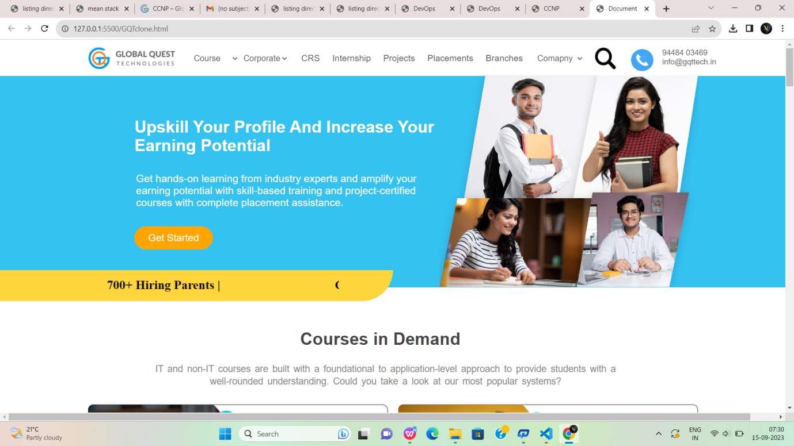

Fig:1

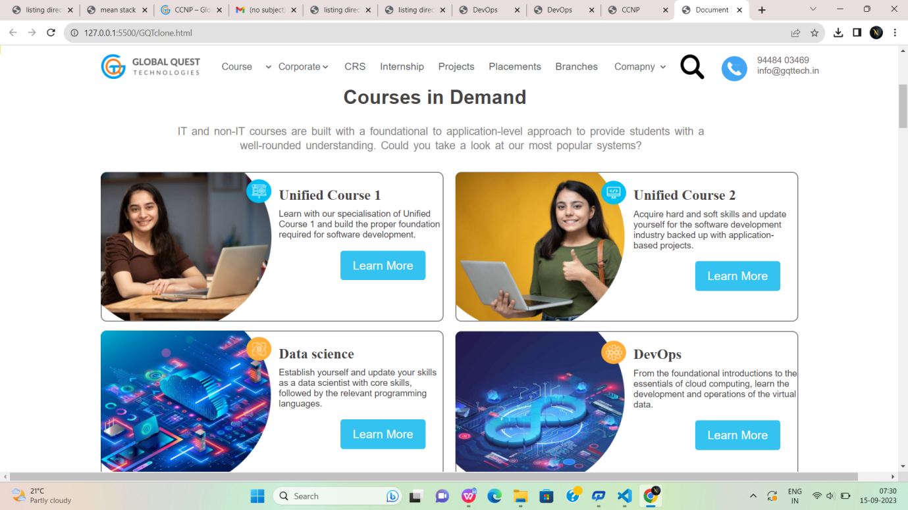

Fig:1.2

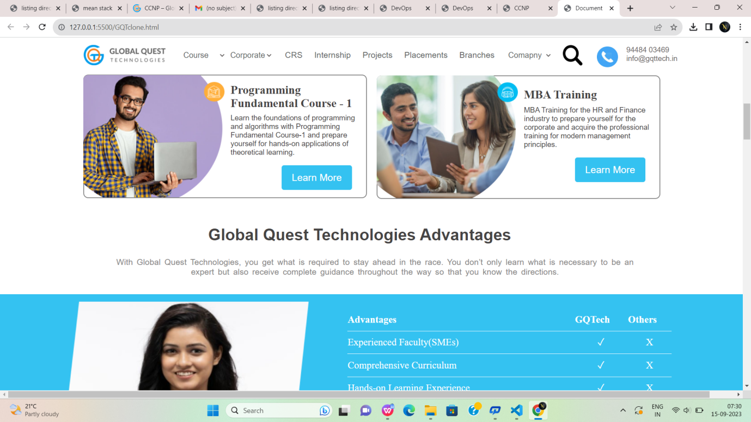

Fig:1.3

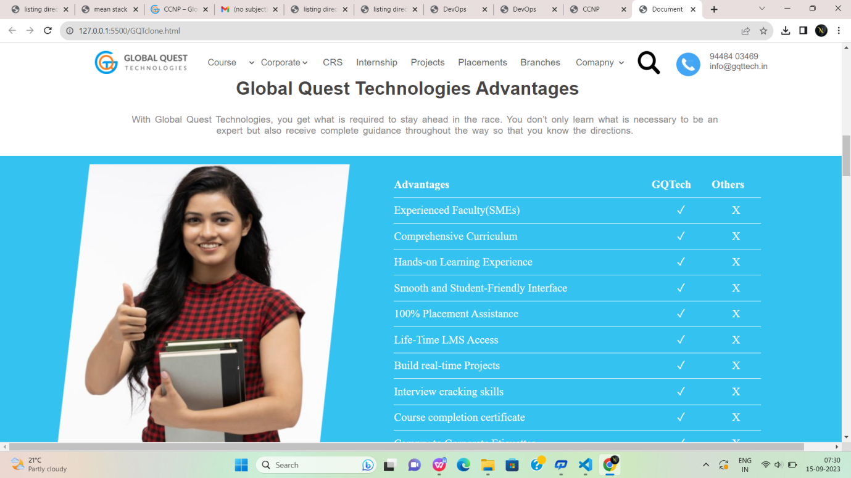

Fig:1.4

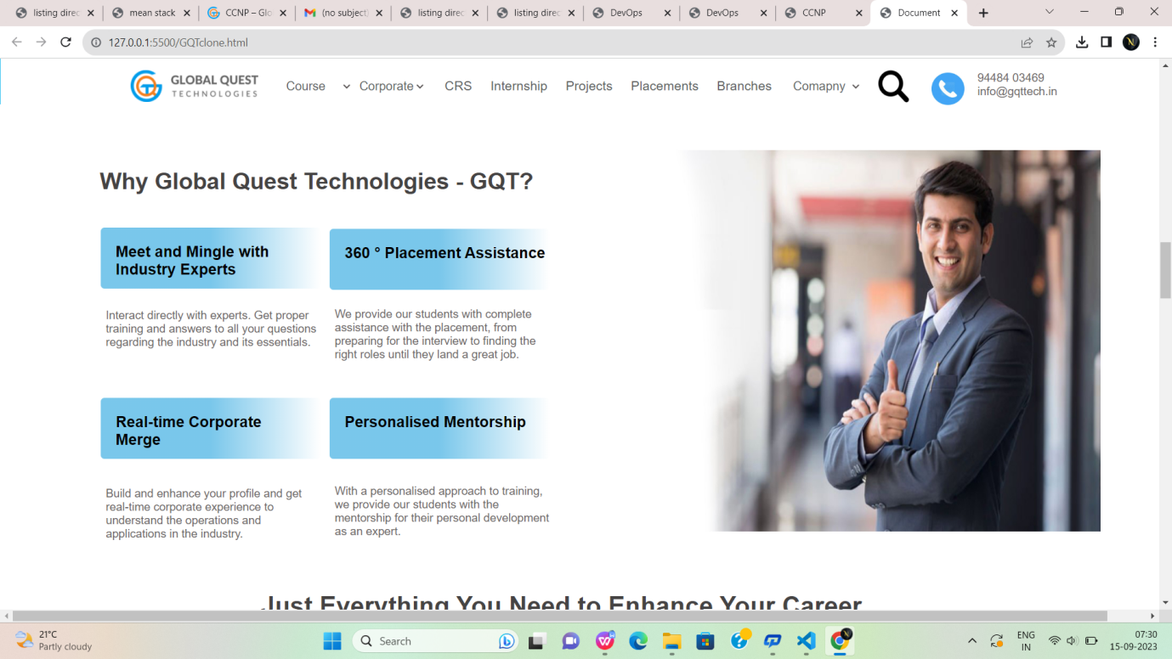

Fig:1.5

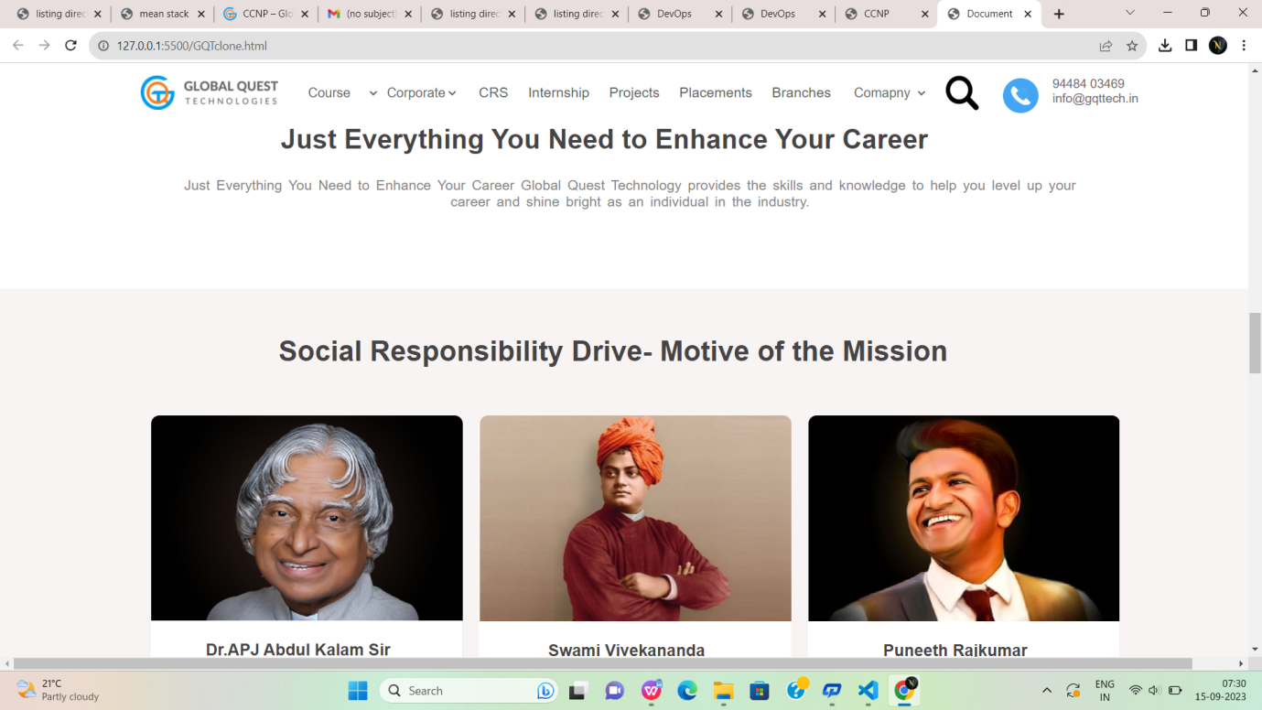

Fig:1.6

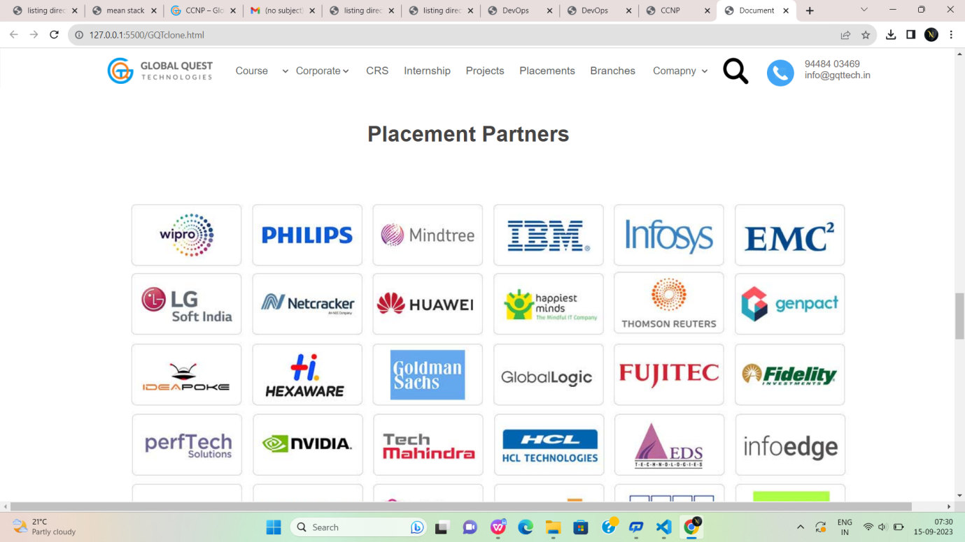

Fig:1.7

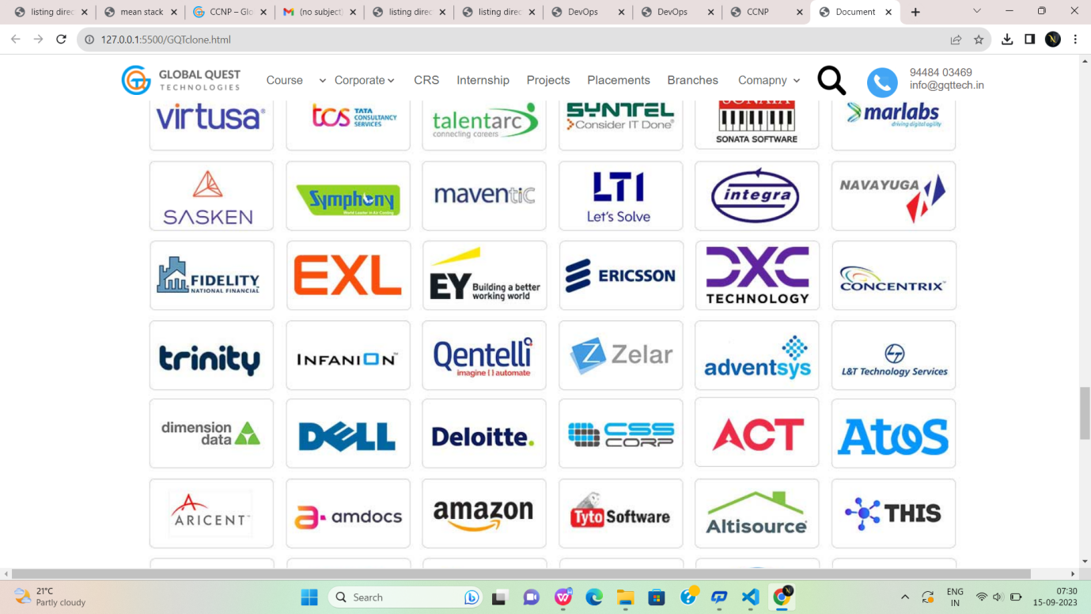

Fig:1.8

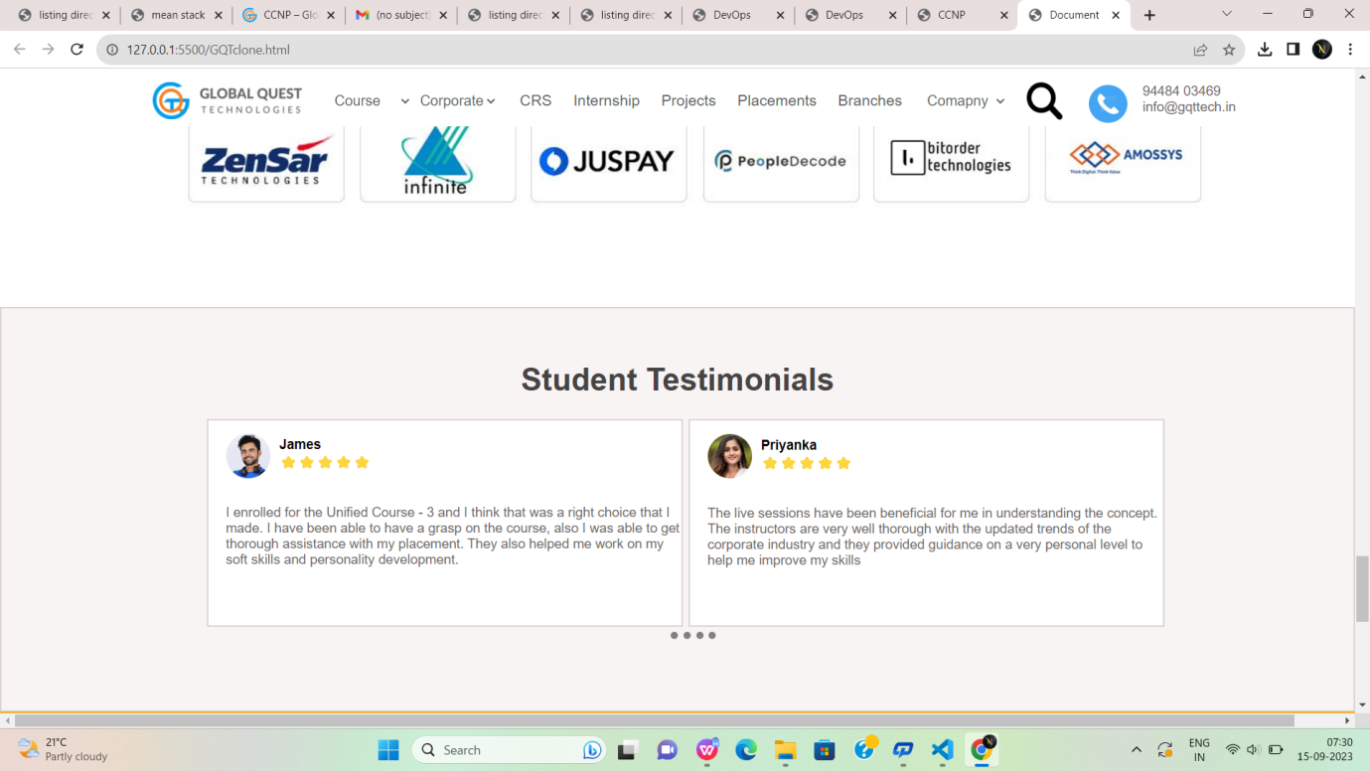

Fig:1.9

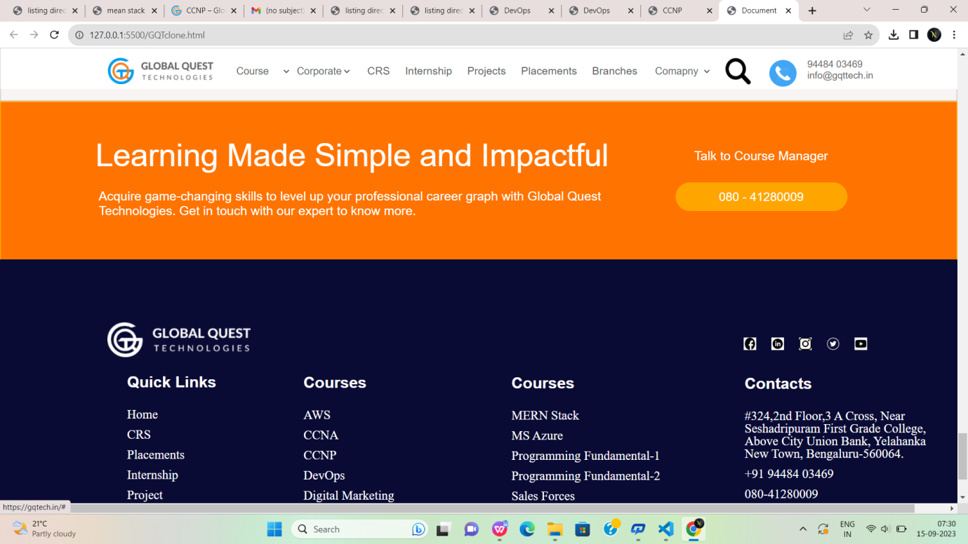

Fig:1.10

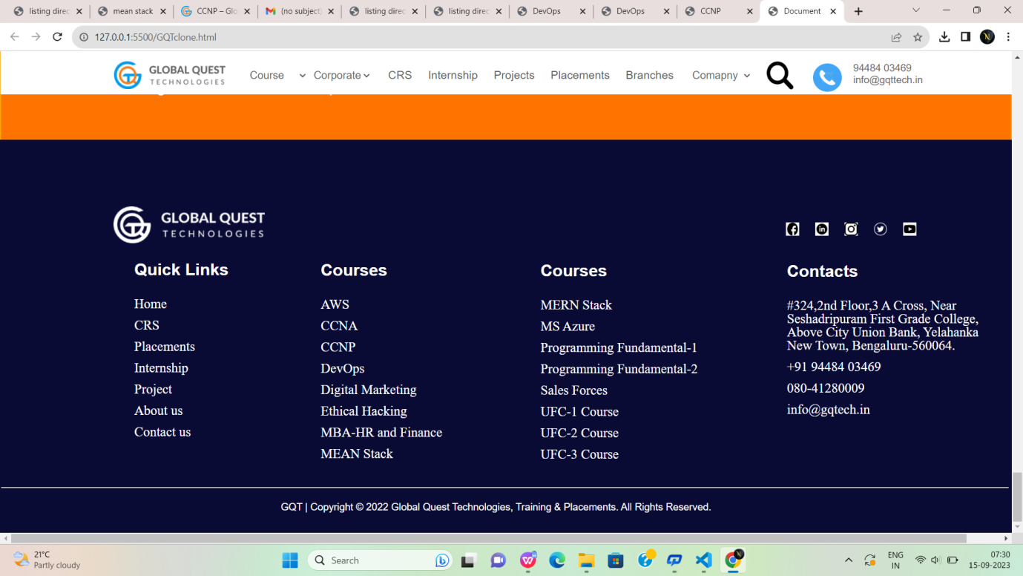

Fig:1.11

**CRS.html:**

<!DOCTYPE html>

<html lang="en">

<head>

<meta charset="UTF-8">

<meta name="viewport" content="width=device-width, initial-scale=1.0">

<title>CSR</title>

<link rel="stylesheet" href="https://cdnjs.cloudflare.com/ajax/libs/font-awesome/6.1.1/css/all.min.css">

<style>

.div1:hover {

color: rgb(15, 148, 196);

}

#id1:hover {

color: rgb(15, 148, 196);

}

#id2:hover {

color: rgb(15, 148, 196);

}

#colorid1:hover {

background-color: #FFAE39;

}

.hovering:hover {

color: rgb(15, 148, 196);

}

.hovering {

padding-left: 20px;

color: black;

text-decoration: none;

}

</style>

</head>

<body style="margin: 0; font-family: sans-serif; ">

<header id="id1" style="position: fixed;">

<div style="border: 0 red solid; height: 80px; font-size: 17px;width: 100%; background-color: white;">

<img src="https://gqtech.in/wp-content/uploads/2022/04/cropped-GQT_Logo_H_.png"

style="height: 45px; padding-top: 15px; margin-left: 150px;">

<div class="1"

style="border: 0 solid; width: 100%; height: 50px; margin-top: -35px; padding-left: 350px; font-family: sans-serif; background-color: white;">

<select class="div1"

style="width: 80px; border: 0; font-size: 17px; margin-left: 20px; margin-top: -40px;" name="Course"

id="Course">

<option class="div1" value=" Course" style="margin-top: 40px;">Course</option>

<option value="Unified Course-1">Unified Course-1</option>

<option value="Unified Course-2">Unified Course-2</option>

<option value="Unified Course-3">Unified Course-3</option>

<option value="Data Science">Data Science</option>

<option value="Programming Fundamental Course-1">Programming Fundamental Course-1</option>

<option value="Programming Fundamental Course-2">Programming Fundamental Course-2</option>

<option value="Amazon Web Services">Amazon Web Services</option>

<option value="Mircosoft Azure">Mircosoft Azure</option>

<option value="MEAN Stack">MEAN Stack</option>

<option value="MERN Stack">MERN Stack</option>

<option value="MBA-HR and Finance">MBA-HR and Finance</option>

<option value="DevOps">DevOps</option>

<option value="Salesforce">Salesforce</option>

</select>

<select class="div1"

style="width: 100px; border: 0; font-size: 17px; margin-left: 20px; margin-top: -40px;">

<option class="div1" value="">Corporate</option>

<option value="">Need Corporate Training</option>

<option value="">Want to hire our students</option>

</select>

<a class="hovering" href="#">CSR</a>

<a class="hovering" href="#">Internship</a>

<a class="hovering" href="#">Projects</a>

<a class="hovering" href="#">Placements</a>

<a class="hovering" href="#">Branches</a>

<select class="div1"

style="width: 100px; border: 0; font-size: 17px; margin-left: 20px; margin-top: -40px;">

<option class="1" value="">Comapny</option>

<option value="">About Us</option>

<option value="">Contact Us</option>

</select>

<div class="div1"

style="border: 0 solid; width: 100px; height: 60px; font-size: 50px; margin-top: -40px; margin-left: 830px;">

<a href="#"><img src="https://static.thenounproject.com/png/5959138-200.png" alt=""

style="width: 40px; height: 40px; "></a>

<a href="#"><img

src="https://www.iconbunny.com/icons/media/catalog/product/cache/2/thumbnail/600x/1b89f2fc96fc819c2a7e15c7e545e8a9/1/6/168.9-phone-icon-iconbunny.jpg"

alt="" style="width: 45px; height: 45px; "></a>

</div>

<div style="border: 0 solid; height: 50px; width: 150px; margin-top: -55px; margin-left: 935px;">

9448403469 info@gqtech.in</div>

<div

style="border: orangered solid 0; height: 40px; width: 150px; margin-top: -68px;margin-left: 1036px; background-color: white;">

</div>

</div>

</div>

</header><br><br><br><br>

<div style="border: 1px solid ; width: 99.9%; height: 415px; margin-top: 8px; background-color: #09454C;">

<div

style="border: 1px solid transparent ; width: 580px; height: 109.2px;font-size: 42px;font-weight: 600;line-height: 1.3em; color: white; margin-left: 160px; margin-top: 70px;">

Corporate Social Responsibility Program</div>

<p

style="border: 1px solid transparent ; width: 580px; height: 62px;font-size: 16px;font-weight: 400;line-height: 1.3em; margin-left: 160px; color: white;">

All the programs under the Corporate Social Responsibility Initiative shall be conducted free. It is the

social initiative of Global Quest Technologies to help all the students and the teachers be Industry ready.

</p>

<div

style="border: 1px solid transparent ; width: 150px; height: 50px; margin-left: 160px; font-size: 18px;font-weight: 500;line-height: 20px; color: black; border-radius: 5px; background-color: #F48120;">

<br><a style="text-decoration: none; color: black;" href="">

<p

style="text-decoration: none; color: black; min-height: 1.3rem; padding-left: 20px; margin-top: -5px;">

READ MORE</p>

</a></div>

</div><br><br><br>

<!----------------------------------------------------------------------------------------------------------------------------------------------->

<div

style="border: 1px solid transparent; height: 42.9px; width: 1180px;font-size: 33px;font-weight: 600;line-height: 1.3em; color: #54595F; margin-left:160px;">

What is Corporate Social Responsibility (CSR)?</div><br>

<div

style="border: 1px solid transparent; height: 70.2px; width: 1180px;font-size: 18px;font-weight: 400;line-height: 1.3em; color: #54595F; margin-left:160px;">

Corporate Social Responsibility is the policies and practices undertaken by a corporate institution to impact

society positively. Businesses and corporations try to benefit the community through CSR programs while building

a better bond with their stakeholders. Contributing to an organization with the influence the institutions have,

they aim for long-term growth and success of society and their corporation.</div><br><br>

<div

style="border: 1px solid transparent; height: 23.4px; width: 1180px; margin-left: 160px;font-size: 18px;font-weight: 400;line-height: 1.3em; color: #54595F; ">

Through the CSR programs, GQT aims to build a space for those who cannot access professional training and pave

the way for a better future.</div><br><br><br><br><br><br><br><br>

<!------------------------------------------------------------------------------------------------------------------------------------------------>

<div

style="border: 1px solid transparent; height: 42.9px; width: 1180px;font-size: 33px;font-weight: 600;line-height: 1.3em; color: #54595F; margin-left:160px;">

Social Responsibility Drive- Motive of the Mission</div><br><br><br>

<div

style="border: 1px solid transparent; height: 1000px; width: 570px; margin-left: 160px;box-shadow: 2px 2px 10px 3px rgb(203, 200, 200) ;">

<div

style="border: 1px solid transparent ; height: 380px; width: 570px; background-image: url('/kalam.jpg'); background-size: cover; ">

</div><br>

<div

style="border: 1px solid transparent ; height: 30px; width: 530px;font-size: 23px;font-weight: 600; color: #54595F; line-height: 1.3em; padding-left: 30px; ">

<img src="https://gqtech.in/wp-content/uploads/2022/05/kalam.jpg" alt="" width="550px" height="420px"

style="margin-top: -450px;margin-left: -20px;">Dr.APJ Abdul Kalam Sir</div>

<div

style="border: 1px solid transparent ; height: 46px; width: 500px; padding: 30px; text-align: justify; font-size: 19px; color: #54595F; padding-bottom: 0px; ">

“All of us do not have equal talent. But, we all have an equal opportunity to develop our talents.”</div>

<div

style="border: 1px solid transparent ; height: 46px; width: 500px; padding: 30px; text-align: justify; font-size: 18px; color: #54595F; padding-bottom: 0px;">

GQT’s prestigious social initiative program, we reach out to all the government colleges where the students

require high-end expertise per corporate expectations.</div>

<div

style="border: 1px solid transparent; height: 46px; width: 500px; padding: 30px; text-align: justify; font-size: 18px; color: #54595F; padding-bottom: 0px; margin-top: 15px;">

Dr APJ Abdul Kalam was one such individual who always strived hard to help the poor and needy talents to

shine in their field.</div>

<div

style="border: 1px solid transparent; height: 46px; width: 500px; padding: 30px; text-align: justify; font-size: 18px; color: #54595F; padding-bottom: 0px;margin-top: 15px;">

Our research shows that many students are well-equipped but are not given the proper guidance. Through this

program, GQT will handhold such students and lead them to the destination meant for them.</div>

<div

style="border: 1px solid transparent; height: 46px; width: 500px; padding: 30px; text-align: justify; font-size: 18px; color: #54595F; padding-bottom: 0px;margin-top: 36px;">

In this program, the students are not just given the technical knowledge but also offered a suitable

placement opportunity.</div>

<div

style="border: 1px solid transparent; height: 46px; width: 500px; padding: 30px; text-align: justify; font-size: 18px; color: #54595F; padding-bottom: 0px;margin-top: 2px;">

Global Quest Technologies will assist every student until they are placed. This isn’t only a phrase. GQT has

a responsibility to the student fraternity..</div>

</div>

<!------------------------------------------------------------------------------------------------------------------------------------------------>

<div

style="border: 1px solid transparent; height: 1000px; width: 570px; margin-left: 160px; margin-left: 750px; margin-top: -1001px;box-shadow: 2px 2px 10px 3px rgb(203, 200, 200) ;">

<div

style="border: 1px solid transparent ; height: 380px; width: 570px; background-image: url('/swamy.jpg'); background-size: cover; ">

</div><br>

<div

style="border: 1px solid transparent ; height: 30px; width: 530px;font-size: 23px;font-weight: 600; color: #54595F; line-height: 1.3em; padding-left: 30px; ">

<img src="https://gqtech.in/wp-content/uploads/2022/05/swamy.jpg" alt="" width="550px" height="420px"

style="margin-top: -450px;margin-left: -20px;">Swami Vivekananda</div>

<div

style="border: 1px solid transparent ; height: 46px; width: 500px; padding: 30px; text-align: justify; font-size: 19px; color: #54595F; padding-bottom: 0px; ">

“Experience is the only teacher we have. We may talk and reason all our lives, but we shall not understand a

word of truth.”</div>

<div

style="border: 1px solid transparent ; height: 46px; width: 500px; padding: 30px; text-align: justify; font-size: 18px; color: #54595F; padding-bottom: 0px; margin-top: 20px;">

“Swami Vivekananda Project” is the most ambitious program of Global Quest Technologies. In this program, the

faculties will be trained by industry experts who possess rich technical & practical expertise & we believe

that by implementing this curriculum, all the faculty will be well-versed in contemporary trends and

technologies. With the evolution of Industry, 5.0 new technologies are in the market. Our ambition is to

ensure that the faculties at different Schools & Colleges, who are the backbone of every IT professional,

are well-equipped with practical industry trends to produce excellent engineers and lead the country to

Greater Heights.</div>

<div

style="border: 1px solid transparent; height: 46px; width: 500px; padding: 30px; text-align: justify; font-size: 18px; color: #54595F; padding-bottom: 0px; margin-top: 185px;">

As the program’s name implies, “Shri Swami Vivekananda” spoke worldwide about the brotherhood that India has

adopted. Similarly, we at GQT pledge that our faculty will contribute to the nation’s technical progress and

assist India in becoming a significant centre for techies..</div>

</div><br><br>

<!------------------------------------------------------------------------------------------------------------------------------------------------>

<div

style="border: 1px solid transparent; height: 1000px; width: 570px; margin-left: 160px; box-shadow: 2px 2px 10px 3px rgb(203, 200, 200) ;">

<div

style="border: 1px solid transparent ; height: 380px; width: 570px; background-image: url('/punneth.png'); background-size: cover; ">

</div><br>

<div

style="border: 1px solid transparent ; height: 30px; width: 530px;font-size: 23px;font-weight: 600; color: #54595F; line-height: 1.3em; padding-left: 30px; ">

<img src="https://gqtech.in/wp-content/uploads/2022/05/New-Project.png" alt="" width="550px" height="420px"

style="margin-top: -450px;margin-left: -20px;">Puneeth Rajkumar</div>

<div

style="border: 1px solid transparent ; height: 46px; width: 500px; padding: 30px; text-align: justify; font-size: 19px; color: #54595F; padding-bottom: 0px; ">

“Stop Waiting For The Right Time. Time Isn’t Waiting For You.”</div>

<div

style="border: 1px solid transparent ; height: 46px; width: 500px; padding: 30px; text-align: justify; font-size: 18px; color: #54595F; padding-bottom: 0px; margin-top: 10px;">

“Puneeth Rajkumar Social Responsibility” Program is one of the most esteemed projects of GQT. Through this

project, GQT gives a tribute to Mr Puneeth Rajkumar, one of the Most Sensational Human Beings we have ever

witnessed.</div>

<div

style="border: 1px solid transparent; height: 46px; width: 500px; padding: 30px; text-align: justify; font-size: 18px; color: #54595F; padding-bottom: 0px; margin-top: 50px;">

Through this program, GQT offers free training and career development opportunities to all students who

possess talents but cannot afford to get the required knowledge.</div>

<div

style="border: 1px solid transparent; height: 46px; width: 500px; padding: 30px; text-align: justify; font-size: 18px; color: #54595F; padding-bottom: 0px; margin-top: 35px;">

GQT recognizes such talents through this program. These candidates will be made IT ready through our

Corporate Trainers. These candidates will then start contributing to the upliftment of the nation by making

the country technically strong to face any global challenges.</div>

</div>

<!------------------------------------------------------------------------------------------------------------------------------------------------>

<div

style="border: 1px solid #00BDF2; height: 261.4px; width: 99.9%; margin-top: 100px; background-color: #00BDF2;">

<div

style="border: 1px solid #00BDF2; height: 54.6px; width: 820px; font-size: 42px; color: white; margin-top: 70px; margin-left: 150px;">

<b>Learning Made Simple and Impactful</b></div>

<div

style="border: 1px solid #00BDF2; height: 54.6px; width: 760px; font-size: 18px; color: white; margin-top: 30px; margin-left: 150px;">

Learn courses that could prove a game changer in your professional career graph. Get in touch with our

expert to know more.</div>

<div

style="border: 1px solid #00BDF2; height: 54.6px; width: 420px; font-size: 20px; color: white; margin-top: -150px; margin-left: 1000px;">

Talk to Course Manager</div>

<a style="text-decoration: none;" href="">

<div id="colorid1"

style="border: 1px solid #FFAE39; height: 27.3px; width: 240px; margin-left: 950px; background-color: #FFAE39 ; font-size: 21px; padding: 15px; padding-left: 80px; border-radius: 5px; color: black; box-shadow: 1px 1px 3px 1px #FFAE39;">

+91 &nbsp;&nbsp;9448403469</div>

</a>

</div>

<div style="border: 1px solid; height: 572.1px; width: 99.9%; background-color: #092C4C;">

<div style="border: 1px solid #092C4C; height: 452.3px; width: 1509.2px; margin-top: 70px;">

<div

style="border: 1px solid #092C4C; height: 56px; width: 228px; margin-left: 200px; background-image: url('/GQT_Logo_H_@2x.png');">

</div>

<div

style="border: 1px solid #092C4C; height: 50px; width: 270px; margin-top: -56px; margin-left: 1000px; padding-left: 80px;">

<img src="https://gqtech.in/wp-content/uploads/2022/04/GQT_Logo_H_@2x.png" alt=""

style="margin-left: -902px;margin-top: 30px;">

<div

style="border: 1px solid #092C4C; height: 25px; width: 25px; color: white; padding-top: 10px;padding-left: 10px;margin-top: -50px">

<i class="fa-brands fa-facebook fa-2xl"></i></div>

<div

style="border: 1px solid #092C4C; height: 25px; width: 25px; color: white; padding-top: 10px; margin-left: 50px; margin-top: -35px;padding-left: 10px;">

<i class="fa-brands fa-linkedin fa-2xl"></i></div>

<div

style="border: 1px solid #092C4C; height: 25px; width: 25px; color: white; padding-top: 10px; margin-left: 100px; margin-top: -37px;padding-left: 10px;">

<i class="fa-brands fa-instagram fa-2xl"></i></div>

<div

style="border: 1px solid #092C4C; height: 25px; width: 25px; color: white; padding-top: 10px; margin-left: 150px; margin-top: -37px;padding-left: 10px;">

<i class="fa-brands fa-twitter fa-2xl"></i></div>

<div

style="border: 1px solid #092C4C; height: 25px; width: 25px; color: white; padding-top: 10px; margin-left: 200px; margin-top: -37px;padding-left: 10px;">

<i class="fa-brands fa-youtube fa-2xl"></i></div>

<div

style="height: 332.1px; width: 1629.2px;border:0px solid black;background-color: transparent; margin-left: -1200px;">

<div

style="width: 230px;height:70px;margin-left: 250px;margin-top: 72px;border:0px solid transparent;">

</div>

<div

style="width: 230px;height:250px;margin-left: 320px;margin-top:-100px;border:0px solid white;background-color: #092C4C;">

<h4

style="text-align:left;color:white;font-family:'Lucida Sans', 'Lucida Sans Regular', 'Lucida Grande', 'Lucida Sans Unicode', Geneva, Verdana, sans-serif;font-size:22px;font-weight: 300;">

Quick Links</h4>

<div style="margin-left: 0px;">

<a style="text-decoration: none; color: white; font-family: 16px;line-height: 25px;"

href="index.html" target="_blank">Home</a><br>

<a style="text-decoration: none; color: white; font-family: 16px;line-height: 25px;"

href="csr.html" target="_blank">CSR</a><br>

<a style="text-decoration: none; color: white; font-family: 16px;line-height: 25px;" href=""

target="_blank">Placement</a><br>

<a style="text-decoration: none; color: white; font-family: 16px;line-height: 25px;" href=""

target="_blank">Internship</a><br>

<a style="text-decoration: none; color: white; font-family: 16px;line-height: 25px;" href=""

target="_blank">Projects</a><br>

<a style="text-decoration: none; color: white; font-family: 16px;line-height: 25px;" href=""

target="_blank">About Us</a><br>

<a style="text-decoration: none; color: white; font-family: 16px;line-height: 25px;" href=""

target="_blank">Contact us</a><br>

</div>

</div>

<div

style="width: 230px;height:299px;margin-left: 600px;margin-top:-280px;border:0px solid white;background-color: #092C4C;">

<h4

style="text-align:left;color:white;font-family:'Lucida Sans', 'Lucida Sans Regular', 'Lucida Grande', 'Lucida Sans Unicode', Geneva, Verdana, sans-serif;font-size:22px;font-weight: 300;">

Courses</h4>

<div style="margin-left: 0px;">

<a style="text-decoration: none; color: white; font-family: 16px;line-height: 25px;" href=""

target="_blank">AWS</a><br>

<a style="text-decoration: none; color: white; font-family: 16px;line-height: 25px;" href=""

target="_blank">CCNA</a><br>

<a style="text-decoration: none; color: white; font-family: 16px;line-height: 25px;" href=""

target="_blank">CCNP</a><br>

<a style="text-decoration: none; color: white; font-family: 16px;line-height: 25px;" href=""

target="_blank">DevOps</a><br>

<a style="text-decoration: none; color: white; font-family: 16px;line-height: 25px;" href=""

target="_blank">Digital Marketing</a><br>

<a style="text-decoration: none; color: white; font-family: 16px;line-height: 25px;" href=""

target="_blank">Ethical Hacking</a><br>

<a style="text-decoration: none; color: white; font-family: 16px;line-height: 25px;" href=""

target="_blank">MBA - HR and finance</a><br>

<a style="text-decoration: none; color: white; font-family: 16px;line-height: 25px;" href=""

target="_blank">MEAN Stack</a><br>

</div>

</div>

<div

style="width: 230px;height:299px;margin-left: 895px;margin-top:-326px;border:0px solid white;background-color: #092C4C;">

<h4

style="text-align:left;color:white;font-family:'Lucida Sans', 'Lucida Sans Regular', 'Lucida Grande', 'Lucida Sans Unicode', Geneva, Verdana, sans-serif;font-size:22px;font-weight: 300;">

Courses</h4>

<div style="margin-left: 0px;">

<a style="text-decoration: none; color: white; font-family: 16px;line-height: 25px;" href=""

target="_blank">MERN Stack</a><br>

<a style="text-decoration: none; color: white; font-family: 16px;line-height: 25px;" href=""

target="_blank">MS Azure</a><br>

<a style="text-decoration: none; color: white; font-family: 16px;line-height: 25px;" href=""

target="_blank">Programming Fundamental-1</a><br>

<a style="text-decoration: none; color: white; font-family: 16px;line-height: 25px;" href=""

target="_blank">Programming Fundamental-2</a><br>

<a style="text-decoration: none; color: white; font-family: 16px;line-height: 25px;" href=""

target="_blank">Sales Forces</a><br>

<a style="text-decoration: none; color: white; font-family: 16px;line-height: 25px;" href=""

target="_blank">UFC-1 Course</a><br>

<a style="text-decoration: none; color: white; font-family: 16px;line-height: 25px;" href=""

target="_blank">UFC-2 Course</a><br>

<a style="text-decoration: none; color: white; font-family: 16px;line-height: 25px;" href=""

target="_blank">UFC-3 Course</a><br>

</div>

</div>

<div

style="width: 230px;height:299px;margin-left: 1210px;margin-top:-331px;border:0px solid white;background-color: #092C4C;">

<h4

style="text-align:left;color:white;font-family:'Lucida Sans', 'Lucida Sans Regular', 'Lucida Grande', 'Lucida Sans Unicode', Geneva, Verdana, sans-serif;font-size:22px;font-weight: 300;">

Contacts</h4>

<div style="margin-left: 0px;">

<a style="text-decoration: none; color: white; font-family: 16px;line-height: 20px;"

href="https://gqtech.in/" target="_blank">#324,2nd Floor,# A Cross, Near Seshadripuram

First Grade College,Above City Union Bank,Yelahanka New Town,Bengaluru-560064</a><br>

<a style="text-decoration: none; color: white; font-family: 16px;line-height: 50px;" href=""

target="_blank"><i class="fa-solid fa-phone" style="color: #fcfcfc;"></i> +91

9448403469</i></a><br>

<a style="text-decoration: none; color: white; font-family: 16px;line-height:20px;" href=""

target="_blank"><i class="fa-solid fa-phone" style="color: #fcfcfc;"></i>

080-41280009</a><br>

<a style="text-decoration: none; color: white; font-family: 16px;line-height: 45px;" href=""

target="_blank"><i class="fa-solid fa-envelope" style="color: #ffffff;"></i>

info@gqtech.in</a><br>

</div>

</div>

<div

style="width:320px;height: 40px;border: 0px solid white ;margin-left: 1020px;margin-top: -420px;">

<a style="text-decoration: none; color: white; font-family: 16px;" style="padding: 10px;"

href="" target="_blank"><i class='bx bxl-facebook-circle' style="font-size: 25px;"></i></a>

<a style="text-decoration: none; color: white; font-family: 16px;" style="padding: 10px;"

href="" target="_blank"><i class='bx bxl-linkedin-square' style="font-size: 25px;"></i></a>

<a style="text-decoration: none; color: white; font-family: 16px;" style="padding: 10px;"

href="" target="_blank"><i class='bx bxl-instagram-alt' style="font-size: 25px;"></i></a>

<a style="text-decoration: none; color: white; font-family: 16px;" style="padding: 10px;"

href="" target="_blank"><i class='bx bxl-twitter' style="font-size: 25px;"></i></a>

<a style="text-decoration: none; color: white; font-family: 16px;" style="padding: 10px;"

href="" target="_blank"><i class='bx bxl-youtube' style="font-size: 25px;"></i></a>

</div>

<hr style="color: white;margin-top: 380px;">

<p style="text-align:center;margin-top: 30px; color: white;">GQT | Copyright © 2022 Global Quest

Technologies, Training & Placements. All Rights Reserved.</p>

</div>

</div>

</body>

</html>

**Output:**

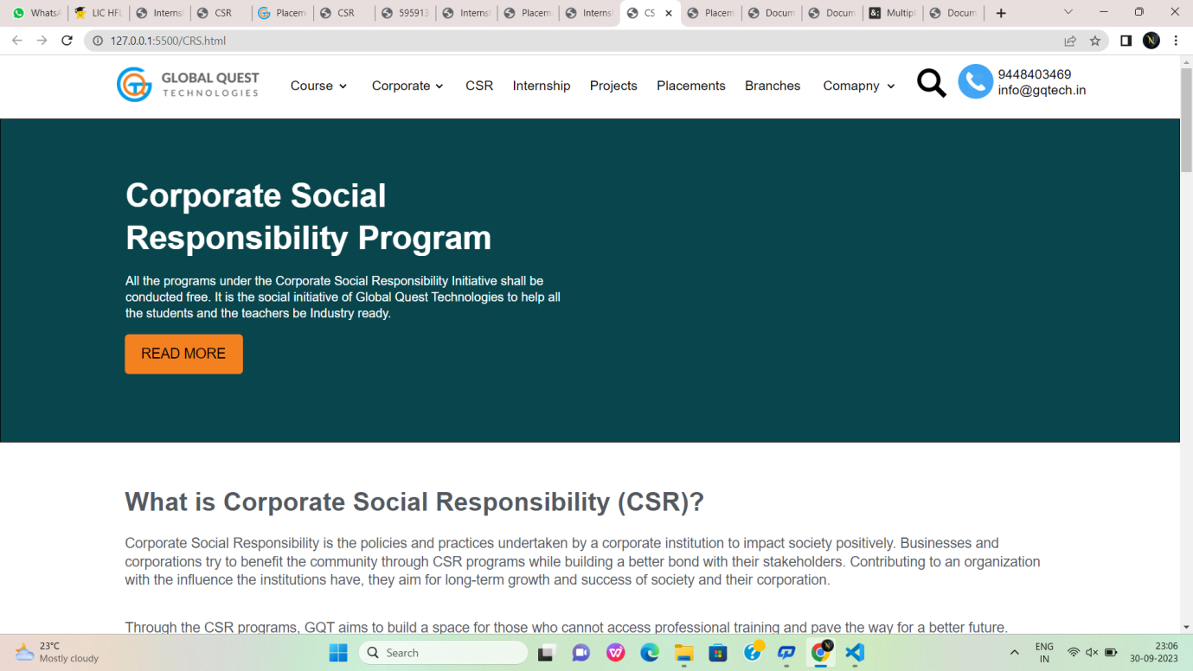

Fig:2

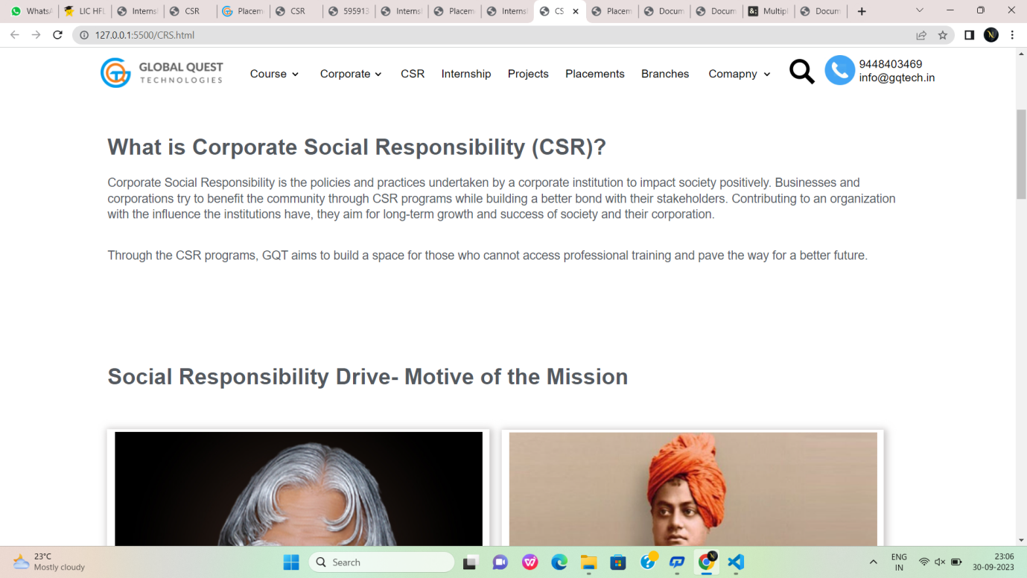

Fig:2.1

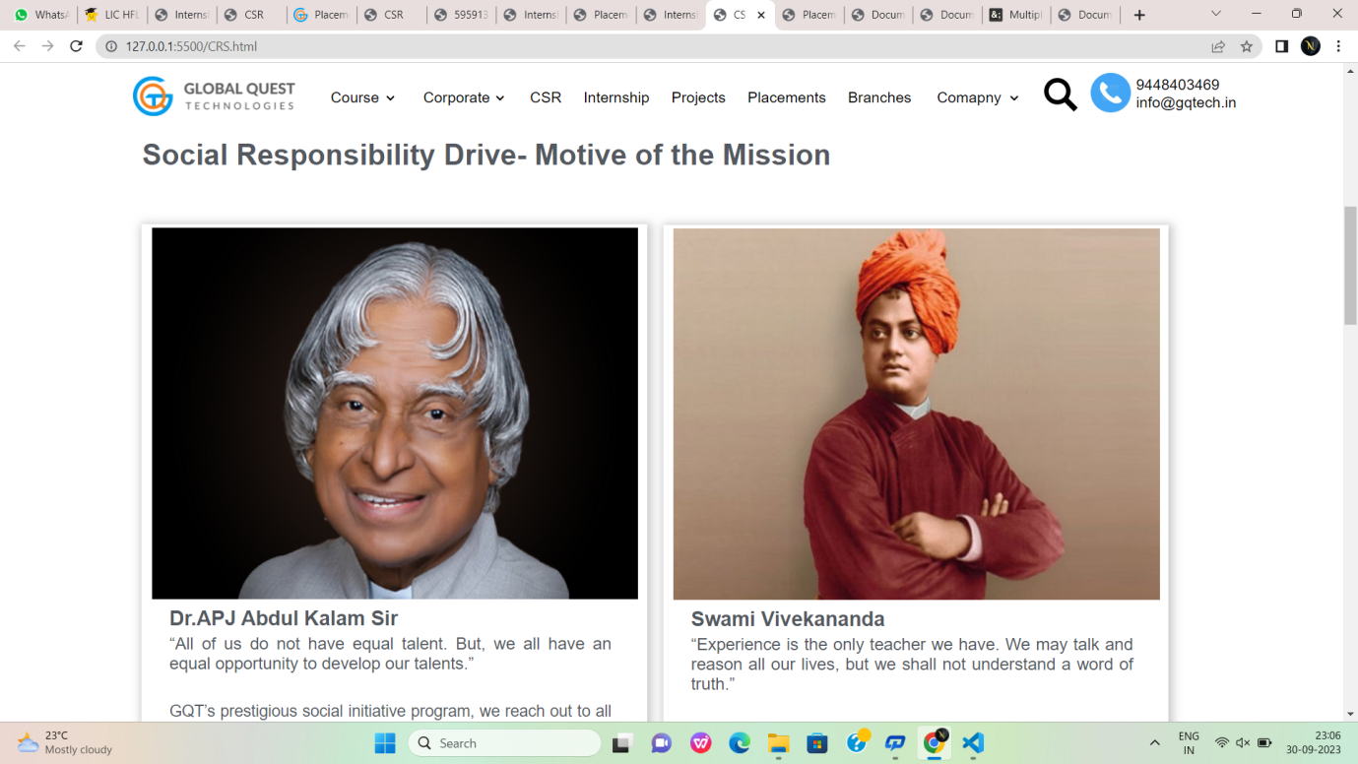

Fig:2.2

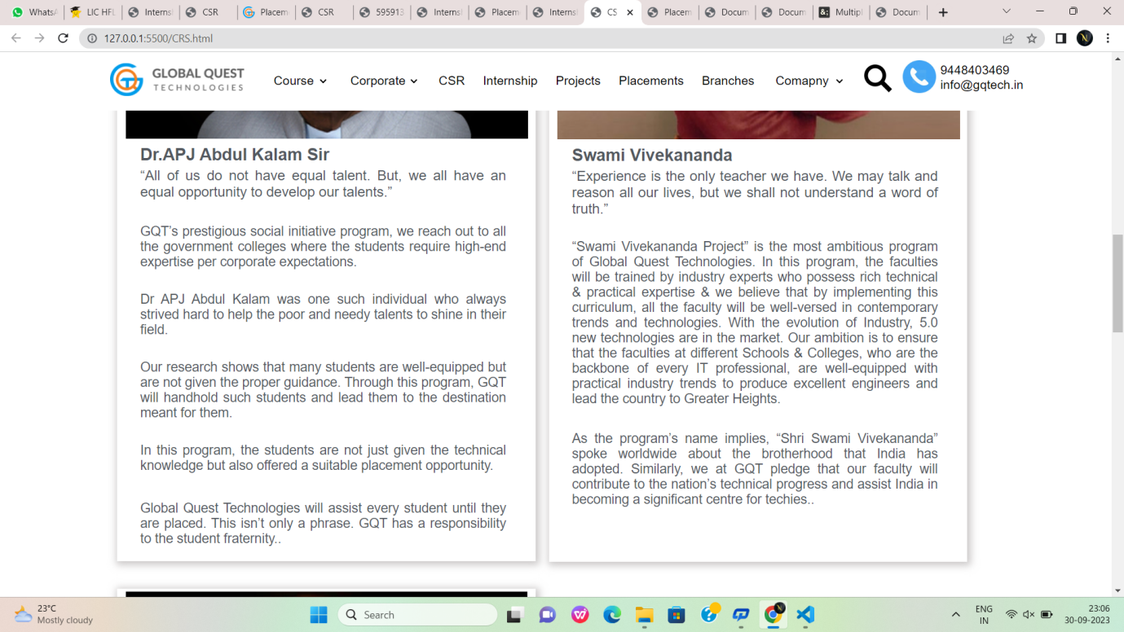

Fig:2.3

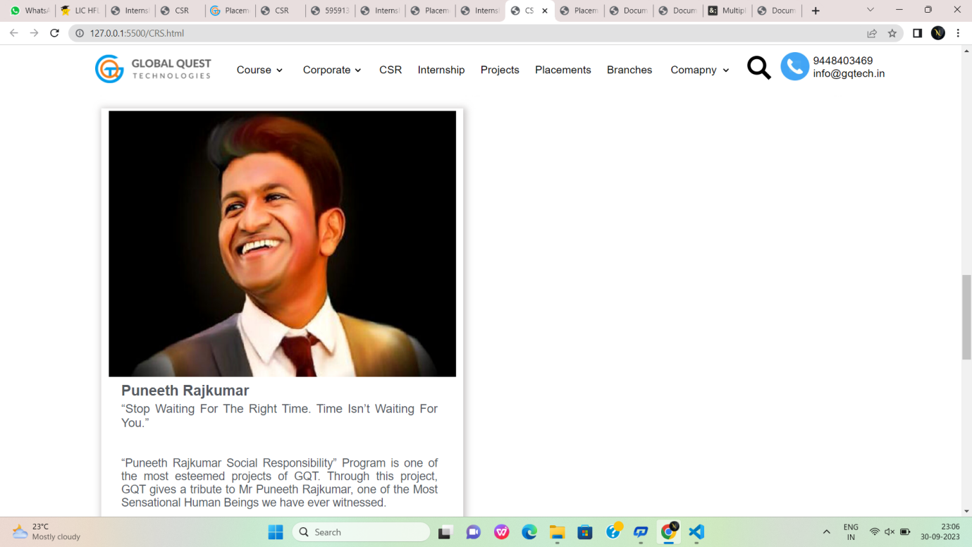

Fig:2.4

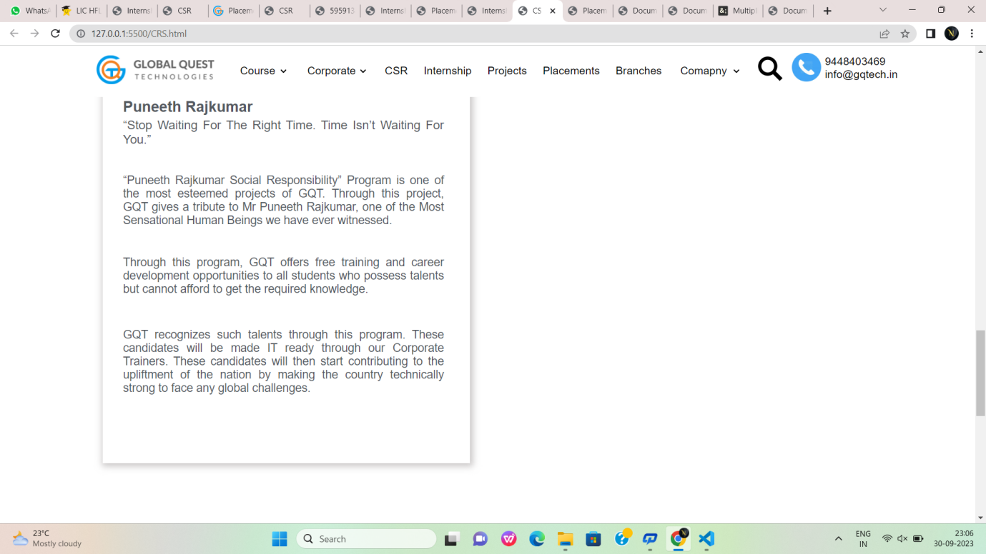

Fig:2.5

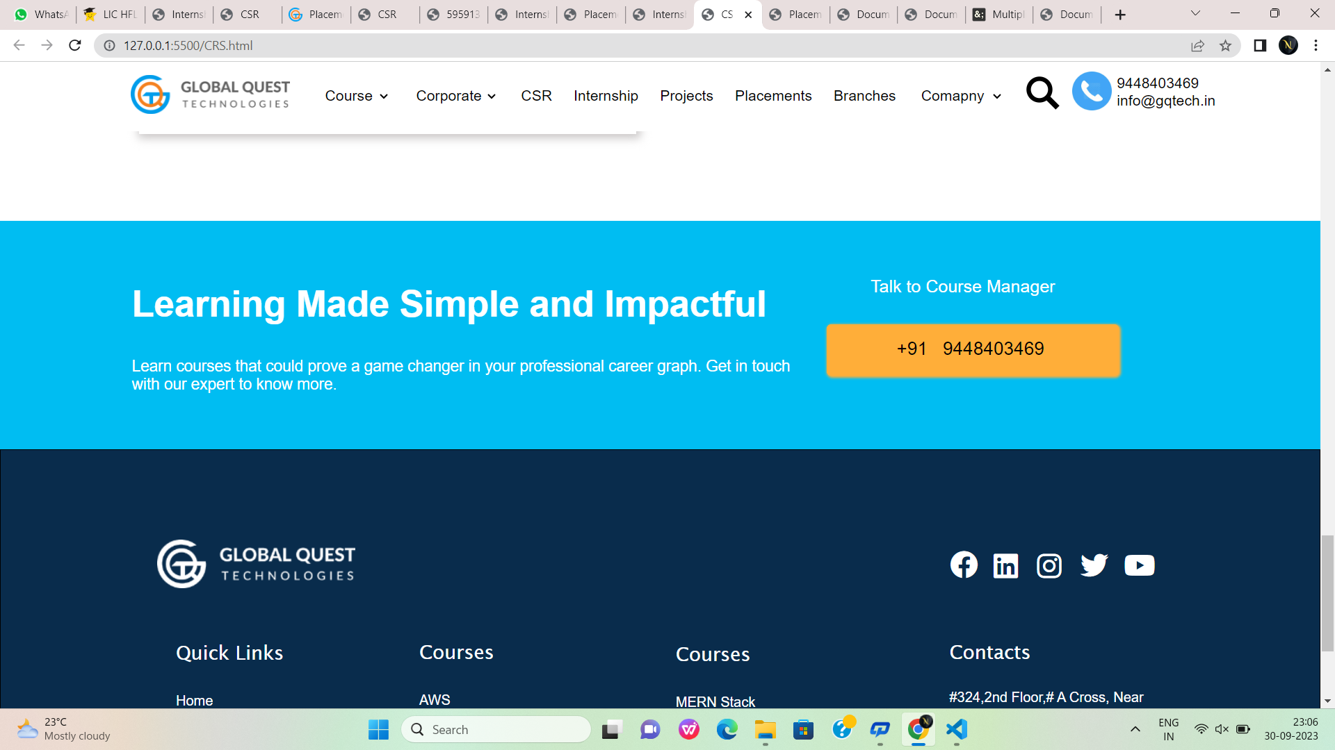

Fig:2.6

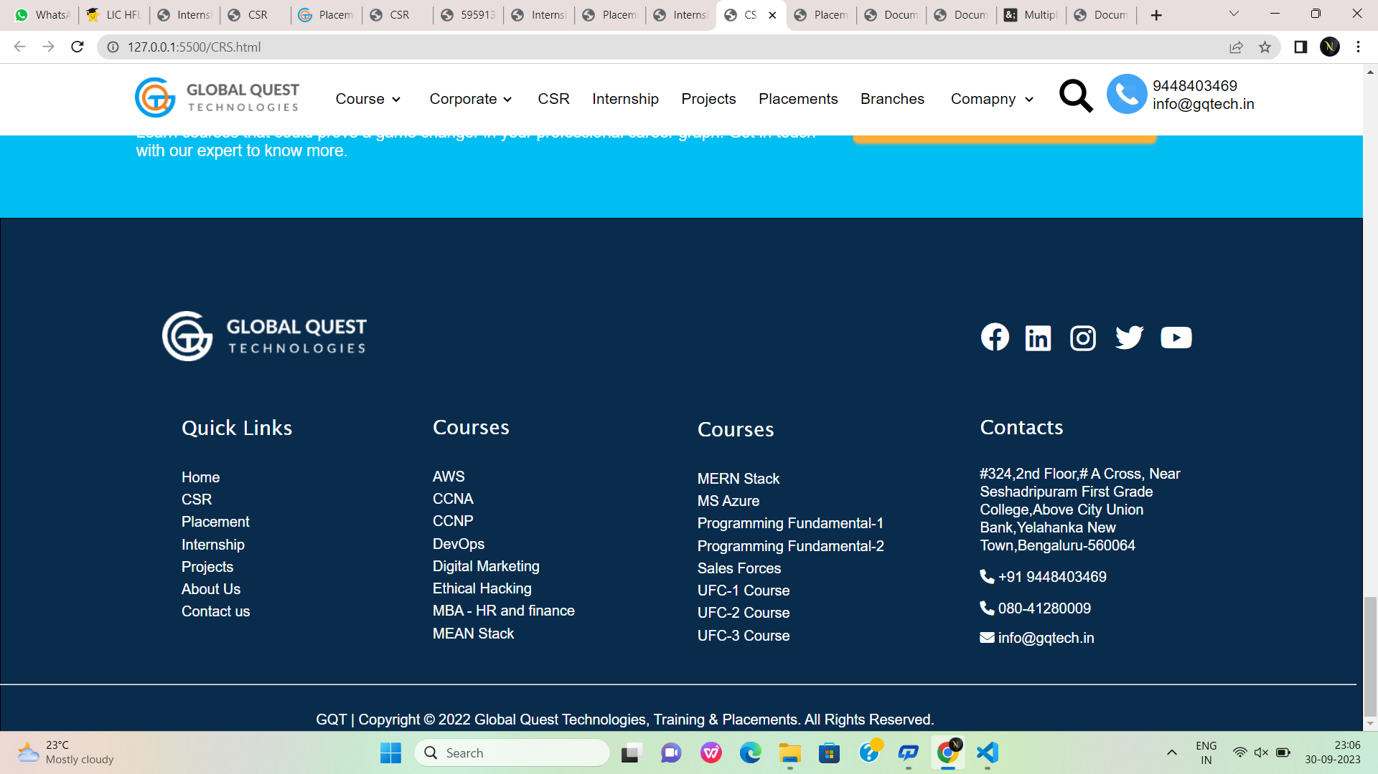

Fig:2.7

**Internships.html:**

<!DOCTYPE html>

<html lang="en">

<head>

<meta charset="UTF-8">

<meta name="viewport" content="width=device-width, initial-scale=1.0">

<title>Internship</title>

<link rel="stylesheet" href="https://cdnjs.cloudflare.com/ajax/libs/font-awesome/6.1.1/css/all.min.css">

<style>

.div1:hover {

color: rgb(15, 148, 196);

}

#id1:hover {

color: rgb(15, 148, 196);

}

#id2:hover {

color: rgb(15, 148, 196);

}

#colorid1:hover {

background-color: #FFAE39;

}

.hovering:hover {

color: rgb(15, 148, 196);

}

.hovering {

padding-left: 20px;

color: black;

text-decoration: none;

}

</style>

</head>

<body style="margin: 0; font-family: sans-serif; ">

<header id="id1" style="position: fixed;">

<div style="border: 0 red solid; height: 80px; font-size: 17px;width: 100%; background-color: white;">

<img src="https://gqtech.in/wp-content/uploads/2022/04/cropped-GQT_Logo_H_.png"

style="height: 45px; padding-top: 15px; margin-left: 150px;">

<div class="1"

style="border: 0 solid; width: 100%; height: 50px; margin-top: -35px; padding-left: 350px; font-family: sans-serif; background-color: white;">

<select class="div1" style="width: 80px; border: 0; font-size: 17px; margin-left: 20px; margin-top: -40px;"

name="Course" id="Course">

<option class="div1" value=" Course" style="margin-top: 40px;">Course</option>

<option value="Unified Course-1">Unified Course-1</option>

<option value="Unified Course-2">Unified Course-2</option>

<option value="Unified Course-3">Unified Course-3</option>

<option value="Data Science">Data Science</option>

<option value="Programming Fundamental Course-1">Programming Fundamental Course-1</option>

<option value="Programming Fundamental Course-2">Programming Fundamental Course-2</option>

<option value="Amazon Web Services">Amazon Web Services</option>

<option value="Mircosoft Azure">Mircosoft Azure</option>

<option value="MEAN Stack">MEAN Stack</option>

<option value="MERN Stack">MERN Stack</option>

<option value="MBA-HR and Finance">MBA-HR and Finance</option>

<option value="DevOps">DevOps</option>

<option value="Salesforce">Salesforce</option>

</select>

<select class="div1" style="width: 100px; border: 0; font-size: 17px; margin-left: 20px; margin-top: -40px;">

<option class="div1" value="">Corporate</option>

<option value="">Need Corporate Training</option>

<option value="">Want to hire our students</option>

</select>

<a class="hovering" href="#">CSR</a>

<a class="hovering" href="#">Internship</a>

<a class="hovering" href="#">Projects</a>

<a class="hovering" href="#">Placements</a>

<a class="hovering" href="#">Branches</a>

<select class="div1" style="width: 100px; border: 0; font-size: 17px; margin-left: 20px; margin-top: -40px;">

<option class="1" value="">Comapny</option>

<option value="">About Us</option>

<option value="">Contact Us</option>

</select>

<div class="div1"

style="border: 0 solid; width: 100px; height: 60px; font-size: 50px; margin-top: -40px; margin-left: 830px;">

<a href="#"><img src="https://static.thenounproject.com/png/5959138-200.png" alt=""

style="width: 40px; height: 40px; "></a>

<a href="#"><img

src="https://www.iconbunny.com/icons/media/catalog/product/cache/2/thumbnail/600x/1b89f2fc96fc819c2a7e15c7e545e8a9/1/6/168.9-phone-icon-iconbunny.jpg"

alt="" style="width: 45px; height: 45px; "></a>

</div>

<div style="border: 0 solid; height: 50px; width: 150px; margin-top: -55px; margin-left: 935px;">9448403469

info@gqtech.in</div>

<div

style="border: orangered solid 0; height: 40px; width: 150px; margin-top: -68px;margin-left: 1036px; background-color: white;">

</div>

</div>

</div>

</header><br><br><br><br>

<!------------------------------------------------------------------------------------------------------------------------------------------------>

<!------------------------------------------------------------------------------------------------------------------------------------------------>

<div style="border: solid 0; height: 440px; width: 100%;background-color: #00bdf2;"><img

src="https://gqtech.in/wp-content/uploads/2022/04/Downloader.la-625f95d8eb284@2x.png" alt="" width="30%"

height="430px" style="margin-top: 8px;margin-left: 900px;">

<div style="border: 0 solid; height: 440px; width: 502px; margin-left:850px; background-image: url('/intern.png'); background-size: 100% 100%; background-repeat: no-repeat; background-position: 0px 5px;">

</div>

<div

style="border: 0px solid; height: 109px; width: 630px;color: #FFFFFF;font-size: 42px;font-weight: 600;line-height: 1.3em ;margin-top: -750px;margin-left: 160px;">

Your Career Starts Here With GQT</div><br>

<div

style="text-align: left;color: #FFFFFF;font-size: 18px;font-weight: 400;line-height: 1.3em;width: 630px;margin-left: 160px;">

Get access to the best internship openings in leading companies across the industry and get ahead in your career.

Apply with Global Quest Technologies.</div><br>

<a href="#"> <input type="submit" value=" START YOUR JOURNEY HERE"

style="height: 55PX; width: 255px; font-size: 15px; background-color: #FFAE39; border-radius:0px; color: white; border: none; border-radius: 5px; margin-left: 160px; cursor: pointer;"></a>

</div>

<!--------------------------------------------------------------------------------------------------------------------------------------------->

<div style="border: 0px solid; height: 684px; width: 100%;background-color: #F8F8F8;">

<br><br><br><br>

<div

style="height:42.9px ; width: 100%;color: var(--e-global-color-secondary );font-size: 33px;font-weight: 600;line-height: 1.3em;text-align: center;">

Your Future Starts Here</div><br>

<div

style="text-align: center;color: var(--e-global-color-secondary );font-size: 18px;font-weight: 400;line-height: 1.3em;">

Choose from the most reputed hiring partners of Global Quest Technologies. Then, take advantage of the access

given by GQT and get your <br> hands on the best opportunities in the industry.</div><br><br>

<div

style="color: var(--e-global-color-secondary );font-size: 21px;font-weight: 600;line-height: 1.3em;margin-left: 160px;">

The Global Quest Internship Program</div><br>

<div style="background-color: #00BDF2;width: 377px; height: 4px; margin-left: 160px;"></div><br>

<img src="https://gqtech.in/wp-content/uploads/2022/04/Group-2090.png" alt=""

style="margin-left: 770px;margin-top: -60px;">

<div

style="color: var(--e-global-color-secondary );font-size: 16px;font-weight: 400;line-height: 1.3em;width: 36%; margin-left: 160px;margin-top: -332px;">

To enhance the students’ career learning here at GQT, we provide them with projects and opportunities to help them

acquire the hands-on industry experience they know. Moreover, we bring them the best internship openings that are

well-suited for their desired job profile. During their internship, they get to work with some reputed names in

the industry and get the guidance they need straight-up from the industry experts.</div><br><br>

<div

style="color: var(--e-global-color-secondary );font-size: 16px;font-weight: 400;line-height: 1.3em;width: 36%; margin-left: 160px;">

Hence, the learners wishing for a heads up in their careers should check the internship openings per their aspired

job profiles.</div>

<div

style="height: 380px; width: 570px; background-image: url('/Group-2090.png'); background-size: cover; margin-top: -270px; margin-left: 750px;">

</div>

</div><br><br><br><br>

<!---------------------------------------------------------------------------------------------------------------------------------------------->

<div

style="height: 363px; width: 580px;background-image: url('/learn.jpg'); background-size: cover;margin-left: 160px;">

</div>

<div

style="color: var(--e-global-color-secondary );font-size: 33px;font-weight: 600;line-height: 1.3em; margin-top: -360px; margin-left: 780px;">

What Can You Learn?</div><br>

<img src="https://gqtech.in/wp-content/uploads/2022/05/learn.jpg" alt=""

style="margin-left: 100px;margin-top: -60px;">

<div

style="color: var(--e-global-color-secondary );font-size: 16px;font-weight: 400;line-height: 1.3em; width: 520px;margin-left: 780px;margin-top: -332px;">

You would get to take away a lot of valuable outputs from the internships. Here are some key takeaways:</div>

<div style="margin-left: 780px; margin-top: 20px;"><i class="fa-solid fa-circle fa-sm" style="color: #00bdf2;"></i>

</div>

<div style="margin-left: 800px;margin-top: -20px; width: 35%;line-height: 1.3rem;">The ways to switch your knowledge

from theoretical ideas to practical applications</div>

<div style="margin-left: 780px; margin-top: 13px;"><i class="fa-solid fa-circle fa-sm" style="color: #00bdf2;"></i>

</div>

<div style="margin-left: 800px;margin-top: -15px; width: 35%;line-height: 0.8rem;">Proper work culture and etiquette

of the industry</div>

<div style="margin-left: 780px; margin-top: 13px;"><i class="fa-solid fa-circle fa-sm" style="color: #00bdf2;"></i>

</div>

<div style="margin-left: 800px;margin-top: -15px; width: 35%;line-height: 0.8rem;">Hands-on learning working with the

industry experts</div>

<div style="margin-left: 780px; margin-top: 13px;"><i class="fa-solid fa-circle fa-sm" style="color: #00bdf2;"></i>

</div>

<div style="margin-left: 800px;margin-top: -15px; width: 35%;line-height: 0.8rem;">Get rid of the hesitation and gain

confidence in implementing ideas</div>

<div style="margin-left: 780px; margin-top: 13px;"><i class="fa-solid fa-circle fa-sm" style="color: #00bdf2;"></i>

</div>

<div style="margin-left: 800px;margin-top: -15px; width: 35%;line-height: 0.8rem;">Build your industry linguistics

</div>

<div style="margin-left: 780px; margin-top: 13px;"><i class="fa-solid fa-circle fa-sm" style="color: #00bdf2;"></i>

</div>

<div style="margin-left: 800px;margin-top: -15px; width: 35%;line-height: 0.8rem;">Get access to the most updated

technologies in the industry</div>

<div style="margin-left: 780px; margin-top: 13px;"><i class="fa-solid fa-circle fa-sm" style="color: #00bdf2;"></i>

</div>

<div style="margin-left: 800px;margin-top: -15px; width: 35%;line-height: 0.8rem;">Complete access to the details of a

project development</div><br><br><br><br><br><br><br><br>

<!---------------------------------------------------------------------------------------------------------------------------------------------->

<div

style="color: var(--e-global-color-secondary );font-size: 33px;font-weight: 600;line-height: 1.2em; width: 30%; margin-left: 160px;">

Check Out Latest Student Openings</div>

<img src="https://gqtech.in/wp-content/uploads/2022/05/Student-Openings.jpg" alt=""

style="margin-left: 750px;margin-top: -60px;">

<div style="margin-left: 160px; margin-top: 13px;"><i class="fa-solid fa-circle fa-sm" style="color: #00bdf2;"></i>

</div>

<div style="margin-left: 180px;margin-top: -16px; width: 35%;line-height: 0.8rem;margin-top: -332px;">Machine Learning

</div>

<div style="margin-left: 160px; margin-top: 13px;"><i class="fa-solid fa-circle fa-sm" style="color: #00bdf2;"></i>

</div>

<div style="margin-left: 180px;margin-top: -16px; width: 35%;line-height: 0.8rem;">Website and Content Development

</div>

<div style="margin-left: 160px; margin-top: 13px;"><i class="fa-solid fa-circle fa-sm" style="color: #00bdf2;"></i>

</div>

<div style="margin-left: 180px;margin-top: -16px; width: 35%;line-height: 0.8rem;">Back-end Web Development</div>

<div style="margin-left: 160px; margin-top: 13px;"><i class="fa-solid fa-circle fa-sm" style="color: #00bdf2;"></i>

</div>

<div style="margin-left: 180px;margin-top: -16px; width: 35%;line-height: 0.8rem;">Front-end Web Development</div>

<div style="margin-left: 160px; margin-top: 13px;"><i class="fa-solid fa-circle fa-sm" style="color: #00bdf2;"></i>

</div>

<div style="margin-left: 180px;margin-top: -16px; width: 35%;line-height: 0.8rem;">Digital Marketing</div>

<div style="margin-left: 160px; margin-top: 13px;"><i class="fa-solid fa-circle fa-sm" style="color: #00bdf2;"></i>

</div>

<div style="margin-left: 180px;margin-top: -16px; width: 35%;line-height: 0.8rem;">Core JAVA and Selenium</div>

<div style="margin-left: 160px; margin-top: 13px;"><i class="fa-solid fa-circle fa-sm" style="color: #00bdf2;"></i>

</div>

<div style="margin-left: 180px;margin-top: -16px; width: 35%;line-height: 0.8rem;">Python</div>

<div style="margin-left: 160px; margin-top: 13px;"><i class="fa-solid fa-circle fa-sm" style="color: #00bdf2;"></i>

</div>

<div style="margin-left: 180px;margin-top: -16px; width: 35%;line-height: 0.8rem;">IoT</div>

<div style="margin-left: 160px; margin-top: 13px;"><i class="fa-solid fa-circle fa-sm" style="color: #00bdf2;"></i>

</div>

<div style="margin-left: 180px;margin-top: -16px; width: 35%;line-height: 0.8rem;">Embedded Systems</div>

<div style="margin-left: 160px; margin-top: 13px;"><i class="fa-solid fa-circle fa-sm" style="color: #00bdf2;"></i>

</div>

<div style="margin-left: 180px;margin-top: -16px; width: 35%;line-height: 0.8rem;">Robotics</div>

<div style="margin-left: 160px; margin-top: 13px;"><i class="fa-solid fa-circle fa-sm" style="color: #00bdf2;"></i>

</div>

<div style="margin-left: 180px;margin-top: -16px; width: 35%;line-height: 0.8rem;">MATLAB/VLSI</div>

<div style="margin-left: 160px; margin-top: 13px;"><i class="fa-solid fa-circle fa-sm" style="color: #00bdf2;"></i>

</div>

<div style="margin-left: 180px;margin-top: -16px; width: 35%;line-height: 0.8rem;">Android App Development</div>

<div

style="height: 386px; width:580px ; background-image: url('/Student-Openings.jpg'); background-size: cover;margin-top: -410px; margin-left: 780px;">

</div>

<!--------------------------------------------------------------------------------------------------------------------------------------->

<div style="border: 1px solid #00BDF2; height: 261.4px; width: 99.9%; margin-top: 100px; background-color: #00BDF2;">

<div

style="border: 1px solid #00BDF2; height: 54.6px; width: 820px; font-size: 42px; color: white; margin-top: 70px; margin-left: 150px;">

<b>Learning Made Simple and Impactful</b></div>

<div

style="border: 1px solid #00BDF2; height: 54.6px; width: 760px; font-size: 18px; color: white; margin-top: 30px; margin-left: 150px;">

Learn courses that could prove a game changer in your professional career graph. Get in touch with our expert to

know more.</div>

<div

style="border: 1px solid #00BDF2; height: 54.6px; width: 420px; font-size: 20px; color: white; margin-top: -150px; margin-left: 1000px;">

Talk to Course Manager</div>

<a style="text-decoration: none;" href="">

<div id="colorid1"

style="border: 1px solid #FFAE39; height: 27.3px; width: 240px; margin-left: 950px; background-color: #FFAE39 ; font-size: 21px; padding: 15px; padding-left: 80px; border-radius: 5px; color: black; box-shadow: 1px 1px 3px 1px #FFAE39;">

+91 &nbsp;&nbsp;9448403469</div>

</a>

</div>

<div style="border: 1px solid; height: 572.1px; width: 99.9%; background-color: #092C4C;">

<div style="border: 1px solid #092C4C; height: 452.3px; width: 1509.2px; margin-top: 70px;">

<div

style="border: 1px solid #092C4C; height: 56px; width: 228px; margin-left: 200px; background-image: url('/GQT_Logo_H_@2x.png');">

</div>

<div

style="border: 1px solid #092C4C; height: 50px; width: 270px; margin-top: -56px; margin-left: 1000px; padding-left: 80px;">

<img src="https://gqtech.in/wp-content/uploads/2022/04/GQT_Logo_H_@2x.png" alt=""

style="margin-left: -902px;margin-top: 30px;">

<div

style="border: 1px solid #092C4C; height: 25px; width: 25px; color: white; padding-top: 10px;padding-left: 10px;margin-top: -50px">

<i class="fa-brands fa-facebook fa-2xl"></i></div>

<div

style="border: 1px solid #092C4C; height: 25px; width: 25px; color: white; padding-top: 10px; margin-left: 50px; margin-top: -35px;padding-left: 10px;">

<i class="fa-brands fa-linkedin fa-2xl"></i></div>

<div

style="border: 1px solid #092C4C; height: 25px; width: 25px; color: white; padding-top: 10px; margin-left: 100px; margin-top: -37px;padding-left: 10px;">

<i class="fa-brands fa-instagram fa-2xl"></i></div>

<div

style="border: 1px solid #092C4C; height: 25px; width: 25px; color: white; padding-top: 10px; margin-left: 150px; margin-top: -37px;padding-left: 10px;">

<i class="fa-brands fa-twitter fa-2xl"></i></div>

<div

style="border: 1px solid #092C4C; height: 25px; width: 25px; color: white; padding-top: 10px; margin-left: 200px; margin-top: -37px;padding-left: 10px;">

<i class="fa-brands fa-youtube fa-2xl"></i></div>

<div

style="height: 332.1px; width: 1629.2px;border:0px solid black;background-color: transparent; margin-left: -1200px;">

<div style="width: 230px;height:70px;margin-left: 250px;margin-top: 72px;border:0px solid transparent;">

</div>

<div

style="width: 230px;height:250px;margin-left: 320px;margin-top:-100px;border:0px solid white;background-color: #092C4C;">

<h4

style="text-align:left;color:white;font-family:'Lucida Sans', 'Lucida Sans Regular', 'Lucida Grande', 'Lucida Sans Unicode', Geneva, Verdana, sans-serif;font-size:22px;font-weight: 300;">

Quick Links</h4>

<div style="margin-left: 0px;">

<a style="text-decoration: none; color: white; font-family: 16px;line-height: 25px;" href="index.html"

target="_blank">Home</a><br>

<a style="text-decoration: none; color: white; font-family: 16px;line-height: 25px;" href="csr.html"

target="_blank">CSR</a><br>

<a style="text-decoration: none; color: white; font-family: 16px;line-height: 25px;" href=""

target="_blank">Placement</a><br>

<a style="text-decoration: none; color: white; font-family: 16px;line-height: 25px;" href=""

target="_blank">Internship</a><br>

<a style="text-decoration: none; color: white; font-family: 16px;line-height: 25px;" href=""

target="_blank">Projects</a><br>

<a style="text-decoration: none; color: white; font-family: 16px;line-height: 25px;" href=""

target="_blank">About Us</a><br>

<a style="text-decoration: none; color: white; font-family: 16px;line-height: 25px;" href=""

target="_blank">Contact us</a><br>

</div>

</div>

<div

style="width: 230px;height:299px;margin-left: 600px;margin-top:-280px;border:0px solid white;background-color: #092C4C;">

<h4

style="text-align:left;color:white;font-family:'Lucida Sans', 'Lucida Sans Regular', 'Lucida Grande', 'Lucida Sans Unicode', Geneva, Verdana, sans-serif;font-size:22px;font-weight: 300;">

Courses</h4>

<div style="margin-left: 0px;">

<a style="text-decoration: none; color: white; font-family: 16px;line-height: 25px;" href=""

target="_blank">AWS</a><br>

<a style="text-decoration: none; color: white; font-family: 16px;line-height: 25px;" href=""

target="_blank">CCNA</a><br>

<a style="text-decoration: none; color: white; font-family: 16px;line-height: 25px;" href=""

target="_blank">CCNP</a><br>

<a style="text-decoration: none; color: white; font-family: 16px;line-height: 25px;" href=""

target="_blank">DevOps</a><br>

<a style="text-decoration: none; color: white; font-family: 16px;line-height: 25px;" href=""

target="_blank">Digital Marketing</a><br>

<a style="text-decoration: none; color: white; font-family: 16px;line-height: 25px;" href=""

target="_blank">Ethical Hacking</a><br>

<a style="text-decoration: none; color: white; font-family: 16px;line-height: 25px;" href=""

target="_blank">MBA - HR and finance</a><br>

<a style="text-decoration: none; color: white; font-family: 16px;line-height: 25px;" href=""

target="_blank">MEAN Stack</a><br>

</div>

</div>

<div

style="width: 230px;height:299px;margin-left: 895px;margin-top:-326px;border:0px solid white;background-color: #092C4C;">

<h4

style="text-align:left;color:white;font-family:'Lucida Sans', 'Lucida Sans Regular', 'Lucida Grande', 'Lucida Sans Unicode', Geneva, Verdana, sans-serif;font-size:22px;font-weight: 300;">

Courses</h4>

<div style="margin-left: 0px;">

<a style="text-decoration: none; color: white; font-family: 16px;line-height: 25px;" href=""

target="_blank">MERN Stack</a><br>

<a style="text-decoration: none; color: white; font-family: 16px;line-height: 25px;" href=""

target="_blank">MS Azure</a><br>

<a style="text-decoration: none; color: white; font-family: 16px;line-height: 25px;" href=""

target="_blank">Programming Fundamental-1</a><br>

<a style="text-decoration: none; color: white; font-family: 16px;line-height: 25px;" href=""

target="_blank">Programming Fundamental-2</a><br>

<a style="text-decoration: none; color: white; font-family: 16px;line-height: 25px;" href=""

target="_blank">Sales Forces</a><br>

<a style="text-decoration: none; color: white; font-family: 16px;line-height: 25px;" href=""

target="_blank">UFC-1 Course</a><br>

<a style="text-decoration: none; color: white; font-family: 16px;line-height: 25px;" href=""

target="_blank">UFC-2 Course</a><br>

<a style="text-decoration: none; color: white; font-family: 16px;line-height: 25px;" href=""

target="_blank">UFC-3 Course</a><br>

</div>

</div>

<div

style="width: 230px;height:299px;margin-left: 1210px;margin-top:-331px;border:0px solid white;background-color: #092C4C;">

<h4

style="text-align:left;color:white;font-family:'Lucida Sans', 'Lucida Sans Regular', 'Lucida Grande', 'Lucida Sans Unicode', Geneva, Verdana, sans-serif;font-size:22px;font-weight: 300;">

Contacts</h4>

<div style="margin-left: 0px;">

<a style="text-decoration: none; color: white; font-family: 16px;line-height: 20px;"

href="https://gqtech.in/" target="_blank">#324,2nd Floor,# A Cross, Near Seshadripuram First Grade

College,Above City Union Bank,Yelahanka New Town,Bengaluru-560064</a><br>

<a style="text-decoration: none; color: white; font-family: 16px;line-height: 50px;" href=""

target="_blank"><i class="fa-solid fa-phone" style="color: #fcfcfc;"></i> +91 9448403469</i></a><br>

<a style="text-decoration: none; color: white; font-family: 16px;line-height:20px;" href=""

target="_blank"><i class="fa-solid fa-phone" style="color: #fcfcfc;"></i> 080-41280009</a><br>

<a style="text-decoration: none; color: white; font-family: 16px;line-height: 45px;" href=""

target="_blank"><i class="fa-solid fa-envelope" style="color: #ffffff;"></i> info@gqtech.in</a><br>

</div>

</div>

<div style="width:320px;height: 40px;border: 0px solid white ;margin-left: 1020px;margin-top: -420px;">

<a style="text-decoration: none; color: white; font-family: 16px;" style="padding: 10px;" href=""

target="_blank"><i class='bx bxl-facebook-circle' style="font-size: 25px;"></i></a>

<a style="text-decoration: none; color: white; font-family: 16px;" style="padding: 10px;" href=""

target="_blank"><i class='bx bxl-linkedin-square' style="font-size: 25px;"></i></a>

<a style="text-decoration: none; color: white; font-family: 16px;" style="padding: 10px;" href=""

target="_blank"><i class='bx bxl-instagram-alt' style="font-size: 25px;"></i></a>

<a style="text-decoration: none; color: white; font-family: 16px;" style="padding: 10px;" href=""

target="_blank"><i class='bx bxl-twitter' style="font-size: 25px;"></i></a>

<a style="text-decoration: none; color: white; font-family: 16px;" style="padding: 10px;" href=""

target="_blank"><i class='bx bxl-youtube' style="font-size: 25px;"></i></a>

</div>

<hr style="color: white;margin-top: 380px;">

<p style="text-align:center;margin-top: 30px; color: white;">GQT | Copyright © 2022 Global Quest Technologies,

Training & Placements. All Rights Reserved.</p>

</div>

</div>

</body>

</html>

**Output:**

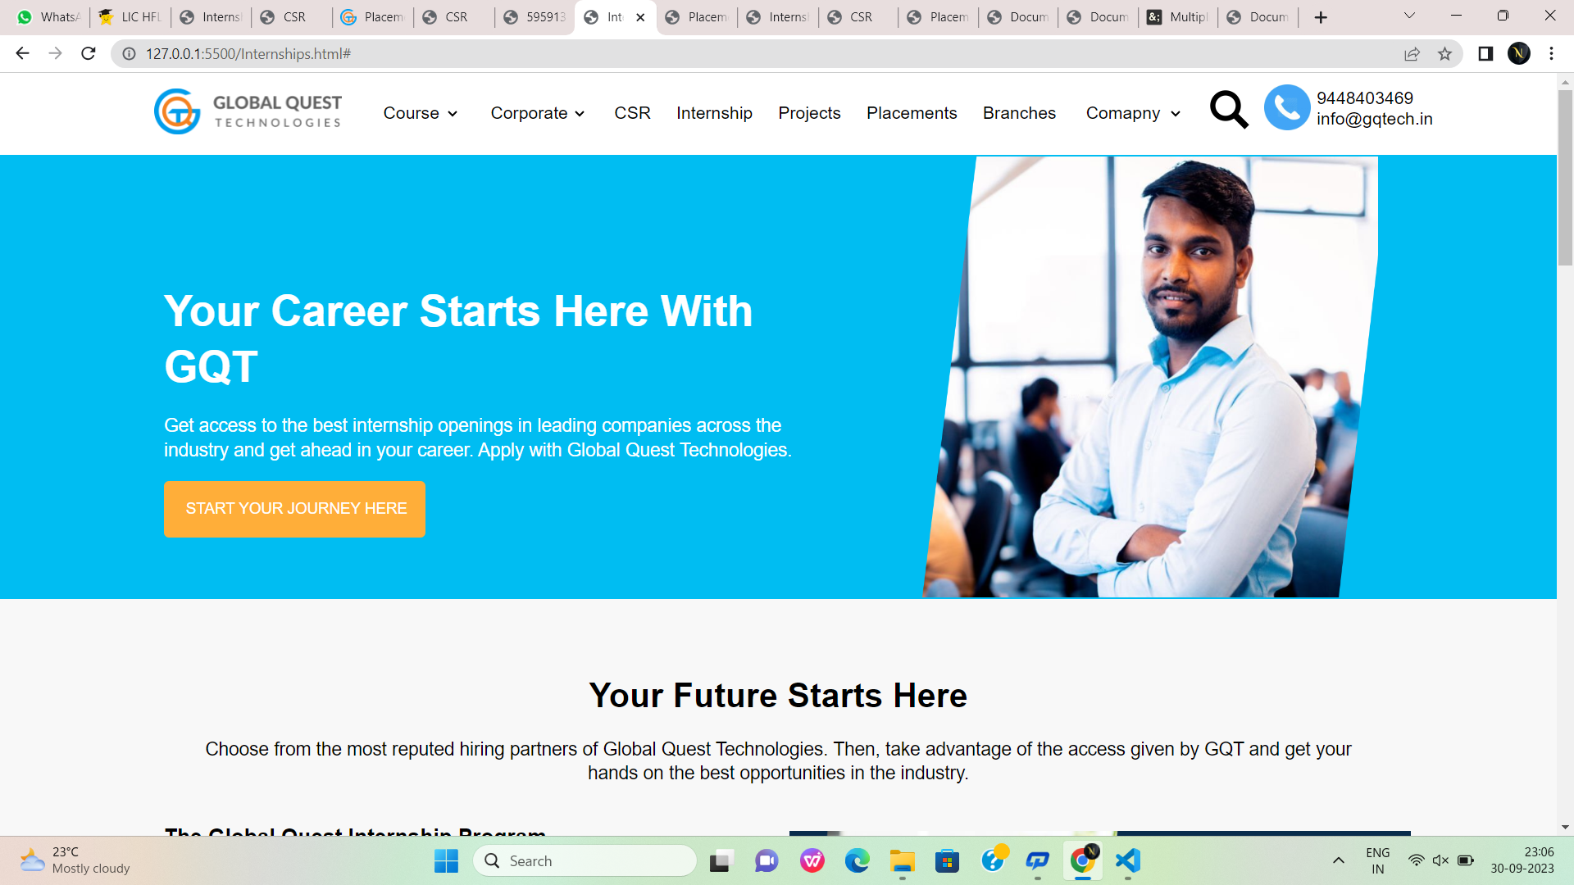

Fig:3

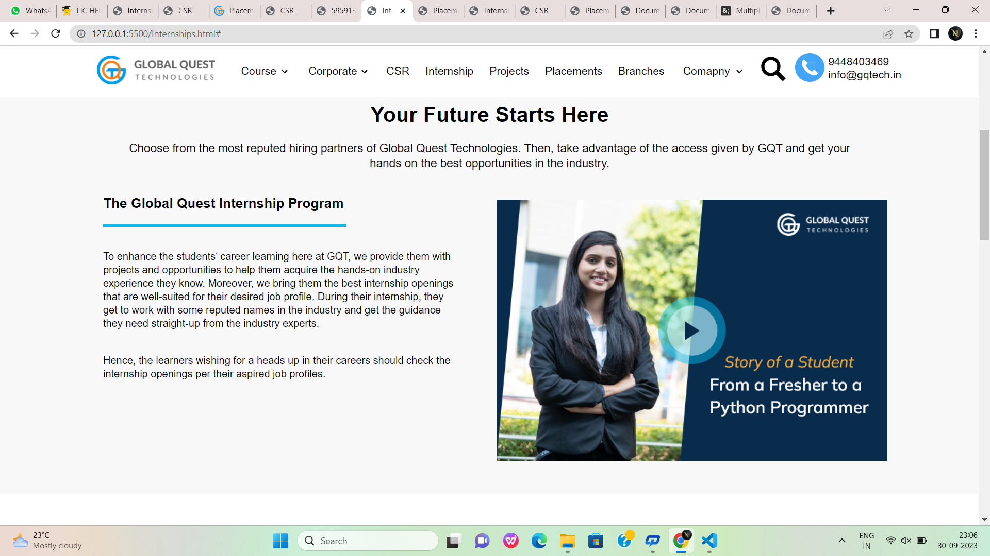

Fig:3.1

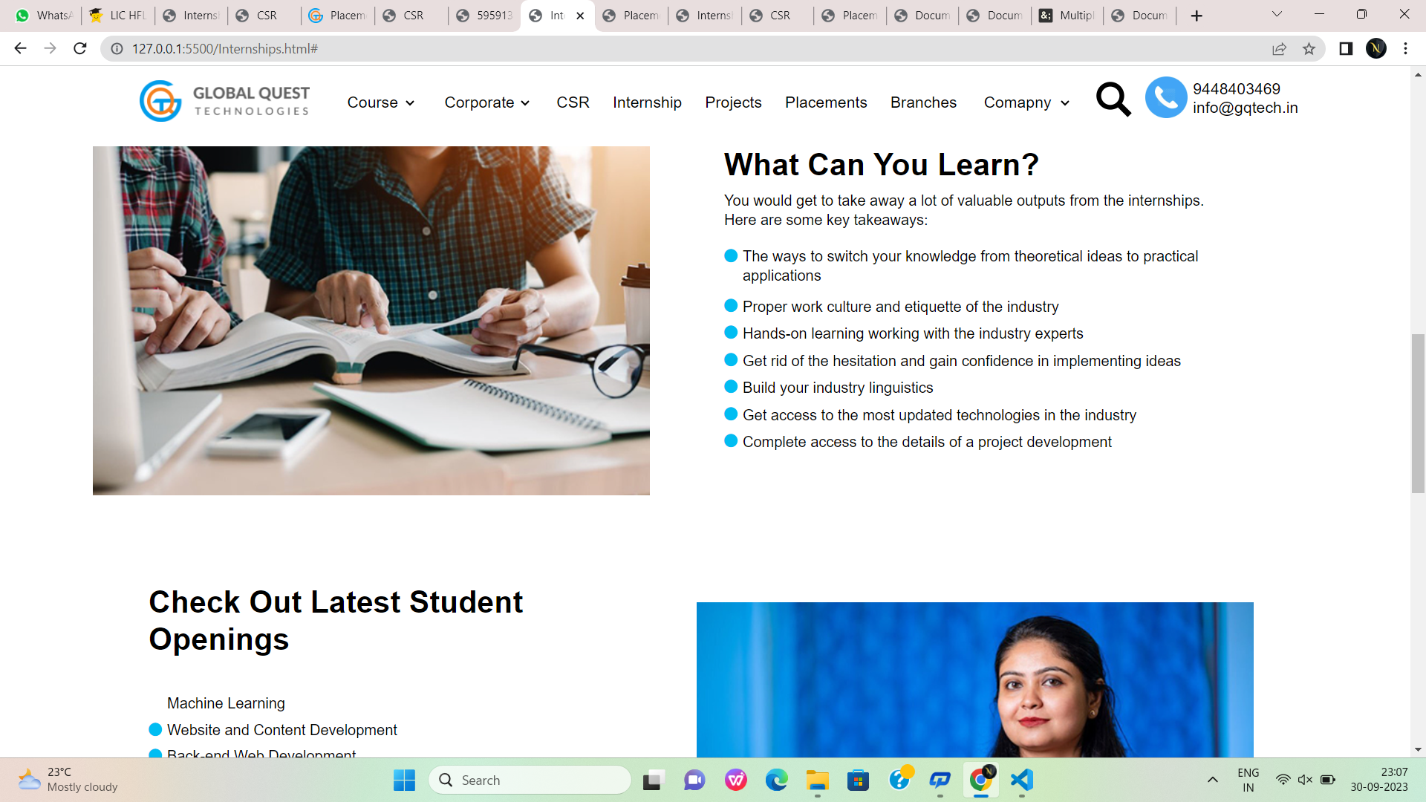

Fig:3.2

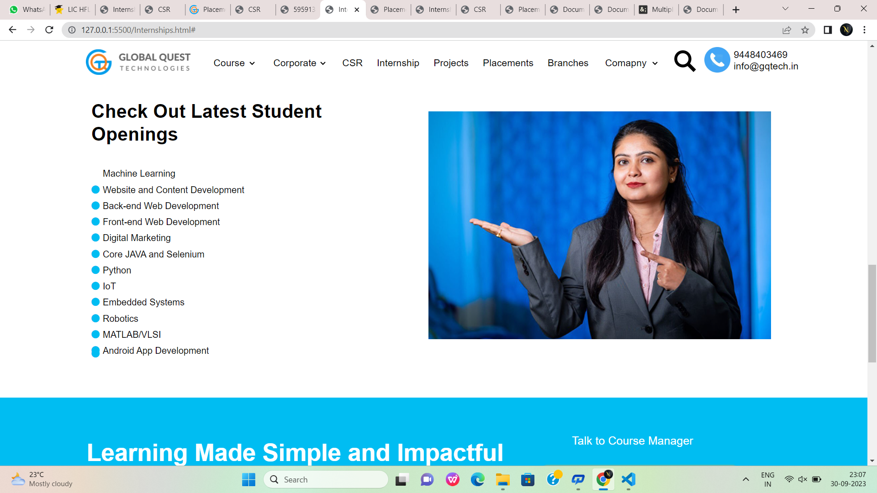

Fig:3.3

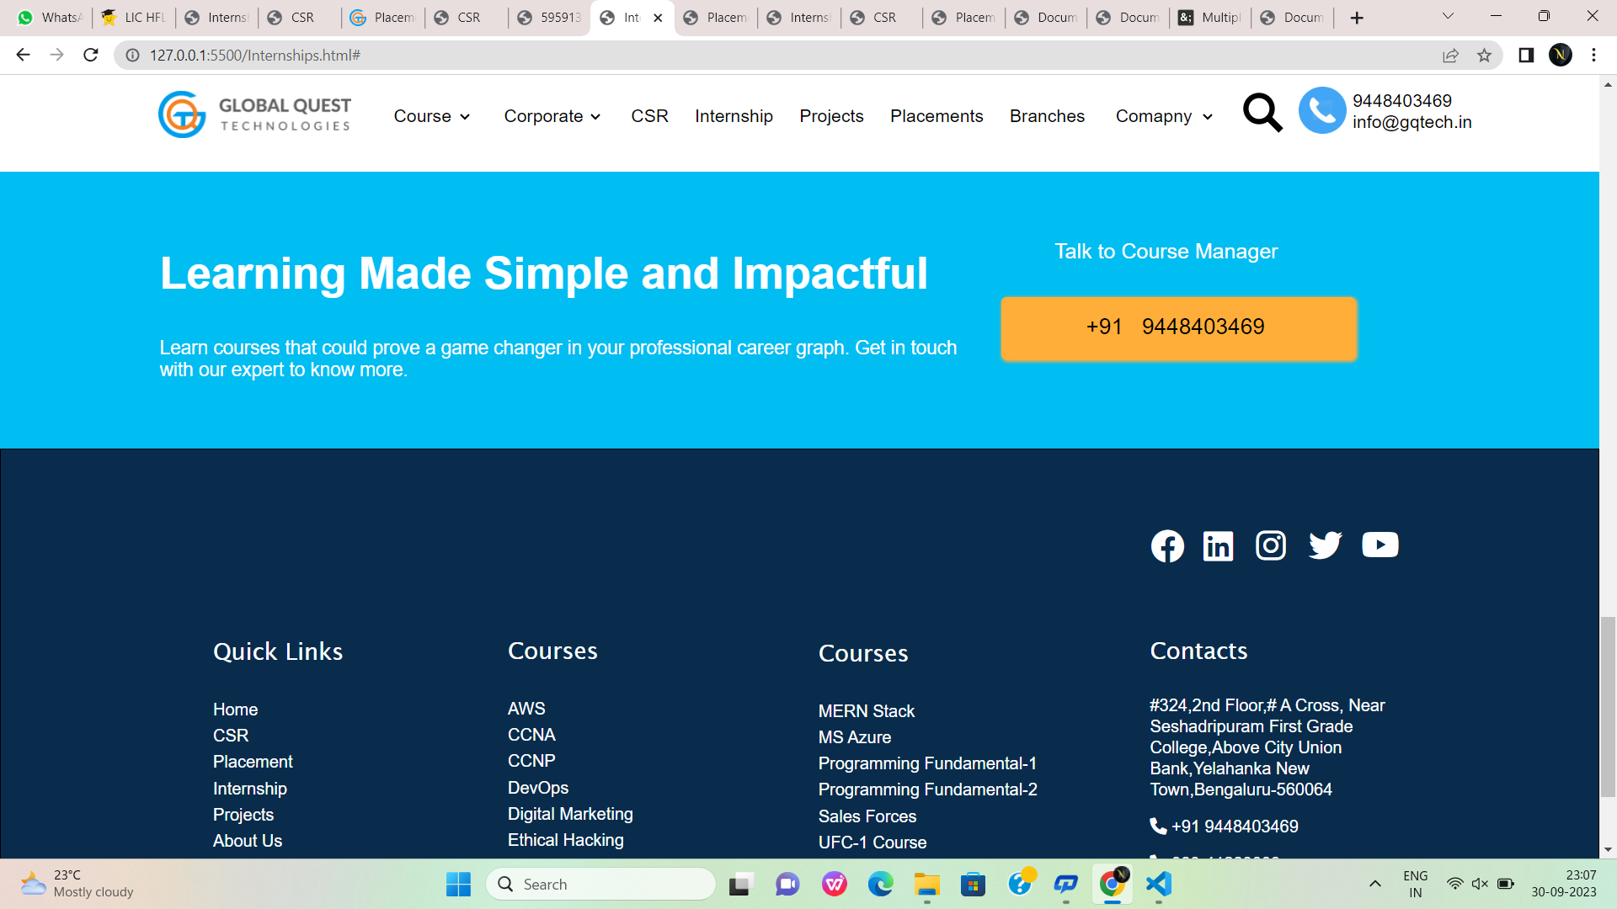

Fig:3.4

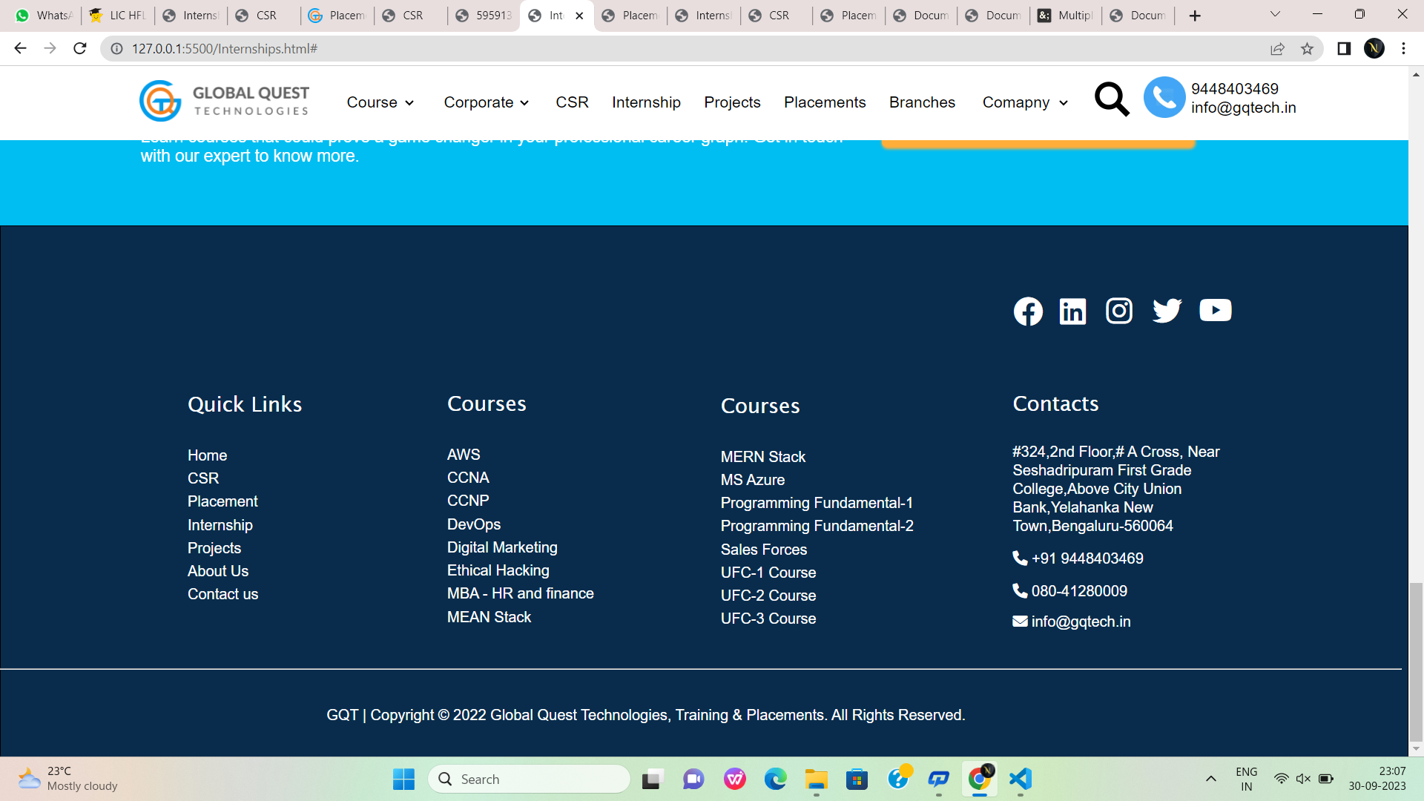

Fig:3.5

**Placementsgqt.html:**

<!DOCTYPE html>

<html lang="en">

<head>

<meta charset="UTF-8">

<meta name="viewport" content="width=device-width, initial-scale=1.0">

<title>Placements</title>

<link rel="stylesheet" href="https://cdnjs.cloudflare.com/ajax/libs/font-awesome/6.1.1/css/all.min.css">

<style>

.div1:hover{

color: rgb(15, 148, 196);

}

#id1:hover{

color: rgb(15, 148, 196);

}

#id2:hover{

color: rgb(15, 148, 196);

}

#colorid1:hover{

background-color: #FFAE39 ;

}

.hovering:hover{

color: rgb(15, 148, 196);

}

.hovering{

padding-left: 20px ;

color: black;

text-decoration: none;

}

</style>

</head>

<body style="margin: 0; font-family: sans-serif; ">

<header id="id1" style="position: fixed;">

<div style="border: 0 red solid; height: 80px; font-size: 17px;width: 100%; background-color: white;">

<img src="https://gqtech.in/wp-content/uploads/2022/04/cropped-GQT_Logo_H_.png" style="height: 45px; padding-top: 15px; margin-left: 150px;">

<div class="1" style="border: 0 solid; width: 100%; height: 50px; margin-top: -35px; padding-left: 350px; font-family: sans-serif; background-color: white;">

<select class="div1" style="width: 80px; border: 0; font-size: 17px; margin-left: 20px; margin-top: -40px;" name="Course" id="Course">

<option class="div1" value=" Course" style="margin-top: 40px;">Course</option>

<option value="Unified Course-1">Unified Course-1</option>

<option value="Unified Course-2">Unified Course-2</option>

<option value="Unified Course-3">Unified Course-3</option>

<option value="Data Science">Data Science</option>

<option value="Programming Fundamental Course-1">Programming Fundamental Course-1</option>

<option value="Programming Fundamental Course-2">Programming Fundamental Course-2</option>

<option value="Amazon Web Services">Amazon Web Services</option>

<option value="Mircosoft Azure">Mircosoft Azure</option>

<option value="MEAN Stack">MEAN Stack</option>

<option value="MERN Stack">MERN Stack</option>

<option value="MBA-HR and Finance">MBA-HR and Finance</option>

<option value="DevOps">DevOps</option>

<option value="Salesforce">Salesforce</option>

</select>

<select class="div1" style="width: 100px; border: 0; font-size: 17px; margin-left: 20px; margin-top: -40px;" >

<option class="div1" value="">Corporate</option>

<option value="">Need Corporate Training</option>

<option value="">Want to hire our students</option>

</select>

<a class="hovering" href="#" >CSR</a>

<a class="hovering" href="#" >Internship</a>

<a class="hovering" href="#" >Projects</a>

<a class="hovering" href="#" >Placements</a>

<a class="hovering" href="#" >Branches</a>

<select class="div1" style="width: 100px; border: 0; font-size: 17px; margin-left: 20px; margin-top: -40px;" >

<option class="1" value="">Comapny</option>

<option value="">About Us</option>

<option value="">Contact Us</option>

</select>

<div class="div1" style="border: 0 solid; width: 100px; height: 60px; font-size: 50px; margin-top: -40px; margin-left: 830px;">

<a href="#"><img src="https://static.thenounproject.com/png/5959138-200.png" alt="" style="width: 40px; height: 40px; "></a>

<a href="#"><img src="https://www.iconbunny.com/icons/media/catalog/product/cache/2/thumbnail/600x/1b89f2fc96fc819c2a7e15c7e545e8a9/1/6/168.9-phone-icon-iconbunny.jpg" alt="" style="width: 45px; height: 45px; "></a></div>

<div style="border: 0 solid; height: 50px; width: 150px; margin-top: -55px; margin-left: 935px;">9448403469 info@gqtech.in</div>

<div style="border: orangered solid 0; height: 40px; width: 150px; margin-top: -68px;margin-left: 1036px; background-color: white;">

</div>

</div>

</div>

</header><br><br><br><br>

<!----------------------------------------------------------------------------------------------------------------------------------------------->

<div style="border: solid 0; height: 440px; width: 100%;background-color: #00bdf2;"><img src="https://gqtech.in/wp-content/uploads/2022/04/hero-career.png" alt="" width="30%" height="430px" style="margin-top: 8px;margin-left: 900px;">

<div style="border: 0 solid; height: 440px; width: 502px; margin-left:850px; background-image: url('/intern.png'); background-size: 100% 100%; background-repeat: no-repeat; background-position: 0px 5px;"></div>

<div style="border: 0px solid; height: 109px; width: 630px;color: #FFFFFF;font-size: 42px;font-weight: 600;line-height: 1.3em ;margin-top: -750px;margin-left: 160px;">Grow your career with GQT</div><br>

<div style="text-align: left;color: #FFFFFF;font-size: 18px;font-weight: 400;line-height: 1.3em;width: 630px;margin-left: 160px;margin-top: -66px;">Explore the top job openings in the most reputed companies across the industry and kick-start your career with Global Quest Technologies</div><br>

<a href="#"> <input type="submit" value="Know More" style="height: 55PX; width: 200px; font-size: 15px; background-color: #FFAE39; border-radius:0px; color: blck; border: none; border-radius: 5px; margin-left: 160px; cursor: pointer;"></a>

</div>

<!----------------------------------------------------------------------------------------------------------------------------------------------->

<br><br><br><br> <div style="height:42.9px ; width: 100%;color: gray;font-size: 33px;font-weight: 600;line-height: 1.3em;text-align: center;">Our Hiring Partners</div><br>

<img src="https://gqtech.in/wp-content/uploads/2022/07/Placements-Logo.jpg" alt="" style="margin-left: 150px;">

<!------------------------------------------------------------------------------------------------------------------------------------------------>

<div style="border: 1px solid #00BDF2; height: 261.4px; width: 99.9%; margin-top: 100px; background-color: #00BDF2;">

<div style="border: 1px solid #00BDF2; height: 54.6px; width: 820px; font-size: 42px; color: white; margin-top: 70px; margin-left: 150px;"><b>Learning Made Simple and Impactful</b></div>

<div style="border: 1px solid #00BDF2; height: 54.6px; width: 760px; font-size: 18px; color: white; margin-top: 30px; margin-left: 150px;">Learn courses that could prove a game changer in your professional career graph. Get in touch with our expert to know more.</div>

<div style="border: 1px solid #00BDF2; height: 54.6px; width: 420px; font-size: 20px; color: white; margin-top: -150px; margin-left: 1000px;">Talk to Course Manager</div>

<a style="text-decoration: none;" href=""><div id="colorid1" style="border: 1px solid #FFAE39; height: 27.3px; width: 240px; margin-left: 950px; background-color: #FFAE39 ; font-size: 21px; padding: 15px; padding-left: 80px; border-radius: 5px; color: black; box-shadow: 1px 1px 3px 1px #FFAE39;">+91 &nbsp;&nbsp;9448403469</div></a>

</div>

<div style="border: 1px solid; height: 572.1px; width: 99.9%; background-color: #092C4C;">

<div style="border: 1px solid #092C4C; height: 452.3px; width: 1509.2px; margin-top: 70px;">

<div style="border: 1px solid #092C4C; height: 56px; width: 228px; margin-left: 200px; background-image: url('/GQT_Logo_H_@2x.png');"></div>

<div style="border: 1px solid #092C4C; height: 50px; width: 270px; margin-top: -56px; margin-left: 1000px; padding-left: 80px;">

<img src="https://gqtech.in/wp-content/uploads/2022/04/GQT_Logo_H_@2x.png" alt="" style="margin-left: -902px;margin-top: 30px;">

<div style="border: 1px solid #092C4C; height: 25px; width: 25px; color: white; padding-top: 10px;padding-left: 10px;margin-top: -50px"><i class="fa-brands fa-facebook fa-2xl"></i></div>

<div style="border: 1px solid #092C4C; height: 25px; width: 25px; color: white; padding-top: 10px; margin-left: 50px; margin-top: -35px;padding-left: 10px;"><i class="fa-brands fa-linkedin fa-2xl"></i></div>

<div style="border: 1px solid #092C4C; height: 25px; width: 25px; color: white; padding-top: 10px; margin-left: 100px; margin-top: -37px;padding-left: 10px;"><i class="fa-brands fa-instagram fa-2xl"></i></div>

<div style="border: 1px solid #092C4C; height: 25px; width: 25px; color: white; padding-top: 10px; margin-left: 150px; margin-top: -37px;padding-left: 10px;"><i class="fa-brands fa-twitter fa-2xl"></i></div>

<div style="border: 1px solid #092C4C; height: 25px; width: 25px; color: white; padding-top: 10px; margin-left: 200px; margin-top: -37px;padding-left: 10px;"><i class="fa-brands fa-youtube fa-2xl"></i></div>

<div style="height: 332.1px; width: 1629.2px;border:0px solid black;background-color: transparent; margin-left: -1200px;">

<div style="width: 230px;height:70px;margin-left: 250px;margin-top: 72px;border:0px solid transparent;">

</div>

<div style="width: 230px;height:250px;margin-left: 320px;margin-top:-100px;border:0px solid white;background-color: #092C4C;"><h4 style="text-align:left;color:white;font-family:'Lucida Sans', 'Lucida Sans Regular', 'Lucida Grande', 'Lucida Sans Unicode', Geneva, Verdana, sans-serif;font-size:22px;font-weight: 300;">Quick Links</h4>

<div style="margin-left: 0px;">

<a style="text-decoration: none; color: white; font-family: 16px;line-height: 25px;" href="index.html" target="_blank">Home</a><br>

<a style="text-decoration: none; color: white; font-family: 16px;line-height: 25px;" href="csr.html" target="_blank">CSR</a><br>

<a style="text-decoration: none; color: white; font-family: 16px;line-height: 25px;" href="" target="_blank">Placement</a><br>

<a style="text-decoration: none; color: white; font-family: 16px;line-height: 25px;"href="" target="_blank">Internship</a><br>

<a style="text-decoration: none; color: white; font-family: 16px;line-height: 25px;" href="" target="_blank">Projects</a><br>

<a style="text-decoration: none; color: white; font-family: 16px;line-height: 25px;" href="" target="_blank">About Us</a><br>

<a style="text-decoration: none; color: white; font-family: 16px;line-height: 25px;" href="" target="_blank">Contact us</a><br>

</div>

</div>

<div style="width: 230px;height:299px;margin-left: 600px;margin-top:-280px;border:0px solid white;background-color: #092C4C;"><h4 style="text-align:left;color:white;font-family:'Lucida Sans', 'Lucida Sans Regular', 'Lucida Grande', 'Lucida Sans Unicode', Geneva, Verdana, sans-serif;font-size:22px;font-weight: 300;">Courses</h4>

<div style="margin-left: 0px;">

<a style="text-decoration: none; color: white; font-family: 16px;line-height: 25px;" href="" target="_blank">AWS</a><br>

<a style="text-decoration: none; color: white; font-family: 16px;line-height: 25px;" href="" target="_blank">CCNA</a><br>

<a style="text-decoration: none; color: white; font-family: 16px;line-height: 25px;" href="" target="_blank">CCNP</a><br>

<a style="text-decoration: none; color: white; font-family: 16px;line-height: 25px;" href="" target="_blank">DevOps</a><br>

<a style="text-decoration: none; color: white; font-family: 16px;line-height: 25px;" href="" target="_blank">Digital Marketing</a><br>

<a style="text-decoration: none; color: white; font-family: 16px;line-height: 25px;" href="" target="_blank">Ethical Hacking</a><br>

<a style="text-decoration: none; color: white; font-family: 16px;line-height: 25px;" href="" target="_blank">MBA - HR and finance</a><br>

<a style="text-decoration: none; color: white; font-family: 16px;line-height: 25px;" href="" target="_blank">MEAN Stack</a><br>

</div>

</div>

<div style="width: 230px;height:299px;margin-left: 895px;margin-top:-326px;border:0px solid white;background-color: #092C4C;"><h4 style="text-align:left;color:white;font-family:'Lucida Sans', 'Lucida Sans Regular', 'Lucida Grande', 'Lucida Sans Unicode', Geneva, Verdana, sans-serif;font-size:22px;font-weight: 300;">Courses</h4>

<div style="margin-left: 0px;">

<a style="text-decoration: none; color: white; font-family: 16px;line-height: 25px;" href="" target="_blank">MERN Stack</a><br>

<a style="text-decoration: none; color: white; font-family: 16px;line-height: 25px;" href="" target="_blank">MS Azure</a><br>

<a style="text-decoration: none; color: white; font-family: 16px;line-height: 25px;" href="" target="_blank">Programming Fundamental-1</a><br>

<a style="text-decoration: none; color: white; font-family: 16px;line-height: 25px;" href="" target="_blank">Programming Fundamental-2</a><br>

<a style="text-decoration: none; color: white; font-family: 16px;line-height: 25px;" href="" target="_blank">Sales Forces</a><br>

<a style="text-decoration: none; color: white; font-family: 16px;line-height: 25px;" href="" target="_blank">UFC-1 Course</a><br>

<a style="text-decoration: none; color: white; font-family: 16px;line-height: 25px;" href="" target="_blank">UFC-2 Course</a><br>

<a style="text-decoration: none; color: white; font-family: 16px;line-height: 25px;" href="" target="_blank">UFC-3 Course</a><br>

</div>

</div>

<div style="width: 230px;height:299px;margin-left: 1210px;margin-top:-331px;border:0px solid white;background-color: #092C4C;"><h4 style="text-align:left;color:white;font-family:'Lucida Sans', 'Lucida Sans Regular', 'Lucida Grande', 'Lucida Sans Unicode', Geneva, Verdana, sans-serif;font-size:22px;font-weight: 300;">Contacts</h4>

<div style="margin-left: 0px;">

<a style="text-decoration: none; color: white; font-family: 16px;line-height: 20px;" href="https://gqtech.in/" target="_blank">#324,2nd Floor,# A Cross, Near Seshadripuram First Grade College,Above City Union Bank,Yelahanka New Town,Bengaluru-560064</a><br>

<a style="text-decoration: none; color: white; font-family: 16px;line-height: 50px;" href="" target="_blank"><i class="fa-solid fa-phone" style="color: #fcfcfc;"></i> +91 9448403469</i></a><br>

<a style="text-decoration: none; color: white; font-family: 16px;line-height:20px;" href="" target="_blank"><i class="fa-solid fa-phone" style="color: #fcfcfc;"></i> 080-41280009</a><br>

<a style="text-decoration: none; color: white; font-family: 16px;line-height: 45px;" href="" target="_blank"><i class="fa-solid fa-envelope" style="color: #ffffff;"></i> info@gqtech.in</a><br>

</div>

</div>

<div style="width:320px;height: 40px;border: 0px solid white ;margin-left: 1020px;margin-top: -420px;">

<a style="text-decoration: none; color: white; font-family: 16px;" style="padding: 10px;" href="" target="_blank"><i class='bx bxl-facebook-circle' style="font-size: 25px;" ></i></a>

<a style="text-decoration: none; color: white; font-family: 16px;" style="padding: 10px;" href="" target="_blank"><i class='bx bxl-linkedin-square' style="font-size: 25px;" ></i></a>

<a style="text-decoration: none; color: white; font-family: 16px;" style="padding: 10px;" href="" target="_blank"><i class='bx bxl-instagram-alt' style="font-size: 25px;"></i></a>

<a style="text-decoration: none; color: white; font-family: 16px;" style="padding: 10px;" href="" target="_blank"><i class='bx bxl-twitter' style="font-size: 25px;"></i></a>

<a style="text-decoration: none; color: white; font-family: 16px;" style="padding: 10px;" href="" target="_blank"><i class='bx bxl-youtube' style="font-size: 25px;"></i></a>

</div>

<hr style="color: white;margin-top: 380px;">

<p style="text-align:center;margin-top: 30px; color: white;">GQT | Copyright © 2022 Global Quest Technologies, Training & Placements. All Rights Reserved.</p>

</div>

  </div>

</body>

</html>

**Output:**

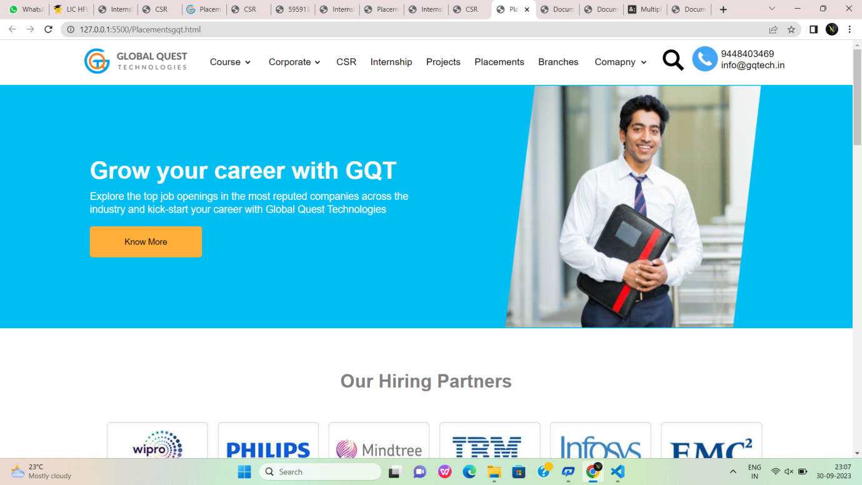

Fig:4

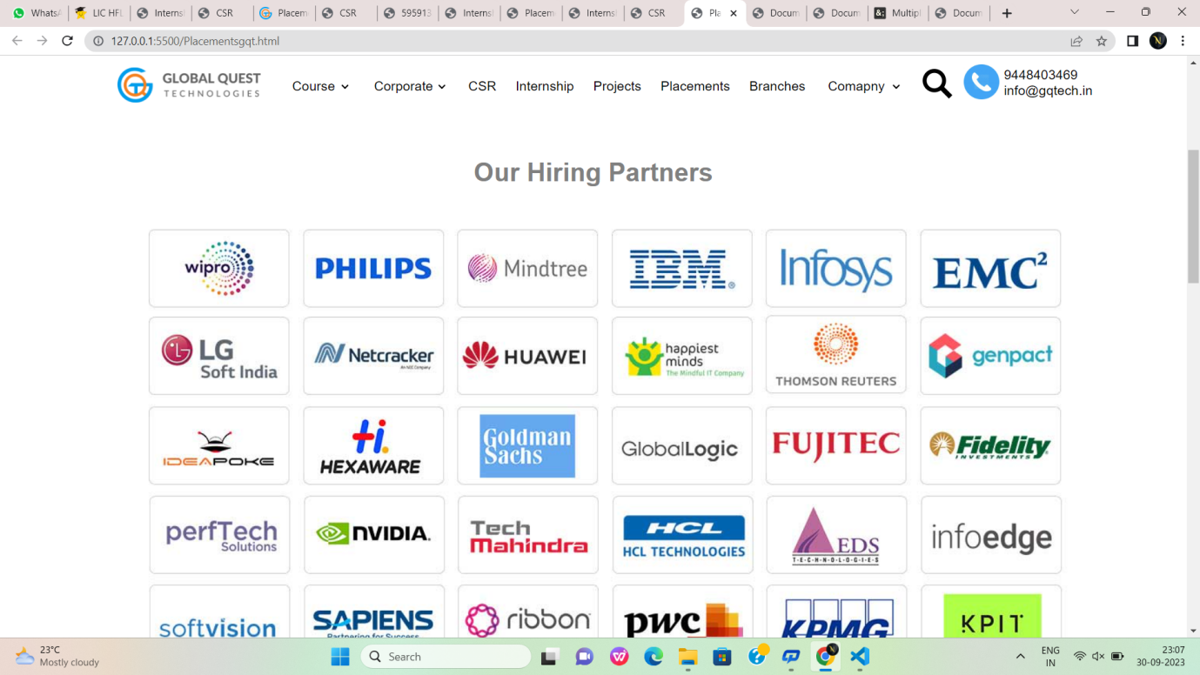

Fig:4.1

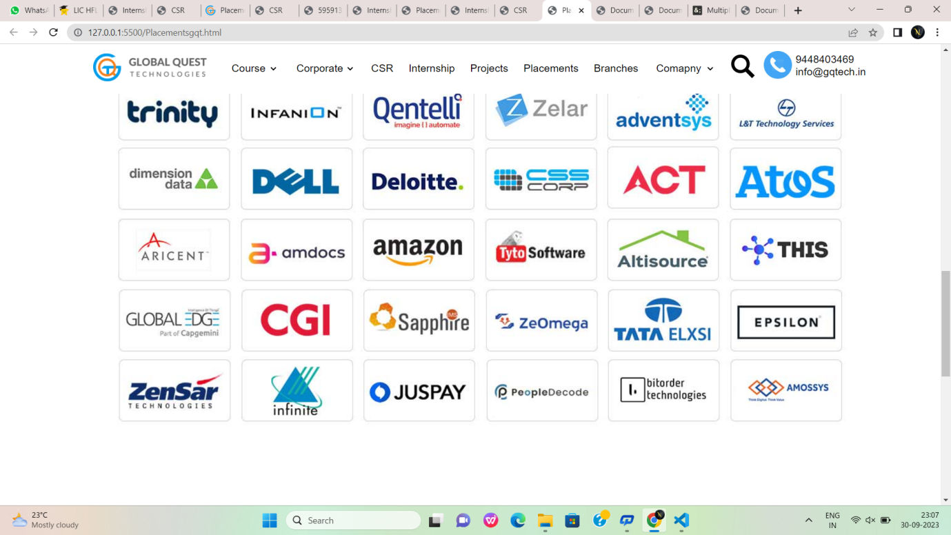

Fig:4.2



Fig:4.3



Fig:4.5

**GQTaws.html:**

<!DOCTYPE html>

<html lang="en">

<head>

<meta charset="UTF-8">

<meta name="viewport" content="width=device-width, initial-scale=1.0">

<title>Amazon Web Services- Global Quest Technologies</title>

<link rel="icon" href="https://gqtech.in/wp-content/uploads/2022/04/cropped-GQT_Logo_H_.png">

<link rel="stylesheet" href="gqtAWS.css">

</head>

<body>

<div id="div1">

<div id="idiv1">

<img class="img1" src="https://gqtech.in/wp-content/uploads/2022/04/cropped-GQT_Logo_H_.png" alt="loaded" width="180px" height="40px">

</div>

<nav id="idiv2">

<a href="">Courses</a>

<a href="">Corporate</a>

<a href="">CSR</a>

<a href="">Internship</a>

<a href="">Projects</a>

<a href="">Placements</a>

<a href="">Branches</a>

<a href="">Company</a>

</nav>

<div id="idiv3">

<img src="https://static.thenounproject.com/png/5959138-200.png" alt="search" width="40%" height="60%">

<img src="https://www.iconbunny.com/icons/media/catalog/product/cache/2/thumbnail/600x/1b89f2fc96fc819c2a7e15c7e545e8a9/1/6/168.9-phone-icon-iconbunny.jpg" alt="Phone" width="40%" height="60%">

</div>

<div id="idiv4">

<b>94484 03469</b>

<small>info@gqtech.in</small>

</div>

</div>

<div id="div2">

<div id="idiv21">

<h1 class="head1">Amazon Web Services</h1>

<p class="p">Learn Amazon Web Service development with the basic to advanced level

curriculum designed by the experts to cater to the current needs of the corporate world.x`</p>

<p style="margin-top:3%; margin-left:2%; font-family:'Segoe UI', Tahoma, Geneva, Verdana, sans-serif;font-size: 113%;color:white;font-weight:bold;">

2 Months &nbsp;&nbsp;&nbsp; | Online/Offline &nbsp;&nbsp;&nbsp; | ⭐⭐⭐⭐⭐(593+)</p>

<div style="margin-left:2%;margin-top:3%;">

<button id="button1">Get Started</button>

&nbsp;&nbsp;&nbsp;<button id="button2">Download Brochure</button>

</div>

<div style="margin-top:3%;margin-left:3%;display:flex;color:white;">

<div>

<b style="font-size:large;">Enquire No:</b>

<p style="font-size:medium;">+91 9448403469</p>

</div>

<div style="margin-left:5%;">

<b style="font-size:large;">Batches Start From:</b>

<p style="font-size:medium;">1st,10th & 20th of every month</p>

</div>

</div>

</div>

<div id="idiv22">

<img src="https://gqtech.in/wp-content/uploads/2022/05/AWS.png" alt="AWS" height="500px" width="100%">

</div>

</div>

<div style="background-color: gold; height:60px;width:50%;transform:skew(-30deg);margin-left:-50px;margin-top:-40px;">

<marquee style="padding-top:20px;font-size:x-large;font-weight: bold;" >

Live Training With Corporate Experts

&nbsp;&nbsp; &nbsp;&nbsp; &nbsp;&nbsp;&nbsp;&nbsp; &nbsp;&nbsp; &nbsp;&nbsp;&nbsp;&nbsp; &nbsp;&nbsp; &nbsp;&nbsp;&nbsp;&nbsp; &nbsp;&nbsp; &nbsp;&nbsp;

Frequent Mock Interviews And Tests

&nbsp;&nbsp; &nbsp;&nbsp; &nbsp;&nbsp;&nbsp;&nbsp; &nbsp;&nbsp; &nbsp;&nbsp;&nbsp;&nbsp; &nbsp;&nbsp; &nbsp;&nbsp;&nbsp;&nbsp; &nbsp;&nbsp; &nbsp;&nbsp;

700+ Hiring Partners

&nbsp;&nbsp; &nbsp;&nbsp; &nbsp;&nbsp;&nbsp;&nbsp; &nbsp;&nbsp; &nbsp;&nbsp;&nbsp;&nbsp; &nbsp;&nbsp; &nbsp;&nbsp;&nbsp;&nbsp; &nbsp;&nbsp; &nbsp;&nbsp;

Curriculum Designed For Industrial Applications

</marquee>

</div>

<!--sticky div-->

<div id="stickydiv">

<a href="#">Overview</a>

<br>

<hr>

<a href="#">Instructors</a>

<br>

<hr>

<a href="#">Syllabus</a>

<br>

<hr>

<a href="#">Course Features</a>

<br>

<hr>

<a href="#">Course Fee</a>

<br>

<hr>

<a href="#">FAQ's</a>

<br>

<hr>

<p style="margin-left:10%;">Next class starts June 05</p>

<button id="button3">Apply Now</button>

<button style="margin-top: 2%;" id="button4">Talk to Admissions<br>

+ 91 9448403469</button>

</div>

<!-- <div id="div3">

</div> -->

<!--third div-->

<div id="div3">

<div style="display:flex;justify-content: space-between;">

<p style=" color:rgb(70, 70, 112);font-size:200%;font-family:'Segoe UI', Tahoma,

Geneva, Verdana, sans-serif;font-weight:600;">

Course Overview</p>

<hr style="background-color:rgb(70, 70, 112); width:65%;height:0.2%;margin-top:2.8%;">

</div>

<div style="display:flex;flex-direction:column;width:50%;height:40%;">

<p style="margin-left:5%;margin-top:9%; font-weight:600;color:black;font-size: larger;font-family: 'Segoe UI', Tahoma, Geneva, Verdana, sans-serif;">

4-Months Course Duration</p>

<p style="margin-left:10%; color:rgb(70, 70, 112);font-size: large;font-family: 'Segoe UI', Tahoma,

Geneva, Verdana, sans-serif;">

We cover the requirements for landing a great job from the foundation to the finish.</p>

<p style="margin-left:5%;margin-top:11%; font-weight:600;color:black;font-size: larger;font-family: 'Segoe UI', Tahoma, Geneva, Verdana, sans-serif;">

100% Placement Assistance</p>

<p style="margin-left:5%; color:rgb(70, 70, 112);font-size: large;font-family: 'Segoe UI',

Tahoma, Geneva, Verdana, sans-serif;">

Providing complete assistance with the preparation to crack the interviews</p>

</div>

<div style="margin-left:50%;margin-top:-40%; display:flex;flex-direction:column;width:50%;height:40%;">

<p style="margin-left:10%;margin-top:10%; font-weight:600;color:black;font-size: larger;font-family: 'Segoe UI', Tahoma, Geneva, Verdana, sans-serif;">

Placement Opportunities</p>

<p style="margin-left:10%; color:rgb(70, 70, 112);font-size: large;font-family: 'Segoe UI', Tahoma,

Geneva, Verdana, sans-serif;">

We are assisting in finding better and more relevant job openings.</p>

<p style="margin-left:10%;margin-top:7%; font-weight:600;color:black;font-size: larger;font-family: 'Segoe UI', Tahoma, Geneva, Verdana, sans-serif;">

320+ hours of Live Training Interactive Sessions</p>

<p style="margin-left:10%; color:rgb(70, 70, 112);font-size: large;font-family: 'Segoe UI',

Tahoma, Geneva, Verdana, sans-serif;">

Thorough guidance ensures the students gain the <br> best out of the course.</p>

</div>

<div>

<p style=" color:black;font-family: 'Segoe UI', Tahoma, Geneva, Verdana, sansserif;font-weight:500;font-size:x-large;margin-top:-2%;">

Why Amazon Web Services Course?</p>

<p style="margin-top:2%; color:rgb(70, 70, 112); font-family: 'Segoe UI', Tahoma,

Geneva, Verdana, sans-serif;font-size:large;">

Amazon Web Services course by Global Quest Technologies is a course designed for building the foundation of an individual as an AWS developer. Along with that, they also get application-level experience through projects and practicals. The students get the relevant resources, training, and insights to help them acquire proper knowledge in the field and outshine the crowd as professionally backed up individuals.<br><br>

Our AWS course is designed by industry experts keeping in mind the requirements and necessities for an industry-ready individual. Our experts provide thorough and personalized guidance that caters to the individualistic needs to grow and learn.<br><br>

With G.Q.T., we ensure that the students are well-through with the theoretical insights and capable of hands-on implementation of the knowledge they acquire. Our courses are accompanied by relevant aptitude training and projects that would give the students a clear idea of the practical use of what they learn.

</p>

</div>

</div>

<!-- Instructors-->

<div id="inst">

<div id="iinst">

<div style="display:flex;justify-content:space-between;">

<p style="margin-left:2%; color:rgb(70, 70, 112);font-size:210%;font-family:'Segoe UI', Tahoma,

Geneva, Verdana, sans-serif;font-weight:600;">

Instructors</p>

<hr style="background-color:rgb(70, 70, 112); width:75%;height:0.2%;margin-top:2.8%;">

</div>

<div style="display:flex;justify-content:space-between;">

<div class="ins">

<img src="https://gqtech.in/wp-content/uploads/2022/05/Bheemesh.png" alt="Bheemesh" width="20%" height="20%" style="border-radius: 50%;margin-left:40%;" >

<p style="font-size:larger;text-align:center;font-weight:bold">Bheemesh Raghu</p>

<p style="text-align:center;font-size:medium;">JAVA Full Stack trainer</p><br>

<p style="text-align:center;">Raghu is a B. E. in Computer Science and Engineering and has teaching experience of over 4.5 years. His expertise comprises Full Stack Java Development, Cyber security, A.W.S., Networking, Python Development and many more. He also possesses various certifications, including JAVA HackerRank, Oracle Certificatified Java Professional-8, Network Security Professional, and Azure - Az900.</p>

</div>

<div class="ins">

<img src="https://gqtech.in/wp-content/uploads/2022/05/Syed-Zabi-2.png" alt="syed zabi ulla" width="20%" height="20%" style="border-radius: 50%;margin-left:40%;" >

<p style="font-size:larger;text-align:center;font-weight:bold">Syed Zabi Ulla</p>

<p style="text-align:center;font-size:medium;">JAVA Full Stack trainer</p><br>

<p style="text-align:center;">Syed Zabi Ulla has a teaching experience of about 4.5 years and has trained up to 2500+ students in JAVA Full Stack Development. He is a B. E. in Computer Science and Engineering. His certifications include HackerRank Certified, Codecademy Certified, Generation India Certified and Active Problem-Solver, Design Thinker, and CodeCheffer</p>

</div>

</div>

</div>

<!--Syllabus-->

<div id="syllabus">

<div style="display:flex;justify-content: space-between;">

<p style=" color:rgb(70, 70, 112);font-size:250%;font-family:'Segoe UI', Tahoma,

Geneva, Verdana, sans-serif;font-weight:600;">

Syllabus</p>

<hr style="background-color:rgb(70, 70, 112); width:78%;height:0.2%;margin-top:3%;">

</div>

<br><br>

<div class="syl">

<a href="">Linux Fundamentals</a>

</div>

<hr>

<div class="syl">

<a href="">Introduction to Cloud Computing</a>

</div>

<hr>

<div class="syl">

<a href="">AWS - An Overview</a>

</div>

<hr>

<div class="syl">

<a href="">Understanding Identity Management of AWS</a>

</div>

<hr>

<div class="syl">

<a href="">EC2 Instance</a>

</div>

<hr>

<div class="syl">

<a href="">Auto - Scaling</a>

</div>

<hr>

<div class="syl">

<a href="">Load Balancing</a>

</div>

<a href=""> <button id="button55">Load More</button></a>

</div>

<!--course features-->

<div id="coursediv">

<div id="course">

<p style="font-family: 'Segoe UI', Tahoma, Geneva, Verdana, sans-serif;

font-size:30px;font-weight:500;color:black;">

Course Features</p>

<p class="cls1">Mentorship by Industry Experts</p>

<p class="cls2">Get hands-on learning from the industry experts and polish <br> your real-life

application skills.</p>

<p class="cls1">Industrial Boost camps</p>

<p class="cls2">Polish your skills for the industry with the updated<br> Industrial Boot Camps</p>

<p class="cls1">Peer Networking</p><p class="cls2">Learn with the like-minded individuals and grow together<br> with them with the

network you form</p>

<p class="cls1">Placement Assistance</p>

<p class="cls2">Get thorough placement assistance from finding openings<br> to cracking the

interview.</p>

</div>

</div>

<!--course fees div-->

<div style="margin-top:5%;height:600px;">

<p style="font-family: 'Segoe UI', Tahoma, Geneva, Verdana, sans-serif;

font-size:40px;font-weight:500;color:black;margin-left:30%;margin-top: 5%;">Course Fees</p>

<hr style="background-color:rgb(70, 70, 112); width:45%;height:0.05%;float:right;border:none;">

<div style="box-shadow: 5px 5px 7px grey;

height:450px;width:65%;margin-left:30%;

margin-top:3%;background-color:rgb(0, 0, 85) ;color:white;">

<p style="font-size:xx-large;text-align: center;">Online/Offline Training + Mentorship</p>

<br>

<p style="font-size:x-large;color:orange;text-align:center;">Rs. 25,000/-</p>

<br>

<p style="font-size: medium;margin-left:5%;">&#x2713;&nbsp;&nbsp; Train with the industry

experts</p>

<br>

<p style="font-size: medium;margin-left:5%;">&#x2713;&nbsp;&nbsp; Get access to the updated

curriculum for the courses</p>

<br>

<p style="font-size: medium;margin-left:5%;">&#x2713;&nbsp;&nbsp; Prepare for both hard and soft

skill improvement</p>

<br>

<p style="font-size: medium;margin-left:5%;">&#x2713;&nbsp;&nbsp; Get a complete start to end

guidance</p>

<br>

<p style="font-size: medium;margin-left:5%;">&#x2713;&nbsp;&nbsp; Placement assistance to find

better opportunities</p>

<br>

<button style="height:10%;width:15%;margin-left:40%;margin-top:3%;

background-color: rgb(86, 177, 233);color:white;font-size:large;border-radius:2px;

font-family:'Segoe UI', Tahoma, Geneva, Verdana, sans-serif;border:none;">Apply Now</button>

</div>

</div>

<!--Apply now div-->

<div id="apply">

<div style="display:flex;justify-content: space-between;">

<p style=" color:rgb(70, 70, 112);font-size:200%;font-family:'Segoe UI', Tahoma,

Geneva, Verdana, sans-serif;font-weight:600;">

Apply Now</p>

<hr style="background-color:rgb(70, 70, 112); width:65%;height:0.2%;margin-top:2.8%;">

</div>

<div id="formdiv">

<div style="margin-top:5%;margin-left:5%;">

<form>

<input type="text" id="name" placeholder="Enter your name" class="for">

&nbsp;&nbsp;&nbsp;

<input type="email" id="name" placeholder="Enter your email" class="for">

<br><br><input type="tel" id="name" placeholder="Enter your Mobile number" class="for">

&nbsp;&nbsp;&nbsp;

<input type="text" id="name" placeholder="Enter your Designation" class="for">

<textarea rows="4" cols="50" placeholder="Work Experience" class="for1"></textarea>

<br><br>

<input type="submit" value="Submit" class="btn6">

</form>

</div>

</div>

</div>

<!--Frequently Asked Questions-->

<div id="questions">

<div style="display:flex;justify-content: space-between;">

<p style=" color:rgb(70, 70, 112);font-size:200%;font-family:'Segoe UI', Tahoma,

Geneva, Verdana, sans-serif;font-weight:600;">

Frequentlu Asked Questions</p>

</div>

<br><br>

<div class="syl">

<a href="">Why should I take the Amazon Web Services course by Global Quest Technologies?</a>

</div>

<hr>

<div class="syl">

<a href="">What is the duration of Amazon Web Development courses provided by GQT?</a>

</div>

<hr>

<div class="syl">

<a href="">How much do I need to pay for the Amazon Web Development course?</a>

</div>

<hr>

<div class="syl">

<a href="">Who should enroll in the Amazon Web Development couse by Global Quest Technologies?</a>

</div>

<hr>

<div class="syl">

<a href="">Does GQT provide placement assistance?</a>

</div>

</div>

<!--students div-->

<div style="height:500px;background-color: rgb(248, 252, 253);margin-top:2%;">

<div style=" margin-left:30%;height:30px;display:flex;justify-content:space-between;">

<p style="margin-left:2%; color:rgb(70, 70, 112);font-size:210%;font-family:'Segoe UI', Tahoma,

Geneva, Verdana, sans-serif;font-weight:600;">

Student Testimonals</p>

<hr style="background-color:rgb(70, 70, 112); width:55%;height:0.2%;margin-top:2.8%;">

</div>

<!--parent div for student testimonial-->

<div style="height:300px;width:63%;margin-top:60px;margin-left:32%;overflow:hidden;box-shadow: 0px 0px 10px grey;">

<!--child div for student testimonial-->

<marquee scrollamount="15">

<div style="border:1px solid grey; height:250px;width:54%;background-color:whitesmoke;border-radius:7px;margin-top:25px;">

<img style="height:40px;width:8%;border-radius:30px;" src="https://gqtech.in/wp-content/uploads/2022/05/students4.jpg">

<h3 style="margin-left:60px;margin-top:-40px;">james<br>&#11088 &#11088 &#11088 &#11088

&#11088</h3>

<p style="font-family:'Segoe UI', Tahoma, Geneva, Verdana, sans-serif;line-height: 30px;font-size:

medium;margin-left:20px;margin-top:20px;">I enrolled for Unified Course 3 and i think it was the

right choice<br> that I made.

I have been able to have a grasp on the course.

Also I was<br> able to get through assistance with my placement.

They also helped<br> me to work on my soft skills and personality development.</p>

</div>

<div style="border:1px solid grey; margin-left:570px;margin-top:-251px;

height:250px;width:54%;background-color:whitesmoke;border-radius:7px;">

<img style="height:40px;width:8%;border-radius:30px;" src="https://gqtech.in/wp-content/uploads/2022/05/students3.jpg">

<h3 style="margin-left:60px;margin-top:-40px;">Priyanka<br>&#11088 &#11088 &#11088

&#11088 &#11088</h3>

<p style="font-family:'Segoe UI', Tahoma, Geneva, Verdana, sans-serif;line-height: 30px;font-size: medium;margin-left:20px;margin-top:20px;">I enrolled for Unified Course 3 and i think it was

the right choice<br> that I made.

I have been able to have a grasp on the course.

Also I was<br> able to get through assistance with my placement.

They also helped<br> me to work on my soft skills and personality development.</p>

</div>

<div style="border:1px solid grey; margin-left:1140px;margin-top:-251px;

height:250px;width:54%;background-color:whitesmoke;border-radius:7px;">

<img style="height:40px;width:8%;border-radius:30px;" src="https://gqtech.in/wp-content/uploads/2022/05/students2.jpg">

<h3 style="margin-left:60px;margin-top:-40px;">Ramya<br>&#11088 &#11088 &#11088

&#11088 &#11088</h3>

<p style="font-family:'Segoe UI', Tahoma, Geneva, Verdana, sans-serif;line-height: 30px;font-size: medium;margin-left:20px;margin-top:20px;">I enrolled for Unified Course 3 and i think it was

the right choice<br> that I made.

I have been able to have a grasp on the course.

Also I was<br> able to get through assistance with my placement.

They also helped<br> me to work on my soft skills and personality development.</p>

</div>

<div style="border:1px solid grey; margin-left:1710px;margin-top:-251px;

height:250px;width:54%;background-color: whitesmoke; border-radius:7px;">

<img style="height:40px;width:8%;border-radius:30px;" src="https://gqtech.in/wp-content/uploads/2022/05/students1.jpg">

<h3 style="margin-left:60px;margin-top:-40px;">Radha<br>&#11088 &#11088 &#11088

&#11088 &#11088</h3>

<p style="font-family:'Segoe UI', Tahoma, Geneva, Verdana, sans-serif;line-height: 30px;font-size: medium;margin-left:20px;margin-top:20px;">I enrolled for Unified Course 3 and i think it was

the right choice<br> that I made.

I have been able to have a grasp on the course.

Also I was<br> able to get through assistance with my placement.

They also helped<br> me to work on my soft skills and personality development.</p>

</div>

</marquee>

</div>

</div>

<!--course manager div-->

<div style="height:240px;background-color:rgb(33, 134, 174);border: 2px solid rgb(33, 134, 174);">

<h2 style="font-size:48px;color:white;padding-top:70px;padding-left:70px;font-weight:200;">Learning Made Simple and Impactful</h2>

<br>

<p style="padding-left:70px;font-size:20px;color:white;">Acquire game-changing skills to level up

your professional career graph with Global Quest <br>Technologies.

Get in touch with our expert to know more.</p>

<div style="height:70px;width:30%;margin-left:800px;margin-top:-100px;">

<p style="font-size:25px;color:white;text-align:right;">Talk To Course Manager</p><br>

<button id="button10" style="border:none;margin-left:170px;font-size:xlarge;height:50px;width:70%;background-color: rgb(247, 85, 26);color:white;

border-bottom:4px solid rgb(95, 55, 55);">+91 9448403469</button>

</div>

</div>

<!--last footer div-->

<div id="p1">

<img id="p2" src="https://gqtech.in/wp-content/uploads/2022/04/GQT_Logo_H_@2x.png">

<div id="p3">

<img class="z" src="https://encrypted-tbn0.gstatic.com/images?q=tbn:ANd9GcS9QIwGkz33neLbjfP6seN6ycBchzciwXS_KQ&usqp=CAU">

<img class="z" src="https://encrypted-tbn0.gstatic.com/images?q=tbn:ANd9GcS7bVv7wzhQtvTMoZPTJkYcIrN-EFfbQiCPFg&usqp=CAU">

<img class="z" src="https://encrypted-tbn0.gstatic.com/images?q=tbn:ANd9GcTFcnDLO5SGDO2_G_iygk8dxEQAS2c0cVXXEQ&usqp=CAU" >

<img class="z" src="https://encrypted-tbn0.gstatic.com/images?q=tbn:ANd9GcTnKjujHfPrr6WD2lrbzkCBwmzPIKTj02_BJg&usqp=CAU">

<img class="z" src="https://encrypted-tbn0.gstatic.com/images?q=tbn:ANd9GcTVJeTWM--_ulJr2AdOEQ7WyrAfx3qFmdv7ZQ&usqp=CAU">

</div>

<div style="width: 90%;height: 330px;margin-left: 7%;display: flex;">

<div class="u" style="margin-left: 1%;">

<h1 style="color: white;font-family: sans-serif;font-size: x-large;">Quick Links</h1>

<br>

<a href=""class="g" > Home</a><br>

<a href="" class="g">CSR</a><br>

<a href="" class="g">Placements</a><br>

<a href="" class="g">Internship</a><br>

<a href="" class="g">Project</a><br>

<a href=""class="g">About us</a><br>

<a href="" class="g">Contact us</a>

</div>

<div class="u">

<h1 style="color: white;font-family: sans-serif;font-size: xx-large;">Courses</h1>

<br>

<a href=""class="g" > AWS</a><br>

<a href="" class="g">CCNA</a><br>

<a href="" class="g">CCNP</a><br>

<a href="" class="g">DevOps</a><br>

<a href="" class="g">Digital Marketing</a><br>

<a href=""class="g">Ethical Hacking</a><br>

<a href="" class="g">MBA -HR and Finance</a><br>

<a href="" class="g">MEAN Stack</a>

</div>

<div class="u">

<h1 style="color: white;font-family: sans-serif;font-size: xx-large;">Courses</h1>

<br>

<a href=""class="g" >MERN Stack </a><br>

<a href="" class="g">MS Azure</a><br>

<a href="" class="g">Programming Fundamental -1</a><br>

<a href="" class="g">Programming Fundamental -2</a><br>

<a href="" class="g">Sales Forces</a><br>

<a href=""class="g">UFC-1 Course</a><br>

<a href="" class="g">UFC-2 Course</a><br>

<a href="" class="g">UFC-3 Course</a>

</div>

<div class="u">

<h1 style="color: white;font-family: sans-serif;font-size: xx-large;">Contacts</h1>

<br>

<a href="" class="g">#324,2nd Floor,3 A Cross, Near Seshadripuram First Grade College, Above City Union Bank, Yelahanka New Town, Bengaluru-560064.</a><br><br>

<a href="" class="g">+91 94484 03469</a><br>

<a href="" class="g">080-41280009</a><br>

<a href="" class="g">info@gqtech.in</a><br>

</div>

</div>

<hr>

<h1 style="color: white;font-family: sans-serif;font-size: small;margin-left: 29%;margin-top: 30px;">GQT | Copyright © 2022 Global Quest Technologies, Training & Placements. All Rights Reserved.</h1>

</div>

</body>

</html>

**GQTaws.css:**

</html>

*{

margin:0px;

padding:0px;

font-family:'Segoe UI', Tahoma,

Geneva, Verdana, sans-serif;

}

#div1{

width:100%;

min-height:80px;

line-height:30px;

display:flex;

}

#idiv1{

margin-left:10%;

}

.img1{

padding-top: 10px;

}

#idiv2{

min-height:80px;

line-height: 80px;

width:50%;

display: flex;

justify-content: space-around;

}

#idiv2 a{

text-decoration: none;

color:black;

font-size: large;

}

#idiv2 a:hover{

color:rgb(26, 153, 250);

}

#idiv3{

width:10%;

height:50px;

margin-top:20px;

display: flex;

justify-content: space-around;

}

#idiv4{

width:15%;

height:50px;

line-height:15px;

margin-top: 1.5%;

display:flex;

flex-direction: column;

}

#div2{

height:500px;

background-color: #00BDF2;;

display:flex;

justify-content: space-around;

}

#idiv21{

height:400px;

margin-top:2%;

width:45%;

margin-left:2%;

}

#idiv22{

height:500px;

width:35%;

}

.head1{

color:white;

font-size: 42px;

padding:1%;

}

.p{

color:white;

font-size:20px;

padding:2%;

}

#button1{

height: 50px;

width:28%;

background-color: #FFAE39;

border-bottom: 4px solid #F48120;

border-top: none;

border-left: none;

border-right: none;

color: white;

font-weight: bold;

font-size: large;

}

#button2{

height: 50px;

width:28%;

background-color: #54595F;

border-bottom: 4px solid #0f0e0e;

border-top: none;

border-left: none;

border-right: none;

color: white;

font-weight: bold;

font-size: large;

}

#stickydiv{

display:flex;

align-items:flex-start;

box-shadow: -5px 5px 5px grey;

flex-direction: column;

margin-top:7%;

height:500px;

width: 20%;

margin-left:6%;

position:sticky;

top:60px;

bottom:770px;

background-color: rgb(235, 238, 240);

}

#stickydiv a{

margin-left:5%;

padding-top:5%;

background-color: rgb(235, 238, 240);

text-decoration:none;

color:black;

font-size: 130%;

font-weight: bold;

font-family:'Segoe UI', Tahoma, Geneva, Verdana, sans-serif;

}

#stickydiv hr{

height:5px;

background-color: white;width:100%;

border:none;

}

#button3{

background-color:rgb(202, 135, 9);

height:10%;

width:100%;

border-bottom: 4px solid rgb(75, 24, 24);

border-top:none;

border-left:none;

border-right:none;

color:white;

font-family: 'Segoe UI', Tahoma, Geneva, Verdana, sans-serif;

font-weight: bold;

font-size:125%;

border-radius:5px;

padding:10px;

}

#button3:hover{

background-color:rgb(75, 24, 24) ;

}

#button4{

color:white;

background-color: rgb(56, 55, 55);

width:100%;

height:15%;

font-size: 110%;

font-family: 'Segoe UI', Tahoma, Geneva, Verdana, sans-serif;

font-weight: bold;

border:none;

padding:10px;

}

#stickydiv a:active{

margin-left:10%;

color:rgb(62, 62, 170);

border-left:solid 4px orangered;

}

#div3{

width:62%;

margin-top:-500px;

height:900px;

margin-left:27%;

margin-right: 5%;

}

#inst{

height:600px;

width:100%;

background-color: rgb(249, 249, 246);

margin-top: -150px;

}

#iinst{

height:600px;

width:62%;

margin-left: 27%;

margin-right: 5%;

}

.ins{

background-color: white;

width:44%;

height:360px;

margin-top:70px;

line-height: 1.3em;

padding:2%;

}

#syllabus{

height:600px;

width:62%;

margin-left: 27%;

margin-right: 5%;

margin-top: 5%;

}

#syllabus hr{

height:5px;

background-color: white;width:100%;

border:none;

}

.syl{

min-height: 50px;

line-height:50px;

width:97%;

background-color: rgb(233, 233, 231);

padding-left: 2%;

}

.syl a{

font-size: 18px;

color:black;

font-weight: 600;

}

.syl a:hover{

color:#FFAE39;

}

#button55{

background-color:rgb(223, 148, 8);

height:8%;

width:20%;

border-bottom: 4px solid #F48120;

border-top: none;

border-left: none;

border-right: none;

color:white;

font-weight: bold;

font-size:125%;

padding:10px;

margin-left:38%;

margin-top:3%;

}

#coursediv{

width:100%;

height:800px;

background-image: url(https://images.unsplash.com/photo-1622151834677-70f982c9adef?ixlib=rb-4.0.3&ixid=M3wxMjA3fDB8MHxzZWFyY2h8Mnx8bWFuJTIwd29ya2luZ3xlbnwwfHwwfHx8MA%3D%3D&auto=format&fit=crop&w=500&q=60);

background-repeat: no-repeat;

background-size: 100% 100%;

}

#course{

height:500px;

width: 35%;

margin-left: 50%;

margin-right: 5%;

margin-top: 5%;

padding:0% 2% 0% 2%;

background-color: white;

}

.cls1{

margin-top:2%;

color:black;

font-family: 'Segoe UI', Tahoma, Geneva, Verdana, sans-serif;

font-weight:500;

font-size:22px;

}

.cls2{margin-top:2%;

color:rgb(70, 70, 112);

font-family: 'Segoe UI', Tahoma, Geneva, Verdana, sans-serif;

font-size:14px;

}

#formdiv{

height:450px;

width:100%;

margin-top:3%;

background-color: rgb(227, 230, 233);

box-shadow: rgba(0,0,0,0.35) 0px 5px 15px;

padding-top:1%;

}

.for{

border:none;

box-shadow:0px 0px 2px grey ;

height:35px;

width:45%;

color:rgb(135,135, 182);

font-size:large;

padding:1%;

}

.for1{

border:none;

box-shadow:0px 0px 2px grey ;

height:150px;

width:95%;

font-size:18px;

margin-top:3%;

font-weight:500;

padding-top: 1%;

padding-left: 1%;

font-family:'Segoe UI', Tahoma, Geneva, Verdana, sans-serif;

}

.btn6{

background-color:rgb(85, 144, 245);

height:50px;

width:35%;

border:none;

color:white;

font-size: larger;

font-weight: 600;

border-radius: 3px;

margin-left:30%;

}

.btn6:hover{

background-color:rgb(14, 100, 249);

}

#apply{

height:600px;

width:62%;

margin-left: 30%;

margin-right: 5%;

margin-top: 5%;

}

#questions hr{

height:5px;

background-color: white;width:100%;

border:none;

}

#questions{

height:400px;

width:62%;

margin-left: 30%;

margin-right: 5%;

margin-top: 5%;

}

#button10:hover{

background-color: rgb(95, 55, 55);

}

#p1{

height: 570px;

width: 100%;

background-color:rgb(2, 2, 78) ;

}

#p2{

margin-left: 5%;

margin-top: 80px;

}

#p3{

width: 25%;

height: 40px;

margin-left: 70%;

margin-top: -40px;

}

.z{

width: 30px;

height: 30px;

border-radius: 90px;

flex-direction: column;

justify-content: space-around;

margin-left: 20px;

}

.u{

width: 20%;

height: 300px;

flex-direction: row;

margin-left: 4%;

margin-top: 2%;

}

.g{

line-height: 30px;

margin-left: 3.5%;

color: white;

font-size: small;

}

a{

text-decoration: none;

font-size: small;

}

.div12{

height: 250px;

border: 2px solid rgb(253, 141, 13);

background-color: rgb(253, 141, 13);

}

#learn1{

color: white;

font-size: 45px;

margin-left: 90px;

margin-top: 70px;

}

#learn2{

color: white;

width: 52%;

margin-left:90px ;

font-size: 20px;

margin-top: -20px;

}

#talk{

color: white;

float: right;

margin-right: 100px;

margin-top: -140px;

font-size: 25px;

}

#num{

float: right;

margin-right: 110px;

margin-top: -80px;

border: 2px solid orange;

width: 17%;

height: 50px;

background-color: rgb(255, 173, 20);

border-radius: 30px;

}

**Output:**

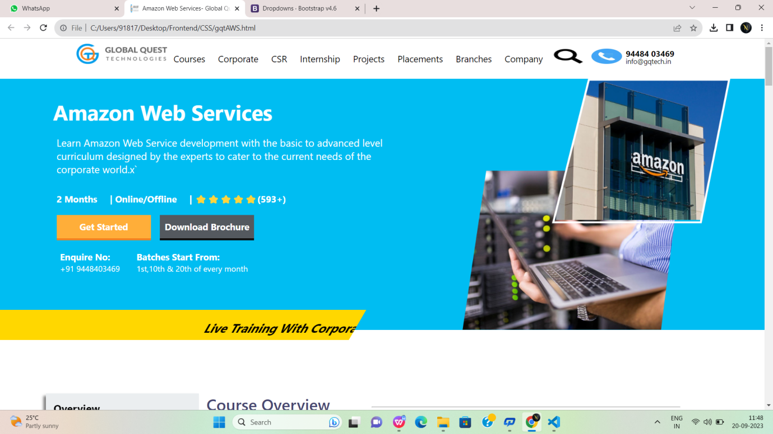

Fig:5

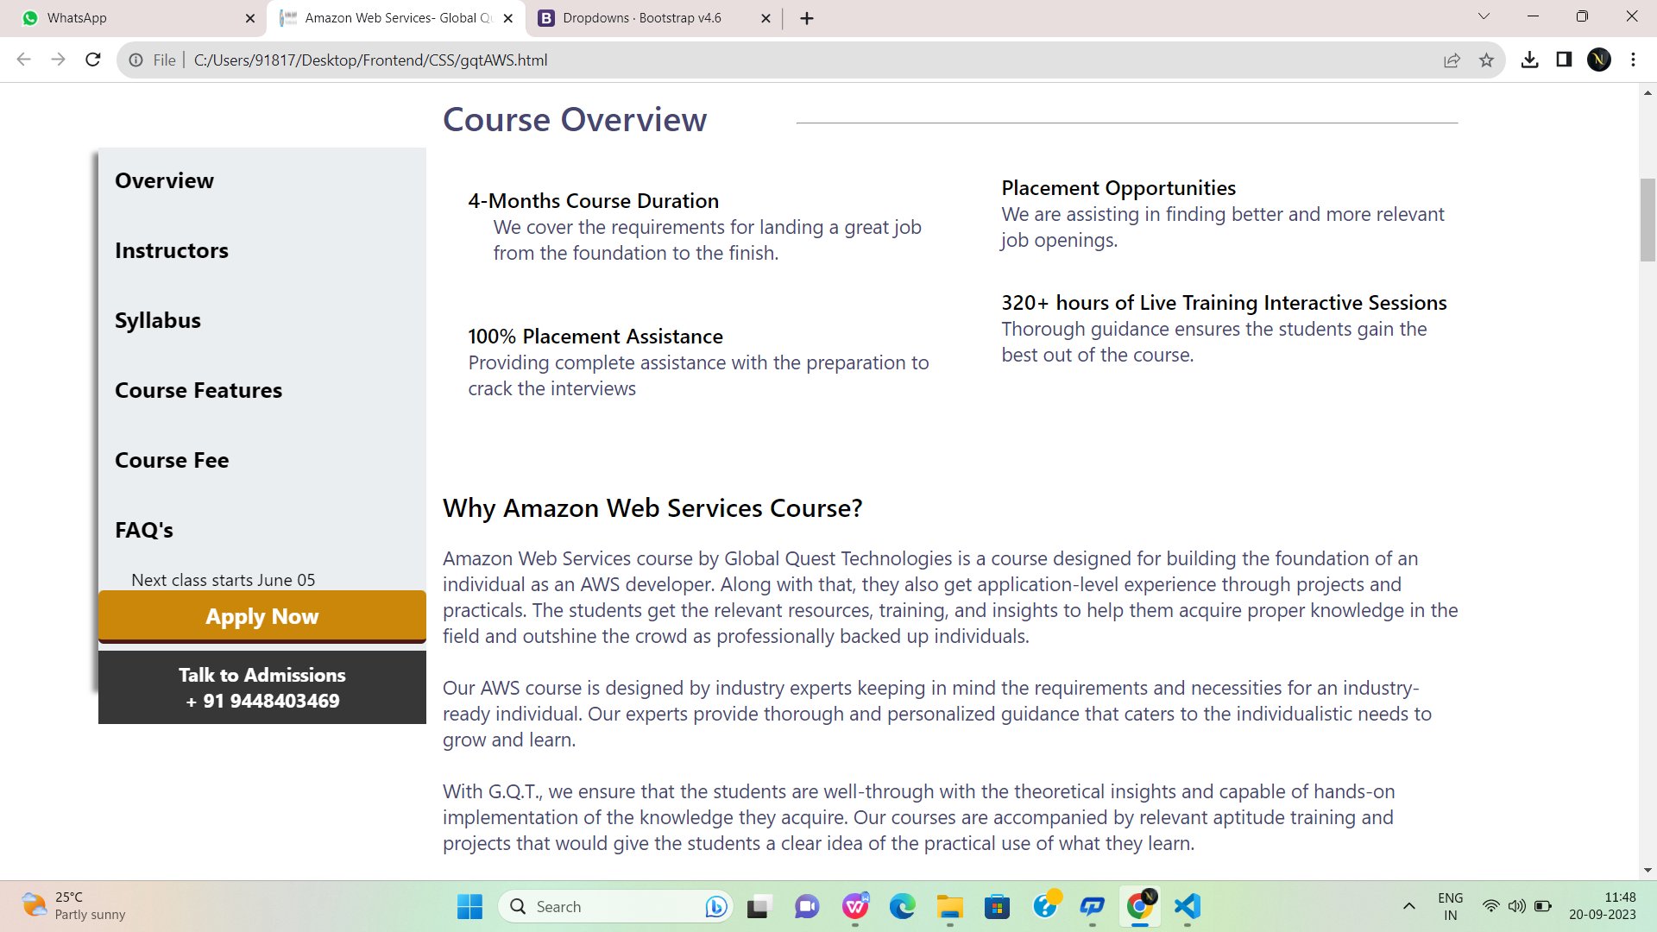

Fig:5.1

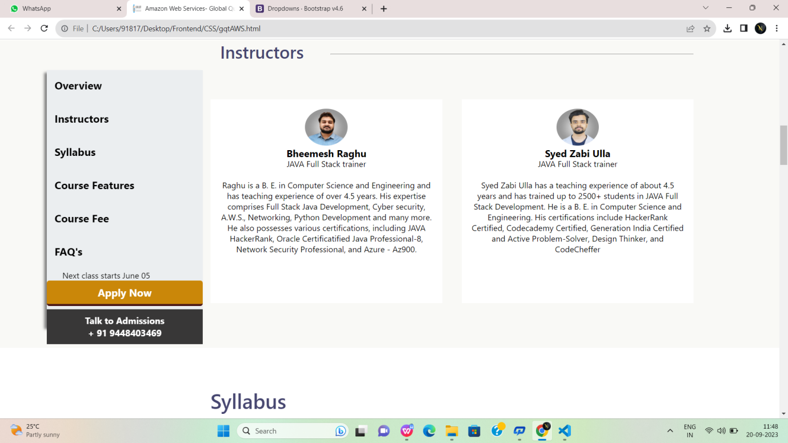

Fig:5.2

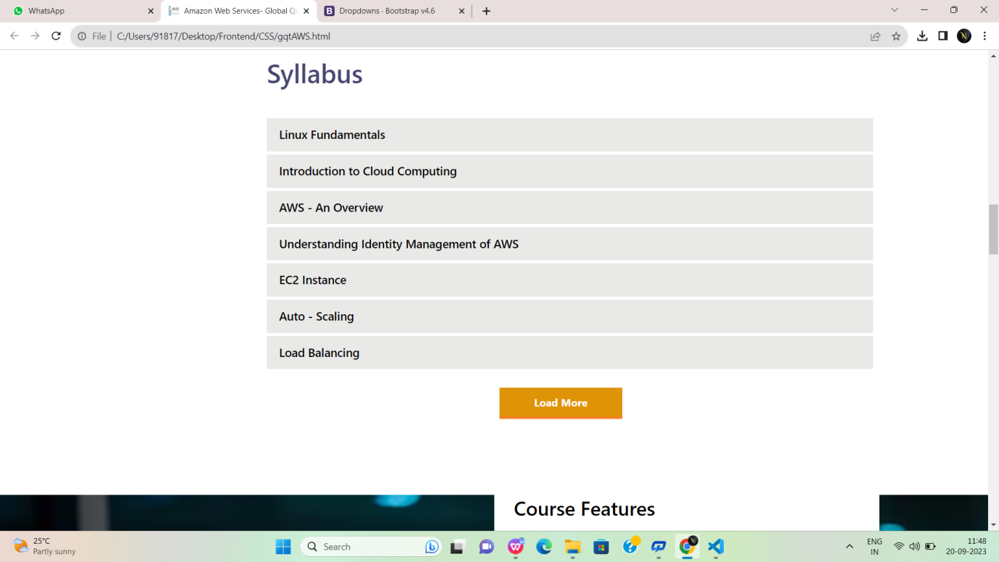

Fig:5.3

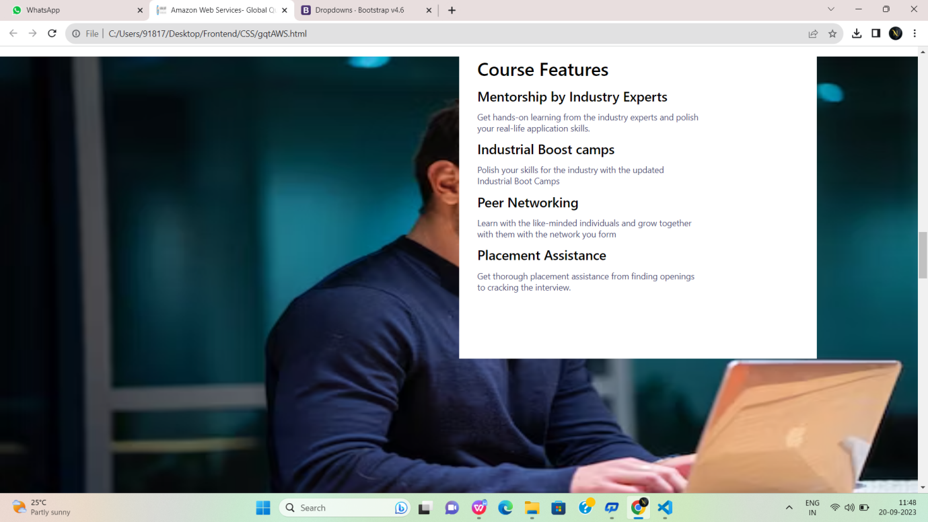

Fig:5.4

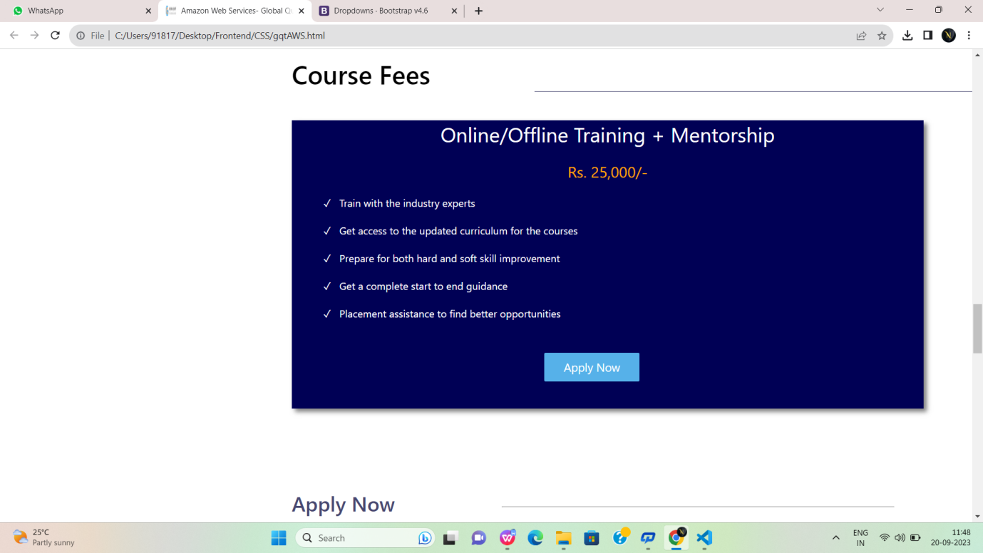

Fig:5.5

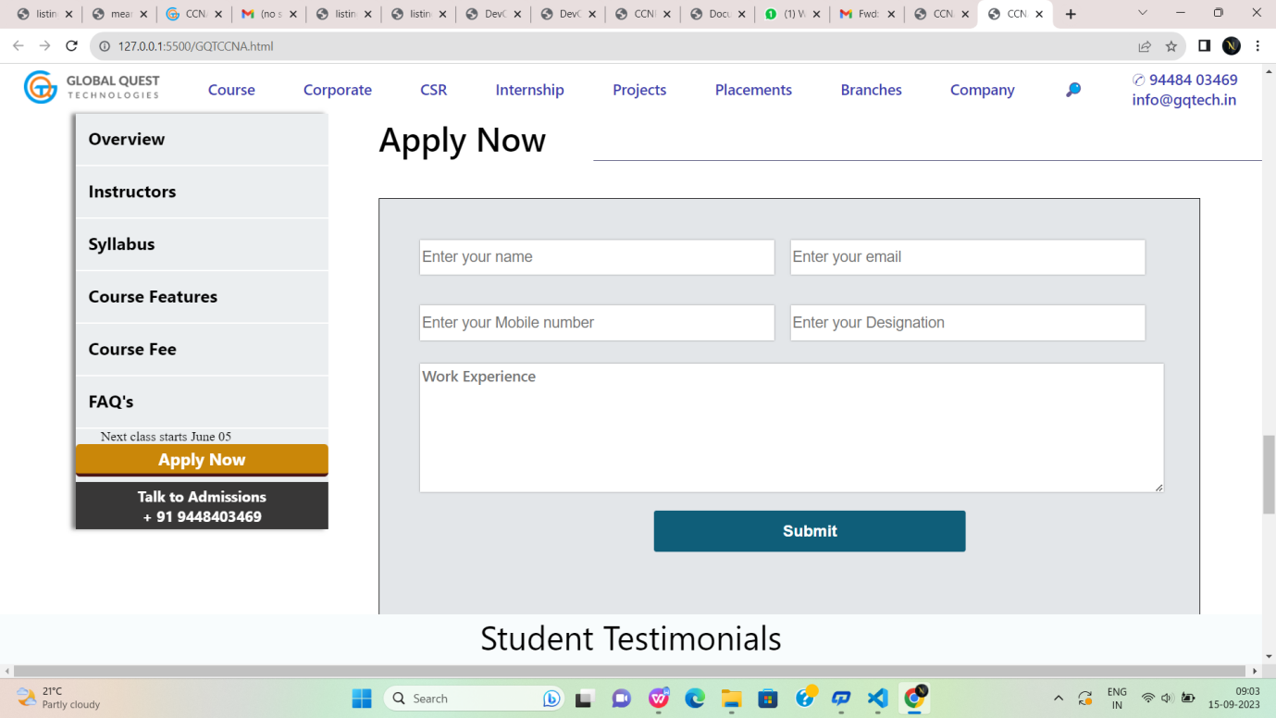

Fig:5.6

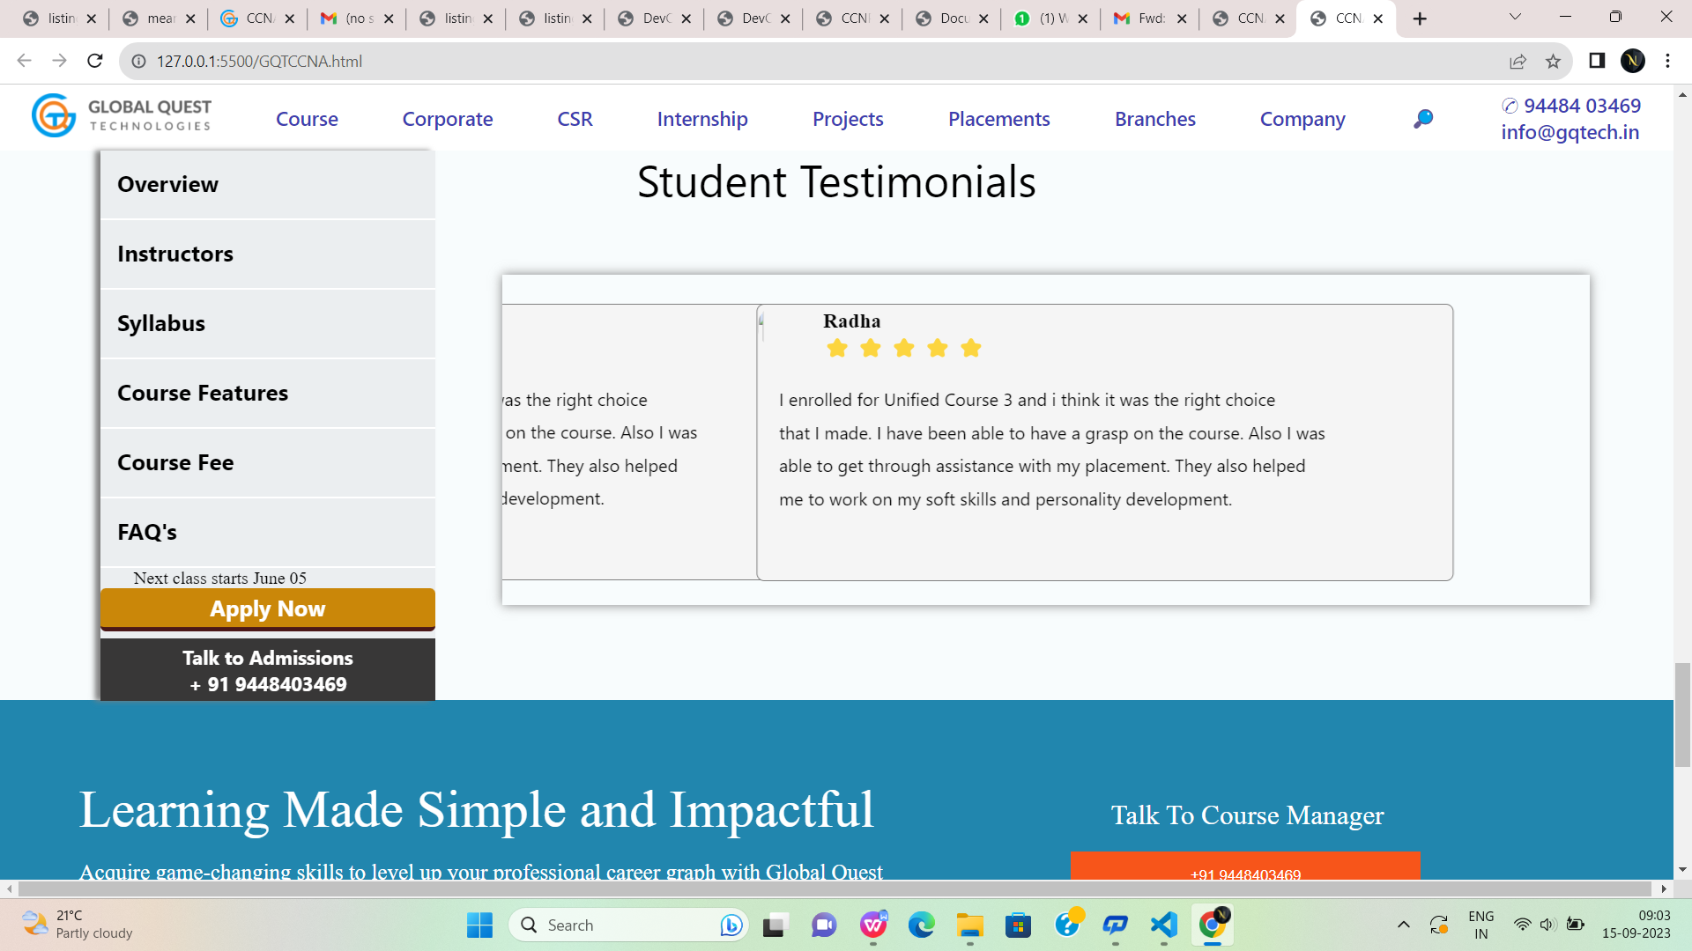

Fig:5.7

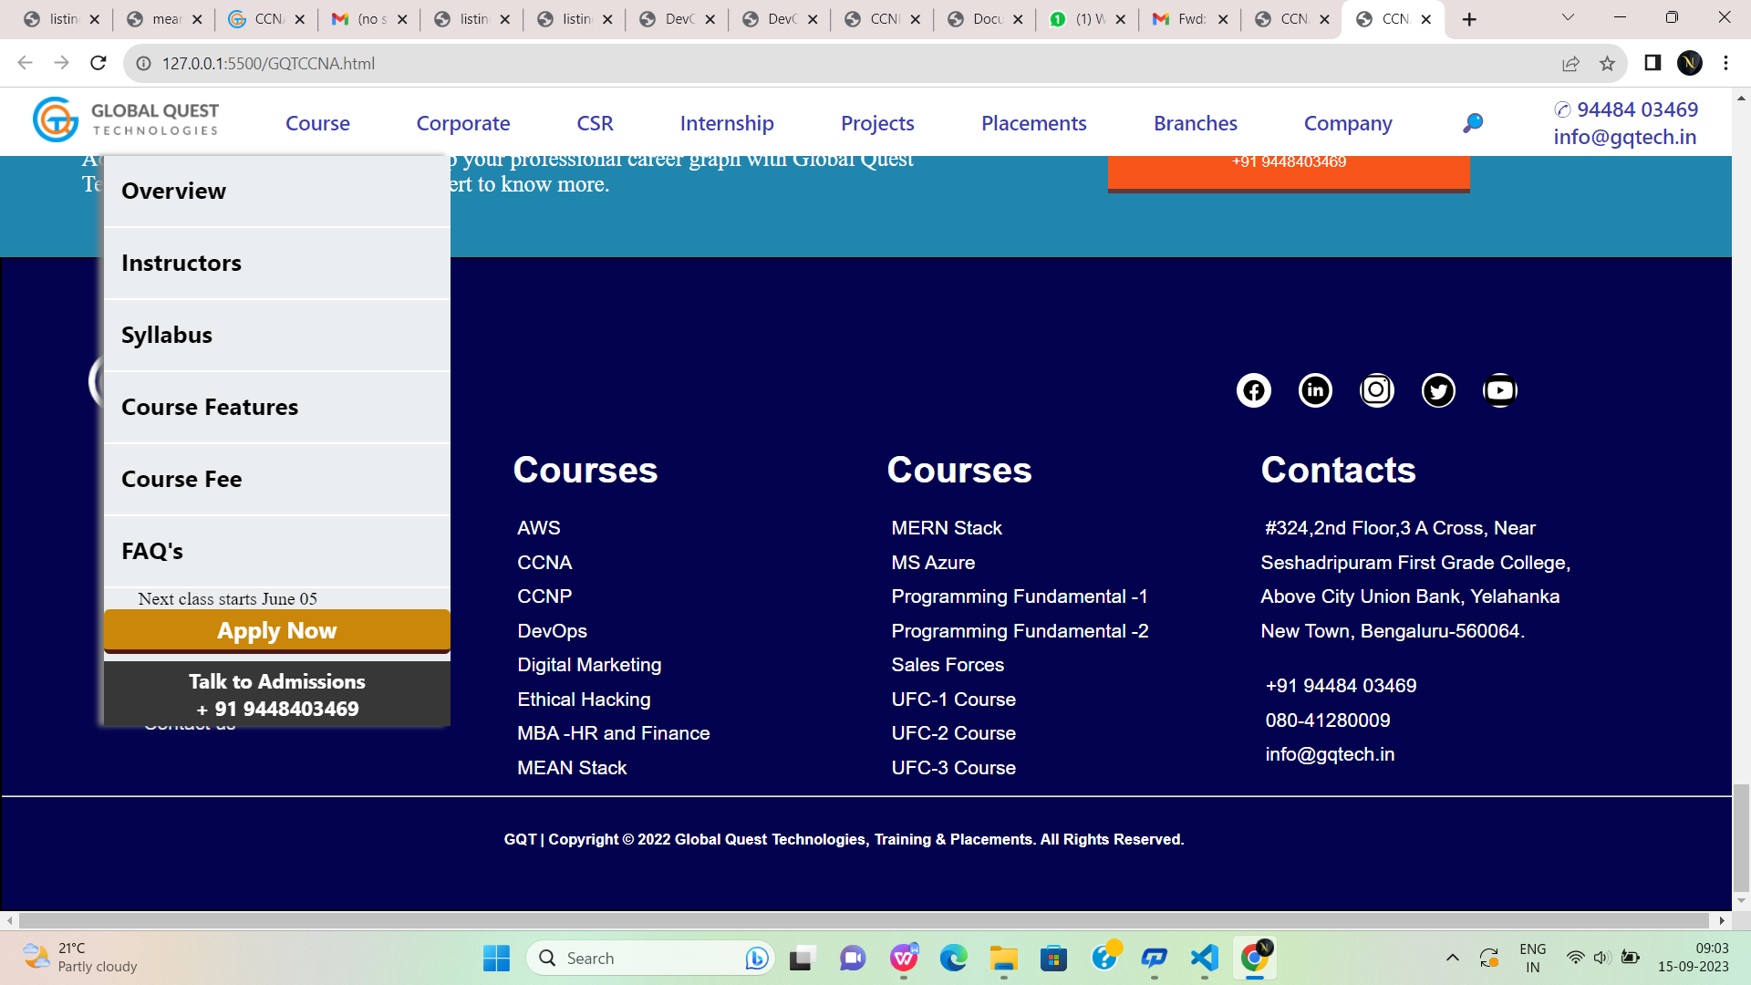

Fig:5.8

**CCNA.html:**

<!DOCTYPE html>

<html lang="en">

<head>

<meta charset="UTF-8">

<meta name="viewport" content="width=device-width, initial-scale=1.0">

<title>CCNA</title>

<link rel="stylesheet" href="meanstack.css">

</head>

<body>

<!--first div-->

<div id="div1">

<a href="#"><img style="height: 40px;" src="https://gqtech.in/wp-content/uploads/2022/04/cropped-GQT_Logo_H_.png"></a>

<a href="#">Course</a>

<a href="#">Corporate</a>

<a href="#">CSR</a>

<a href="#">Internship</a>

<a href="#">Projects</a>

<a href="#">Placements</a>

<a href="#">Branches</a>

<a href="#">Company</a>

<a href="#">&#x1F50E;</a>

<a href="#">&#9990; 94484 03469<br>

info@gqtech.in</a>

</div>

<!--second div-->

<div id="div2">

<div style="height:100%;width:80%;display:flex;flex-direction:column;">

<p style="m…

[9:00 am, 15/09/2023] Noshitha..: <!DOCTYPE html>

<html lang="en">

<head>

<meta charset="UTF-8">

<meta name="viewport" content="width=device-width, initial-scale=1.0">

<title>CCNA</title>

<link rel="stylesheet" href="meanstack.css">

</head>

<body>

<!--first div-->

<div id="div1">

<a href="#"><img style="height: 40px;" src="https://gqtech.in/wp-content/uploads/2022/04/cropped-GQT_Logo_H_.png"></a>

<a href="#">Course</a>

<a href="#">Corporate</a>

<a href="#">CSR</a>

<a href="#">Internship</a>

<a href="#">Projects</a>

<a href="#">Placements</a>

<a href="#">Branches</a>

<a href="#">Company</a>

<a href="#">&#x1F50E;</a>

<a href="#">&#9990; 94484 03469<br>

info@gqtech.in</a>

</div>

<!--second div-->

<div id="div2">

<div style="height:100%;width:80%;display:flex;flex-direction:column;">

<p style="margin-top:5%; margin-left:5%;margin-top:8%; font-family: 'Segoe UI', Tahoma,

Geneva, Verdana, sans-serif;font-size:250%;color:white;font-weight: 500;font-family: sans-serif;">

Cisco Certified Network Associate</p>

<p style="margin-top:3%; margin-left:5%; font-family:'Segoe UI', Tahoma, Geneva, Verdana, sansserif;font-size: 110%;color:white;">

Learn CCNA development with the basic to advanced level curriculum <br>designed by the experts to cater to the current needs of the corporate<br> world.</p>

<p style="margin-top:3%; margin-left:5%; font-family:'Segoe UI', Tahoma, Geneva, Verdana,

sans-serif;font-size: 113%;color:white;font-weight:bold;">

2 Months | Online/Offline | ⭐⭐⭐⭐⭐(593+)</p>

<button id="button1">Get Started</button>

<button id="button2">Download Brochure</button>

<p style="margin-top:3%; margin-left:5%; color:white;font-size:medium;">

<a href="#" style="text-decoration: none;color:white;font-size: larger;font-weight:bold;">

Enquire

No:&nbsp;&nbsp;&nbsp;&nbsp;&nbsp;&nbsp;&nbsp;&nbsp;&nbsp;&nbsp;&nbsp;&nbsp;&nbsp;

&nbsp;&nbsp;Batches Start From:</a><br>+91 9448403469

&nbsp;&nbsp;&nbsp;&nbsp;&nbsp;&nbsp;&nbsp;&nbsp;&nbsp;&nbsp;&nbsp;&nbsp;&nbsp;&nbsp;1

st,10th & 20th of every month</p>

</div>

<div style="height:500px;width:40%;">

<img style="height:100%;width:100%;" src="https://gqtech.in/wp-content/uploads/2022/05/CCNA.png">

</div>

</div>

<div style="background-color: gold; height:60px;width:50%;transform:skew(-30deg);margin-left:-

50px;margin-top:-50px;"><marquee style="padding-top:20px;font-size:x-large;font-weight: bold;" >

Live Training With Corporate Experts

&nbsp;&nbsp; &nbsp;&nbsp; &nbsp;&nbsp;

Frequent Mock Interviews And Tests

&nbsp;&nbsp; &nbsp;&nbsp; &nbsp;&nbsp;

700+ Hiring Partners

&nbsp;&nbsp; &nbsp;&nbsp; &nbsp;&nbsp;

Curriculum Designed For Industrial Applications

</marquee>

</div>

<!--sticky div-->

<div id="stickydiv">

<a href="#">Overview</a>

<br>

<hr>

<a href="#">Instructors</a>

<br>

<hr>

<a href="#">Syllabus</a>

<br>

<hr>

<a href="#">Course Features</a>

<br>

<hr>

<a href="#">Course Fee</a>

<br>

<hr>

<a href="#">FAQ's</a>

<br>

<hr>

<p style="margin-left:10%;">Next class starts June 05</p>

<button id="button3">Apply Now</button>

<button style="margin-top: 2%;" id="button4">Talk to Admissions<br>

+ 91 9448403469</button>

</div>

<!--third div-->

<div id="div3">

<div style="display:flex;justify-content: space-between;">

<p style="margin-left:2%; color:rgb(70, 70, 112);font-size:250%;font-family:'Segoe UI', Tahoma,

Geneva, Verdana, sans-serif;font-weight:600;">

Course Overview</p>

<hr style="background-color:rgb(70, 70, 112); width:60%;height:0.2%;margin-top:2.8%;">

</div>

<div style="display:flex;flex-direction:column;width:50%;height:40%;">

<p style="margin-left:10%;margin-top:9%; font-weight:600;color:black;font-size: larger;font-family: 'Segoe UI', Tahoma, Geneva, Verdana, sans-serif;">

2-Months Course Duration</p>

<p style="margin-left:10%; color:rgb(70, 70, 112);font-size: large;font-family: 'Segoe UI', Tahoma,

Geneva, Verdana, sans-serif;">

We cover the requirements for landing a great job <br>from the foundation to the finish.</p><p style="margin-left:10%;margin-top:11%; font-weight:600;color:black;font-size: larger;font-family: 'Segoe UI', Tahoma, Geneva, Verdana, sans-serif;">

100% Placement Assistance</p>

<p style="margin-left:10%; color:rgb(70, 70, 112);font-size: large;font-family: 'Segoe UI',

Tahoma, Geneva, Verdana, sans-serif;">

We cover the requirements for landing a great job <br>from the foundation to the finish.</p>

</div>

<div style="margin-left:50%;margin-top:-40%; display:flex;flex-direction:column;width:50%;height:40%;">

<p style="margin-left:10%;margin-top:20%; font-weight:600;color:black;font-size: larger;font-family: 'Segoe UI', Tahoma, Geneva, Verdana, sans-serif;">

Placement Opportunities</p>

<p style="margin-left:10%; color:rgb(70, 70, 112);font-size: large;font-family: 'Segoe UI', Tahoma,

Geneva, Verdana, sans-serif;">

We are assisting in finding better and more relevant <br>job openings.</p>

<p style="margin-left:10%;margin-top:7%; font-weight:600;color:black;font-size: larger;font-family: 'Segoe UI', Tahoma, Geneva, Verdana, sans-serif;">

120+ hours of Live Training Interactive Sessions</p>

<p style="margin-left:10%; color:rgb(70, 70, 112);font-size: large;font-family: 'Segoe UI',

Tahoma, Geneva, Verdana, sans-serif;">

Thorough guidance ensures the students gain the<br> best out of the course.</p>

</div>

<div>

<p style="margin-left:5%; color:black;font-family: 'Segoe UI', Tahoma, Geneva, Verdana, sansserif;font-weight:500;font-size:x-large;">

Why CCNA Course?</p>

<p style="margin-left:5%;margin-top:2%; color:rgb(70, 70, 112); font-family: 'Segoe UI', Tahoma,

Geneva, Verdana, sans-serif;font-size:large;">

CCNA course by Global Quest Technologies is designed to build an individual’s foundation as a network engineer. Along with that, they also get application-level experience through projects and practicals. The students get the relevant resources, training, and insights to help them acquire proper knowledge in the field and outshine the crowd as professionally backed up individuals.<br><br>

Our CCNA course is designed by industry experts keeping in mind the requirements and necessities for an industry-ready individual. Our experts provide thorough and personalized guidance that caters to the individualistic needs to grow and learn.<br><br>

With G.Q.T., we ensure that the students are well-through with the theoretical insights and capable of hands-on implementation of the knowledge they acquire. Our courses are accompanied by relevant aptitude training and projects that would give the students a clear idea of the practical use of what they learn.

</p>

</div>

</div>

<br><br><br><br><br><br><br><br><br><br>

<!--course features-->

<div id="course">

<p style="font-family: 'Segoe UI', Tahoma, Geneva, Verdana, sans-serif;

font-size:40px;font-weight:500;color:black;">

Syllabus</p>

<hr style="background-color:rgb(70, 70, 112); width:65%;height:0.05%;margin-top:-

3%;float:right;border:none;">

<p class="cls1">Network Fundamentals</p>

<p class="cls1">Network Access</p>

<p class="cls1">LAN Switching Technologies</p>

<p class="cls1">WAN Technologies</p>

<p class="cls1">IP Addressing IPv4 and IPv6</p>

<p class="cls1">Easy Subnetting</p>

<p class="cls1">IP Connectivity</p>

<p class="cls1">Describe the Routing Concepts</p>

<p class="cls1">Routing Technologies</p>

<p class="cls1">Describe IP Services</p>

<p class="cls1">Security Fundamentals</p>

<p class="cls1">NAT Technologies</p>

<p class="cls1">Troubleshooting</p>

</div>

<br><br><br><br><br><br><br><br><br><br><br><br><br><br><br><br><br><br><br><br><br><br><br><br><br><br><br><br>

<!--course features-->

<div id="course">

<p style="font-family: 'Segoe UI', Tahoma, Geneva, Verdana, sans-serif;

font-size:40px;font-weight:500;color:black;">

Course Features</p>

<hr style="background-color:rgb(70, 70, 112); width:65%;height:0.05%;margin-top:-

3%;float:right;border:none;">

<p class="cls1">Mentorship by Industry Experts</p>

<p class="cls2">Get hands-on learning from the industry experts and polish <br> your real-life

application skills.</p>

<p class="cls1">Industrial Boost camps</p>

<p class="cls2">Polish your skills for the industry with the updated<br> Industrial Boot Camps</p>

<p class="cls1">Peer Networking</p><p class="cls2">Learn with the like-minded individuals and grow together<br> with them with the

network you form</p>

<p class="cls1">Placement Assistance</p>

<p class="cls2">Get thorough placement assistance from finding openings<br> to cracking the

interview.</p>

</div>

<!--course fees div-->

<div style="margin-top:-5%;height:600px;">

<p style="font-family: 'Segoe UI', Tahoma, Geneva, Verdana, sans-serif;

font-size:40px;font-weight:500;color:black;margin-left:30%;margin-top: 5%;">Course Fees</p>

<hr style="background-color:rgb(70, 70, 112); width:53%;height:0.05%;margin-top:-

10%;float:right;border:none;">

<div style="box-shadow: 5px 5px 7px grey;

height:450px;width:65%;margin-left:30%;

margin-top:3%;background-color:rgb(0, 0, 85) ;color:white;">

<p style="font-size:xx-large;text-align: center;">Online/Offline Training + Mentorship</p>

<br>

<p style="font-size:x-large;color:orange;text-align:center;">Rs. 10,000/-</p>

<br>

<p style="font-size: larger;margin-left:5%;">&#x2713;&nbsp;&nbsp; Train with the industry

experts</p>

<br>

<p style="font-size: larger;margin-left:5%;">&#x2713;&nbsp;&nbsp; Get access to the updated

curriculum for the courses</p>

<br>

<p style="font-size: larger;margin-left:5%;">&#x2713;&nbsp;&nbsp; Prepare for both hard and soft

skill improvement</p>

<br>

<p style="font-size: larger;margin-left:5%;">&#x2713;&nbsp;&nbsp; Get a complete start to end

guidance</p>

<br>

<p style="font-size: larger;margin-left:5%;">&#x2713;&nbsp;&nbsp; Placement assistance to find

better opportunities</p>

<br>

<button style="height:10%;width:15%;margin-left:40%;margin-top:3%;

background-color: rgb(86, 177, 233);color:white;font-size:large;border-radius:2px;

font-family:'Segoe UI', Tahoma, Geneva, Verdana, sans-serif;border:none;">Apply Now</button>

</div>

</div>

<!--Apply now div-->

<div style="height:600px;">

<p style="font-family: 'Segoe UI', Tahoma, Geneva, Verdana, sans-serif;

font-size:40px;font-weight:500;color:black;margin-left:30%;">Apply Now</p>

<hr style="background-color:rgb(70, 70, 112); width:53%;height:0.05%;margin-top:-

2%;float:right;border:none;">

<div id="formdiv">

<div style="margin-top:5%;margin-left:5%;">

<form>

<input type="text" id="name" placeholder="Enter your name"

style="border:none;box-shadow:0px 0px 2px grey ; height:40px;width:45%;color:rgb(135,

135, 182);font-size:large;">

&nbsp;&nbsp;&nbsp;

<input type="email" id="name" placeholder="Enter your email"

style="border:none;box-shadow:0px 0px 2px grey ; height:40px;width:45%; color:rgb(135,

135, 182);font-size:large;">

<br><br><br><input type="tel" id="name" placeholder="Enter your Mobile number"

style="border:none;box-shadow:0px 0px 2px grey ; height:40px;width:45%;color:rgb(135,

135, 182);font-size:large;">

&nbsp;&nbsp;&nbsp;

<input type="text" id="name" placeholder="Enter your Designation"

style="border:none;box-shadow:0px 0px 2px grey ; height:40px;width:45%;color:rgb(135,

135, 182);font-size:large;">

<textarea rows="4" cols="50" placeholder="Work Experience"

style="border:none;box-shadow:0px 0px 2px grey ; height:150px;width:95%;font-size:18px;margin-top:3%;

font-weight:500; font-family:'Segoe UI', Tahoma, Geneva, Verdana, sans-serif;"></textarea>

<br><br>

<input type="submit" value="Submit" style="background-color:rgb(15, 94, 121);

height:50px;width:40%;border:none;color:white;font-size: larger;font-weight: 600;

border-radius: 3px;margin-left:30%;">

</form>

</div>

</div>

</div>

<!--students div-->

<div style="height:500px;background-color: rgb(248, 252, 253);">

<p style="font-family:'Segoe UI', Tahoma, Geneva, Verdana, sans-serif;font-size:40px;text-align:center;">Student Testimonials</p>

<!--parent div for student testimonial-->

<div style="height:300px;width:65%;margin-top:60px;margin-left:30%;overflow:hidden;box-shadow: 0px 0px 10px grey;">

<!--child div for student testimonial-->

<marquee>

<div style="border:1px solid grey; height:250px;width:64%;background-color:whitesmoke;border-radius:7px;margin-top:25px;">

<img style="height:40px;width:10%;border-radius:30px;" src="https://gqtech.in/wpcontent/uploads/2022/05/students4.jpg">

<h3 style="margin-left:60px;margin-top:-40px;">james<br>&#11088 &#11088 &#11088 &#11088

&#11088</h3>

<p style="font-family:'Segoe UI', Tahoma, Geneva, Verdana, sans-serif;line-height: 30px;font-size:

medium;margin-left:20px;margin-top:20px;">I enrolled for Unified Course 3 and i think it was the

right choice<br> that I made.

I have been able to have a grasp on the course.

Also I was<br> able to get through assistance with my placement.

They also helped<br> me to work on my soft skills and personality development.</p>

</div>

<div style="border:1px solid grey; margin-left:570px;margin-top:-251px;

height:250px;width:64%;background-color:whitesmoke;border-radius:7px;">

<img style="height:40px;width:10%;border-radius:30px;" src="https://gqtech.in/wpcontent/uploads/2022/05/students3.jpg">

<h3 style="margin-left:60px;margin-top:-40px;">Priyanka<br>&#11088 &#11088 &#11088

&#11088 &#11088</h3>

<p style="font-family:'Segoe UI', Tahoma, Geneva, Verdana, sans-serif;line-height: 30px;font-size: medium;margin-left:20px;margin-top:20px;">I enrolled for Unified Course 3 and i think it was

the right choice<br> that I made.

I have been able to have a grasp on the course.

Also I was<br> able to get through assistance with my placement.

They also helped<br> me to work on my soft skills and personality development.</p>

</div>

<div style="border:1px solid grey; margin-left:1140px;margin-top:-251px;

height:250px;width:64%;background-color:whitesmoke;border-radius:7px;"><img style="height:40px;width:10%;border-radius:30px;" src="https://gqtech.in/wpcontent/uploads/2022/05/students2.jpg">

<h3 style="margin-left:60px;margin-top:-40px;">Ramya<br>&#11088 &#11088 &#11088

&#11088 &#11088</h3>

<p style="font-family:'Segoe UI', Tahoma, Geneva, Verdana, sans-serif;line-height: 30px;font-size: medium;margin-left:20px;margin-top:20px;">I enrolled for Unified Course 3 and i think it was

the right choice<br> that I made.

I have been able to have a grasp on the course.

Also I was<br> able to get through assistance with my placement.

They also helped<br> me to work on my soft skills and personality development.</p>

</div>

<div style="border:1px solid grey; margin-left:1710px;margin-top:-251px;

height:250px;width:64%;background-color: whitesmoke; border-radius:7px;">

<img style="height:40px;width:10%;border-radius:30px;" src="https://gqtech.in/wpcontent/uploads/2022/05/students1.jpg">

<h3 style="margin-left:60px;margin-top:-40px;">Radha<br>&#11088 &#11088 &#11088

&#11088 &#11088</h3>

<p style="font-family:'Segoe UI', Tahoma, Geneva, Verdana, sans-serif;line-height: 30px;font-size: medium;margin-left:20px;margin-top:20px;">I enrolled for Unified Course 3 and i think it was

the right choice<br> that I made.

I have been able to have a grasp on the course.

Also I was<br> able to get through assistance with my placement.

They also helped<br> me to work on my soft skills and personality development.</p>

</div>

</marquee>

</div>

</div>

<!--course manager div-->

<div style="height:240px;background-color:rgb(33, 134, 174);border: 2px solid rgb(33, 134, 174);">

<h2 style="font-size:48px;color:white;padding-top:70px;padding-left:70px;font-weight:200;">Learning Made Simple and Impactful</h2>

<br>

<p style="padding-left:70px;font-size:20px;color:white;">Acquire game-changing skills to level up

your professional career graph with Global Quest <br>Technologies.

Get in touch with our expert to know more.</p>

<div style="height:70px;width:30%;margin-left:800px;margin-top:-100px;">

<p style="font-size:25px;color:white;text-align:right;">Talk To Course Manager</p><br>

<button id="button10" style="border:none;margin-left:170px;font-size:xlarge;height:50px;width:70%;background-color: rgb(247, 85, 26);color:white;

border-bottom:4px solid rgb(95, 55, 55);">+91 9448403469</button>

</div>

</div>

<!--last footer div-->

<div id="p1">

<img id="p2" src="https://gqtech.in/wp-content/uploads/2022/04/GQT_Logo_H_@2x.png">

<div id="p3">

<img class="z" src="https://encrypted-tbn0.gstatic.com/images?q=tbn:ANd9GcS9QIwGkz33neLbjfP6seN6ycBchzciwXS_KQ&usqp=CAU">

<img class="z" src="https://encrypted-tbn0.gstatic.com/images?q=tbn:ANd9GcS7bVv7wzhQtvTMoZPTJkYcIrN-EFfbQiCPFg&usqp=CAU">

<img class="z" src="https://encrypted-tbn0.gstatic.com/images?q=tbn:ANd9GcTFcnDLO5SGDO2_G_iygk8dxEQAS2c0cVXXEQ&usqp=CAU" >

<img class="z" src="https://encrypted-tbn0.gstatic.com/images?q=tbn:ANd9GcTnKjujHfPrr6WD2lrbzkCBwmzPIKTj02_BJg&usqp=CAU">

<img class="z" src="https://encrypted-tbn0.gstatic.com/images?q=tbn:ANd9GcTVJeTWM--_ulJr2AdOEQ7WyrAfx3qFmdv7ZQ&usqp=CAU">

</div>

<div style="width: 90%;height: 330px;margin-left: 7%;display: flex;">

<div class="u" style="margin-left: 1%;">

<h1 style="color: white;font-family: sans-serif;font-size: x-large;">Quick Links</h1>

<br>

<a href=""class="g" > Home</a><br>

<a href="" class="g">CSR</a><br>

<a href="" class="g">Placements</a><br>

<a href="" class="g">Internship</a><br>

<a href="" class="g">Project</a><br>

<a href=""class="g">About us</a><br>

<a href="" class="g">Contact us</a>

</div>

<div class="u">

<h1 style="color: white;font-family: sans-serif;font-size: xx-large;">Courses</h1>

<br>

<a href=""class="g" > AWS</a><br>

<a href="" class="g">CCNA</a><br>

<a href="" class="g">CCNP</a><br>

<a href="" class="g">DevOps</a><br>

<a href="" class="g">Digital Marketing</a><br>

<a href=""class="g">Ethical Hacking</a><br>

<a href="" class="g">MBA -HR and Finance</a><br>

<a href="" class="g">MEAN Stack</a>

</div>

<div class="u">

<h1 style="color: white;font-family: sans-serif;font-size: xx-large;">Courses</h1>

<br>

<a href=""class="g" >MERN Stack </a><br>

<a href="" class="g">MS Azure</a><br>

<a href="" class="g">Programming Fundamental -1</a><br>

<a href="" class="g">Programming Fundamental -2</a><br>

<a href="" class="g">Sales Forces</a><br>

<a href=""class="g">UFC-1 Course</a><br>

<a href="" class="g">UFC-2 Course</a><br>

<a href="" class="g">UFC-3 Course</a>

</div>

<div class="u">

<h1 style="color: white;font-family: sans-serif;font-size: xx-large;">Contacts</h1>

<br>

<a href="" class="g">#324,2nd Floor,3 A Cross, Near Seshadripuram First Grade College, Above City Union Bank, Yelahanka New Town, Bengaluru-560064.</a><br><br>

<a href="" class="g">+91 94484 03469</a><br>

<a href="" class="g">080-41280009</a><br>

<a href="" class="g">info@gqtech.in</a><br>

</div>

</div>

<hr>

<h1 style="color: white;font-family: sans-serif;font-size: small;margin-left: 29%;margin-top: 30px;">GQT | Copyright © 2022 Global Quest Technologies, Training & Placements. All Rights Reserved.</h1>

</div>

</body>

</html>

**Output:**

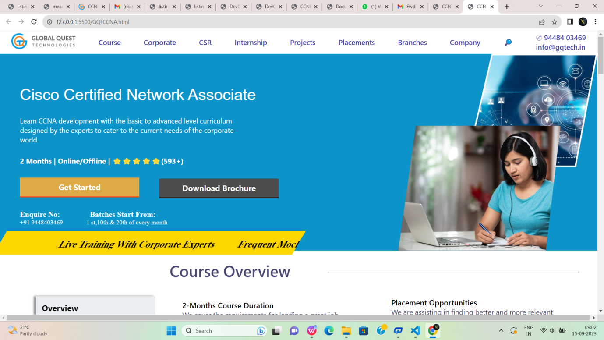

Fig:6

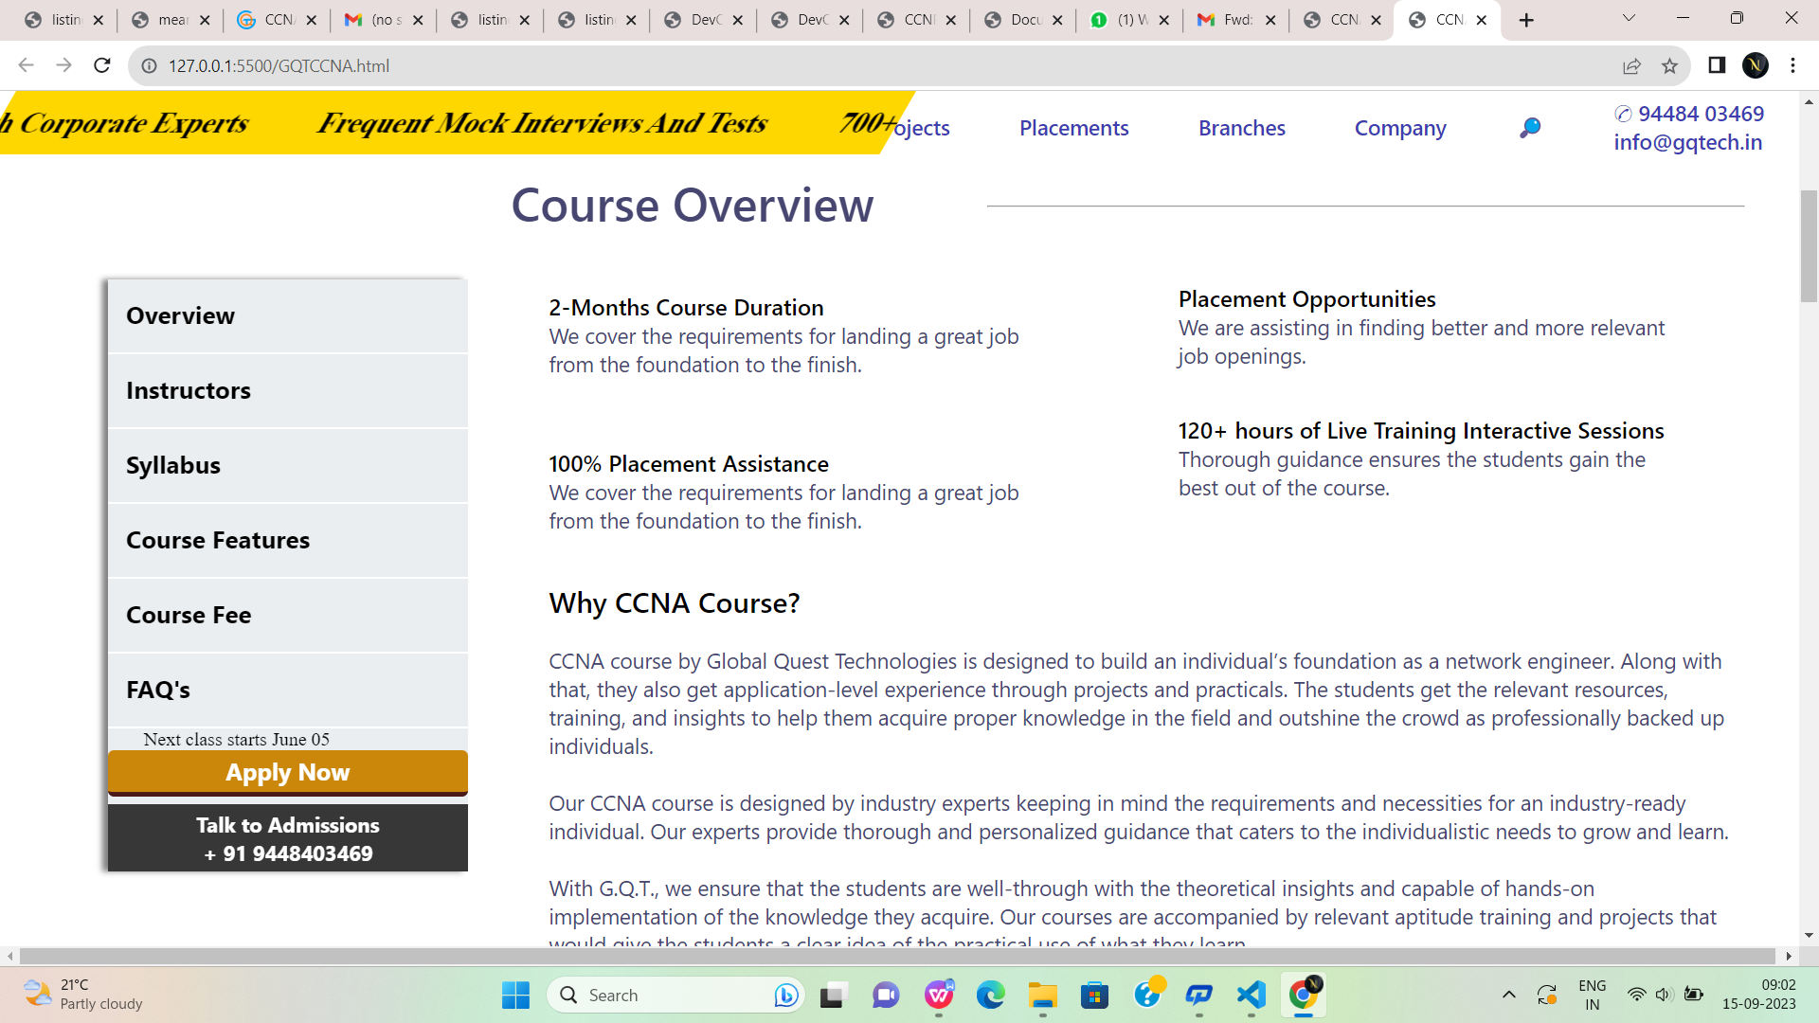

Fig:6.1

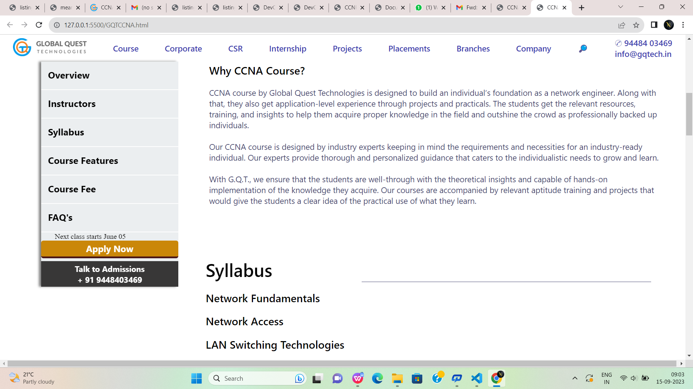

Fig:6.2

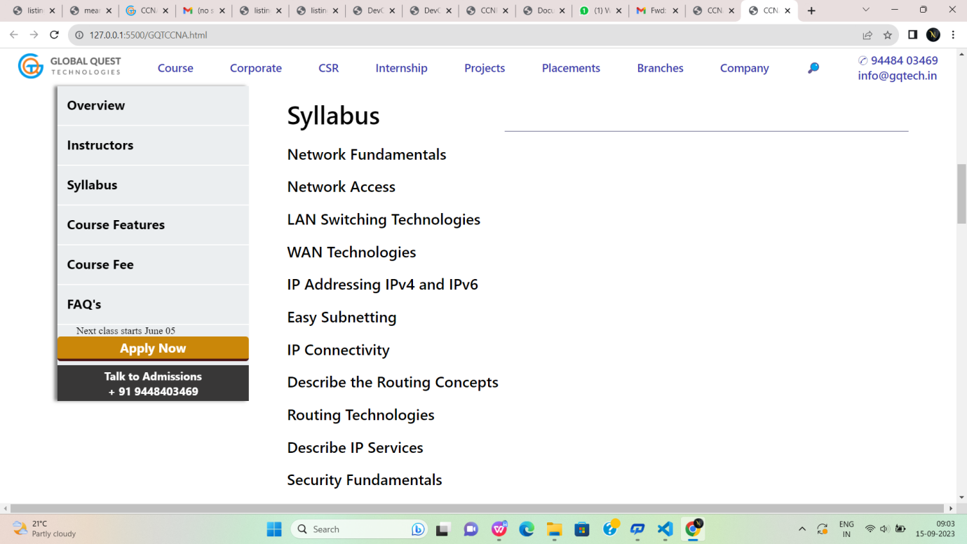

Fig:6.3

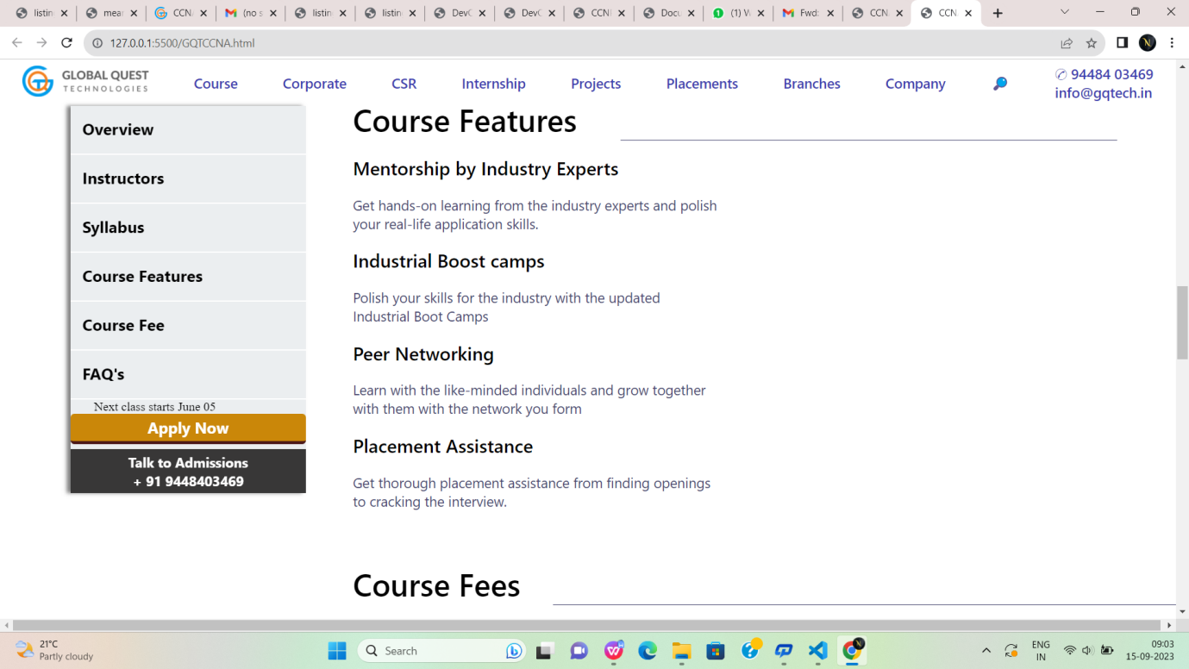

Fig:6.4

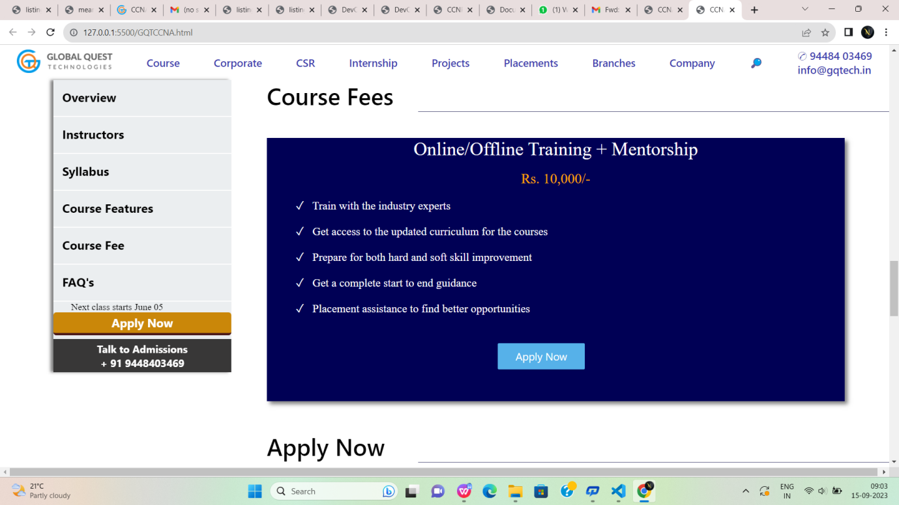

Fig:6.5



Fig:6.6



Fig:6.7



Fig:6.8

**CCNP.html:**

[9:00 am, 15/09/2023] Noshitha..: <!DOCTYPE html>

<html lang="en">

<head>

<meta charset="UTF-8">

<meta name="viewport" content="width=device-width, initial-scale=1.0">

<title>CCNA</title>

<link rel="stylesheet" href="meanstack.css">

</head>

<body>

<!--first div-->

<div id="div1">

<a href="#"><img style="height: 40px;" src="https://gqtech.in/wp-content/uploads/2022/04/cropped-GQT_Logo_H_.png"></a>

<a href="#">Course</a>

<a href="#">Corporate</a>

<a href="#">CSR</a>

<a href="#">Internship</a>

<a href="#">Projects</a>

<a href="#">Placements</a>

<a href="#">Branches</a>

<a href="#">Company</a>

<a href="#">&#x1F50E;</a>

<a href="#">&#9990; 94484 03469<br>

info@gqtech.in</a>

</div>

<!--second div-->

<div id="div2">

<div style="height:100%;width:80%;display:flex;flex-direction:column;">

<p style="margin-top:5%; margin-left:5%;margin-top:8%; font-family: 'Segoe UI', Tahoma,

Geneva, Verdana, sans-serif;font-size:250%;color:white;font-weight: 500;font-family: sans-serif;">

Cisco Certified Network Associate</p>

<p style="margin-top:3%; margin-left:5%; font-family:'Segoe UI', Tahoma, Geneva, Verdana, sansserif;font-size: 110%;color:white;">

Learn CCNA development with the basic to advanced level curriculum <br>designed by the experts to cater to the current needs of the corporate<br> world.</p>

<p style="margin-top:3%; margin-left:5%; font-family:'Segoe UI', Tahoma, Geneva, Verdana,

sans-serif;font-size: 113%;color:white;font-weight:bold;">

2 Months | Online/Offline | ⭐⭐⭐⭐⭐(593+)</p>

<button id="button1">Get Started</button>

<button id="button2">Download Brochure</button>

<p style="margin-top:3%; margin-left:5%; color:white;font-size:medium;">

<a href="#" style="text-decoration: none;color:white;font-size: larger;font-weight:bold;">

Enquire

No:&nbsp;&nbsp;&nbsp;&nbsp;&nbsp;&nbsp;&nbsp;&nbsp;&nbsp;&nbsp;&nbsp;&nbsp;&nbsp;

&nbsp;&nbsp;Batches Start From:</a><br>+91 9448403469

&nbsp;&nbsp;&nbsp;&nbsp;&nbsp;&nbsp;&nbsp;&nbsp;&nbsp;&nbsp;&nbsp;&nbsp;&nbsp;&nbsp;1

st,10th & 20th of every month</p>

</div>

<div style="height:500px;width:40%;">

<img style="height:100%;width:100%;" src="https://gqtech.in/wp-content/uploads/2022/05/CCNA.png">

</div>

</div>

<div style="background-color: gold; height:60px;width:50%;transform:skew(-30deg);margin-left:-

50px;margin-top:-50px;"><marquee style="padding-top:20px;font-size:x-large;font-weight: bold;" >

Live Training With Corporate Experts

&nbsp;&nbsp; &nbsp;&nbsp; &nbsp;&nbsp;

Frequent Mock Interviews And Tests

&nbsp;&nbsp; &nbsp;&nbsp; &nbsp;&nbsp;

700+ Hiring Partners

&nbsp;&nbsp; &nbsp;&nbsp; &nbsp;&nbsp;

Curriculum Designed For Industrial Applications

</marquee>

</div>

<!--sticky div-->

<div id="stickydiv">

<a href="#">Overview</a>

<br>

<hr>

<a href="#">Instructors</a>

<br>

<hr>

<a href="#">Syllabus</a>

<br>

<hr>

<a href="#">Course Features</a>

<br>

<hr>

<a href="#">Course Fee</a>

<br>

<hr>

<a href="#">FAQ's</a>

<br>

<hr>

<p style="margin-left:10%;">Next class starts June 05</p>

<button id="button3">Apply Now</button>

<button style="margin-top: 2%;" id="button4">Talk to Admissions<br>

+ 91 9448403469</button>

</div>

<!--third div-->

<div id="div3">

<div style="display:flex;justify-content: space-between;">

<p style="margin-left:2%; color:rgb(70, 70, 112);font-size:250%;font-family:'Segoe UI', Tahoma,

Geneva, Verdana, sans-serif;font-weight:600;">

Course Overview</p>

<hr style="background-color:rgb(70, 70, 112); width:60%;height:0.2%;margin-top:2.8%;">

</div>

<div style="display:flex;flex-direction:column;width:50%;height:40%;">

<p style="margin-left:10%;margin-top:9%; font-weight:600;color:black;font-size: larger;font-family: 'Segoe UI', Tahoma, Geneva, Verdana, sans-serif;">

2-Months Course Duration</p>

<p style="margin-left:10%; color:rgb(70, 70, 112);font-size: large;font-family: 'Segoe UI', Tahoma,

Geneva, Verdana, sans-serif;">

We cover the requirements for landing a great job <br>from the foundation to the finish.</p><p style="margin-left:10%;margin-top:11%; font-weight:600;color:black;font-size: larger;font-family: 'Segoe UI', Tahoma, Geneva, Verdana, sans-serif;">

100% Placement Assistance</p>

<p style="margin-left:10%; color:rgb(70, 70, 112);font-size: large;font-family: 'Segoe UI',

Tahoma, Geneva, Verdana, sans-serif;">

We cover the requirements for landing a great job <br>from the foundation to the finish.</p>

</div>

<div style="margin-left:50%;margin-top:-40%; display:flex;flex-direction:column;width:50%;height:40%;">

<p style="margin-left:10%;margin-top:20%; font-weight:600;color:black;font-size: larger;font-family: 'Segoe UI', Tahoma, Geneva, Verdana, sans-serif;">

Placement Opportunities</p>

<p style="margin-left:10%; color:rgb(70, 70, 112);font-size: large;font-family: 'Segoe UI', Tahoma,

Geneva, Verdana, sans-serif;">

We are assisting in finding better and more relevant <br>job openings.</p>

<p style="margin-left:10%;margin-top:7%; font-weight:600;color:black;font-size: larger;font-family: 'Segoe UI', Tahoma, Geneva, Verdana, sans-serif;">

120+ hours of Live Training Interactive Sessions</p>

<p style="margin-left:10%; color:rgb(70, 70, 112);font-size: large;font-family: 'Segoe UI',

Tahoma, Geneva, Verdana, sans-serif;">

Thorough guidance ensures the students gain the<br> best out of the course.</p>

</div>

<div>

<p style="margin-left:5%; color:black;font-family: 'Segoe UI', Tahoma, Geneva, Verdana, sansserif;font-weight:500;font-size:x-large;">

Why CCNA Course?</p>

<p style="margin-left:5%;margin-top:2%; color:rgb(70, 70, 112); font-family: 'Segoe UI', Tahoma,

Geneva, Verdana, sans-serif;font-size:large;">

CCNA course by Global Quest Technologies is designed to build an individual’s foundation as a network engineer. Along with that, they also get application-level experience through projects and practicals. The students get the relevant resources, training, and insights to help them acquire proper knowledge in the field and outshine the crowd as professionally backed up individuals.<br><br>

Our CCNA course is designed by industry experts keeping in mind the requirements and necessities for an industry-ready individual. Our experts provide thorough and personalized guidance that caters to the individualistic needs to grow and learn.<br><br>

With G.Q.T., we ensure that the students are well-through with the theoretical insights and capable of hands-on implementation of the knowledge they acquire. Our courses are accompanied by relevant aptitude training and projects that would give the students a clear idea of the practical use of what they learn.

</p>

</div>

</div>

<br><br><br><br><br><br><br><br><br><br>

<!--course features-->

<div id="course">

<p style="font-family: 'Segoe UI', Tahoma, Geneva, Verdana, sans-serif;

font-size:40px;font-weight:500;color:black;">

Syllabus</p>

<hr style="background-color:rgb(70, 70, 112); width:65%;height:0.05%;margin-top:-

3%;float:right;border:none;">

<p class="cls1">Network Fundamentals</p>

<p class="cls1">Network Access</p>

<p class="cls1">LAN Switching Technologies</p>

<p class="cls1">WAN Technologies</p>

<p class="cls1">IP Addressing IPv4 and IPv6</p>

<p class="cls1">Easy Subnetting</p>

<p class="cls1">IP Connectivity</p>

<p class="cls1">Describe the Routing Concepts</p>

<p class="cls1">Routing Technologies</p>

<p class="cls1">Describe IP Services</p>

<p class="cls1">Security Fundamentals</p>

<p class="cls1">NAT Technologies</p>

<p class="cls1">Troubleshooting</p>

</div>

<br><br><br><br><br><br><br><br><br><br><br><br><br><br><br><br><br><br><br><br><br><br><br><br><br><br><br><br>

<!--course features-->

<div id="course">

<p style="font-family: 'Segoe UI', Tahoma, Geneva, Verdana, sans-serif;

font-size:40px;font-weight:500;color:black;">

Course Features</p>

<hr style="background-color:rgb(70, 70, 112); width:65%;height:0.05%;margin-top:-

3%;float:right;border:none;">

<p class="cls1">Mentorship by Industry Experts</p>

<p class="cls2">Get hands-on learning from the industry experts and polish <br> your real-life

application skills.</p>

<p class="cls1">Industrial Boost camps</p>

<p class="cls2">Polish your skills for the industry with the updated<br> Industrial Boot Camps</p>

<p class="cls1">Peer Networking</p><p class="cls2">Learn with the like-minded individuals and grow together<br> with them with the

network you form</p>

<p class="cls1">Placement Assistance</p>

<p class="cls2">Get thorough placement assistance from finding openings<br> to cracking the

interview.</p>

</div>

<!--course fees div-->

<div style="margin-top:-5%;height:600px;">

<p style="font-family: 'Segoe UI', Tahoma, Geneva, Verdana, sans-serif;

font-size:40px;font-weight:500;color:black;margin-left:30%;margin-top: 5%;">Course Fees</p>

<hr style="background-color:rgb(70, 70, 112); width:53%;height:0.05%;margin-top:-

10%;float:right;border:none;">

<div style="box-shadow: 5px 5px 7px grey;

height:450px;width:65%;margin-left:30%;

margin-top:3%;background-color:rgb(0, 0, 85) ;color:white;">

<p style="font-size:xx-large;text-align: center;">Online/Offline Training + Mentorship</p>

<br>

<p style="font-size:x-large;color:orange;text-align:center;">Rs. 10,000/-</p>

<br>

<p style="font-size: larger;margin-left:5%;">&#x2713;&nbsp;&nbsp; Train with the industry

experts</p>

<br>

<p style="font-size: larger;margin-left:5%;">&#x2713;&nbsp;&nbsp; Get access to the updated

curriculum for the courses</p>

<br>

<p style="font-size: larger;margin-left:5%;">&#x2713;&nbsp;&nbsp; Prepare for both hard and soft

skill improvement</p>

<br>

<p style="font-size: larger;margin-left:5%;">&#x2713;&nbsp;&nbsp; Get a complete start to end

guidance</p>

<br>

<p style="font-size: larger;margin-left:5%;">&#x2713;&nbsp;&nbsp; Placement assistance to find

better opportunities</p>

<br>

<button style="height:10%;width:15%;margin-left:40%;margin-top:3%;

background-color: rgb(86, 177, 233);color:white;font-size:large;border-radius:2px;

font-family:'Segoe UI', Tahoma, Geneva, Verdana, sans-serif;border:none;">Apply Now</button>

</div>

</div>

<!--Apply now div-->

<div style="height:600px;">

<p style="font-family: 'Segoe UI', Tahoma, Geneva, Verdana, sans-serif;

font-size:40px;font-weight:500;color:black;margin-left:30%;">Apply Now</p>

<hr style="background-color:rgb(70, 70, 112); width:53%;height:0.05%;margin-top:-

2%;float:right;border:none;">

<div id="formdiv">

<div style="margin-top:5%;margin-left:5%;">

<form>

<input type="text" id="name" placeholder="Enter your name"

style="border:none;box-shadow:0px 0px 2px grey ; height:40px;width:45%;color:rgb(135,

135, 182);font-size:large;">

&nbsp;&nbsp;&nbsp;

<input type="email" id="name" placeholder="Enter your email"

style="border:none;box-shadow:0px 0px 2px grey ; height:40px;width:45%; color:rgb(135,

135, 182);font-size:large;">

<br><br><br><input type="tel" id="name" placeholder="Enter your Mobile number"

style="border:none;box-shadow:0px 0px 2px grey ; height:40px;width:45%;color:rgb(135,

135, 182);font-size:large;">

&nbsp;&nbsp;&nbsp;

<input type="text" id="name" placeholder="Enter your Designation"

style="border:none;box-shadow:0px 0px 2px grey ; height:40px;width:45%;color:rgb(135,

135, 182);font-size:large;">

<textarea rows="4" cols="50" placeholder="Work Experience"

style="border:none;box-shadow:0px 0px 2px grey ; height:150px;width:95%;font-size:18px;margin-top:3%;

font-weight:500; font-family:'Segoe UI', Tahoma, Geneva, Verdana, sans-serif;"></textarea>

<br><br>

<input type="submit" value="Submit" style="background-color:rgb(15, 94, 121);

height:50px;width:40%;border:none;color:white;font-size: larger;font-weight: 600;

border-radius: 3px;margin-left:30%;">

</form>

</div>

</div>

</div>

<!--students div-->

<div style="height:500px;background-color: rgb(248, 252, 253);">

<p style="font-family:'Segoe UI', Tahoma, Geneva, Verdana, sans-serif;font-size:40px;text-align:center;">Student Testimonials</p>

<!--parent div for student testimonial-->

<div style="height:300px;width:65%;margin-top:60px;margin-left:30%;overflow:hidden;box-shadow: 0px 0px 10px grey;">

<!--child div for student testimonial-->

<marquee>

<div style="border:1px solid grey; height:250px;width:64%;background-color:whitesmoke;border-radius:7px;margin-top:25px;">

<img style="height:40px;width:10%;border-radius:30px;" src="https://gqtech.in/wpcontent/uploads/2022/05/students4.jpg">

<h3 style="margin-left:60px;margin-top:-40px;">james<br>&#11088 &#11088 &#11088 &#11088

&#11088</h3>

<p style="font-family:'Segoe UI', Tahoma, Geneva, Verdana, sans-serif;line-height: 30px;font-size:

medium;margin-left:20px;margin-top:20px;">I enrolled for Unified Course 3 and i think it was the

right choice<br> that I made.

I have been able to have a grasp on the course.

Also I was<br> able to get through assistance with my placement.

They also helped<br> me to work on my soft skills and personality development.</p>

</div>

<div style="border:1px solid grey; margin-left:570px;margin-top:-251px;

height:250px;width:64%;background-color:whitesmoke;border-radius:7px;">

<img style="height:40px;width:10%;border-radius:30px;" src="https://gqtech.in/wpcontent/uploads/2022/05/students3.jpg">

<h3 style="margin-left:60px;margin-top:-40px;">Priyanka<br>&#11088 &#11088 &#11088

&#11088 &#11088</h3>

<p style="font-family:'Segoe UI', Tahoma, Geneva, Verdana, sans-serif;line-height: 30px;font-size: medium;margin-left:20px;margin-top:20px;">I enrolled for Unified Course 3 and i think it was

the right choice<br> that I made.

I have been able to have a grasp on the course.

Also I was<br> able to get through assistance with my placement.

They also helped<br> me to work on my soft skills and personality development.</p>

</div>

<div style="border:1px solid grey; margin-left:1140px;margin-top:-251px;

height:250px;width:64%;background-color:whitesmoke;border-radius:7px;"><img style="height:40px;width:10%;border-radius:30px;" src="https://gqtech.in/wpcontent/uploads/2022/05/students2.jpg">

<h3 style="margin-left:60px;margin-top:-40px;">Ramya<br>&#11088 &#11088 &#11088

&#11088 &#11088</h3>

<p style="font-family:'Segoe UI', Tahoma, Geneva, Verdana, sans-serif;line-height: 30px;font-size: medium;margin-left:20px;margin-top:20px;">I enrolled for Unified Course 3 and i think it was

the right choice<br> that I made.

I have been able to have a grasp on the course.

Also I was<br> able to get through assistance with my placement.

They also helped<br> me to work on my soft skills and personality development.</p>

</div>

<div style="border:1px solid grey; margin-left:1710px;margin-top:-251px;

height:250px;width:64%;background-color: whitesmoke; border-radius:7px;">

<img style="height:40px;width:10%;border-radius:30px;" src="https://gqtech.in/wpcontent/uploads/2022/05/students1.jpg">

<h3 style="margin-left:60px;margin-top:-40px;">Radha<br>&#11088 &#11088 &#11088

&#11088 &#11088</h3>

<p style="font-family:'Segoe UI', Tahoma, Geneva, Verdana, sans-serif;line-height: 30px;font-size: medium;margin-left:20px;margin-top:20px;">I enrolled for Unified Course 3 and i think it was

the right choice<br> that I made.

I have been able to have a grasp on the course.

Also I was<br> able to get through assistance with my placement.

They also helped<br> me to work on my soft skills and personality development.</p>

</div>

</marquee>

</div>

</div>

<!--course manager div-->

<div style="height:240px;background-color:rgb(33, 134, 174);border: 2px solid rgb(33, 134, 174);">

<h2 style="font-size:48px;color:white;padding-top:70px;padding-left:70px;font-weight:200;">Learning Made Simple and Impactful</h2>

<br>

<p style="padding-left:70px;font-size:20px;color:white;">Acquire game-changing skills to level up

your professional career graph with Global Quest <br>Technologies.

Get in touch with our expert to know more.</p>

<div style="height:70px;width:30%;margin-left:800px;margin-top:-100px;">

<p style="font-size:25px;color:white;text-align:right;">Talk To Course Manager</p><br>

<button id="button10" style="border:none;margin-left:170px;font-size:xlarge;height:50px;width:70%;background-color: rgb(247, 85, 26);color:white;

border-bottom:4px solid rgb(95, 55, 55);">+91 9448403469</button>

</div>

</div>

<!--last footer div-->

<div id="p1">

<img id="p2" src="https://gqtech.in/wp-content/uploads/2022/04/GQT_Logo_H_@2x.png">

<div id="p3">

<img class="z" src="https://encrypted-tbn0.gstatic.com/images?q=tbn:ANd9GcS9QIwGkz33neLbjfP6seN6ycBchzciwXS_KQ&usqp=CAU">

<img class="z" src="https://encrypted-tbn0.gstatic.com/images?q=tbn:ANd9GcS7bVv7wzhQtvTMoZPTJkYcIrN-EFfbQiCPFg&usqp=CAU">

<img class="z" src="https://encrypted-tbn0.gstatic.com/images?q=tbn:ANd9GcTFcnDLO5SGDO2_G_iygk8dxEQAS2c0cVXXEQ&usqp=CAU" >

<img class="z" src="https://encrypted-tbn0.gstatic.com/images?q=tbn:ANd9GcTnKjujHfPrr6WD2lrbzkCBwmzPIKTj02_BJg&usqp=CAU">

<img class="z" src="https://encrypted-tbn0.gstatic.com/images?q=tbn:ANd9GcTVJeTWM--_ulJr2AdOEQ7WyrAfx3qFmdv7ZQ&usqp=CAU">

</div>

<div style="width: 90%;height: 330px;margin-left: 7%;display: flex;">

<div class="u" style="margin-left: 1%;">

<h1 style="color: white;font-family: sans-serif;font-size: x-large;">Quick Links</h1>

<br>

<a href=""class="g" > Home</a><br>

<a href="" class="g">CSR</a><br>

<a href="" class="g">Placements</a><br>

<a href="" class="g">Internship</a><br>

<a href="" class="g">Project</a><br>

<a href=""class="g">About us</a><br>

<a href="" class="g">Contact us</a>

</div>

<div class="u">

<h1 style="color: white;font-family: sans-serif;font-size: xx-large;">Courses</h1>

<br>

<a href=""class="g" > AWS</a><br>

<a href="" class="g">CCNA</a><br>

<a href="" class="g">CCNP</a><br>

<a href="" class="g">DevOps</a><br>

<a href="" class="g">Digital Marketing</a><br>

<a href=""class="g">Ethical Hacking</a><br>

<a href="" class="g">MBA -HR and Finance</a><br>

<a href="" class="g">MEAN Stack</a>

</div>

<div class="u">

<h1 style="color: white;font-family: sans-serif;font-size: xx-large;">Courses</h1>

<br>

<a href=""class="g" >MERN Stack </a><br>

<a href="" class="g">MS Azure</a><br>

<a href="" class="g">Programming Fundamental -1</a><br>

<a href="" class="g">Programming Fundamental -2</a><br>

<a href="" class="g">Sales Forces</a><br>

<a href=""class="g">UFC-1 Course</a><br>

<a href="" class="g">UFC-2 Course</a><br>

<a href="" class="g">UFC-3 Course</a>

</div>

<div class="u">

<h1 style="color: white;font-family: sans-serif;font-size: xx-large;">Contacts</h1>

<br>

<a href="" class="g">#324,2nd Floor,3 A Cross, Near Seshadripuram First Grade College, Above City Union Bank, Yelahanka New Town, Bengaluru-560064.</a><br><br>

<a href="" class="g">+91 94484 03469</a><br>

<a href="" class="g">080-41280009</a><br>

<a href="" class="g">info@gqtech.in</a><br>

</div>

</div>

<hr>

<h1 style="color: white;font-family: sans-serif;font-size: small;margin-left: 29%;margin-top: 30px;">GQT | Copyright © 2022 Global Quest Technologies, Training & Placements. All Rights Reserved.</h1>

</div>

</body>

</html>

[9:08 am, 15/09/2023] Noshitha..: <!DOCTYPE html>

<html lang="en">

<head>

<meta charset="UTF-8">

<meta name="viewport" content="width=device-width, initial-scale=1.0">

<title>CCNP</title>

<link rel="stylesheet" href="meanstack.css">

</head>

<body>

<!--first div-->

<div id="div1">

<a href="#"><img style="height: 40px;" src="https://gqtech.in/wp-content/uploads/2022/04/cropped-GQT_Logo_H_.png"></a>

<a href="#">Course</a>

<a href="#">Corporate</a>

<a href="#">CSR</a>

<a href="#">Internship</a>

<a href="#">Projects</a>

<a href="#">Placements</a>

<a href="#">Branches</a>

<a href="#">Company</a>

<a href="#">&#x1F50E;</a>

<a href="#">&#9990; 94484 03469<br>

info@gqtech.in</a>

</div>

<!--second div-->

<div id="div2">

<div style="height:100%;width:80%;display:flex;flex-direction:column;">

<p style="margin-top:5%; margin-left:5%;margin-top:8%; font-family: 'Segoe UI', Tahoma,

Geneva, Verdana, sans-serif;font-size:250%;color:white;font-weight: 500;font-family: sans-serif;">

Cisco Certified Network Professional</p>

<p style="margin-top:3%; margin-left:5%; font-family:'Segoe UI', Tahoma, Geneva, Verdana, sansserif;font-size: 110%;color:white;">

Learn CCNP development with the basic to advanced level curriculum <br>designed by the experts to cater to the current needs of the corporate<br> world.</p>

<p style="margin-top:3%; margin-left:5%; font-family:'Segoe UI', Tahoma, Geneva, Verdana,

sans-serif;font-size: 113%;color:white;font-weight:bold;">

2 Months | Online/Offline | ⭐⭐⭐⭐⭐(593+)</p>

<button id="button1">Get Started</button>

<button id="button2">Download Brochure</button>

<p style="margin-top:3%; margin-left:5%; color:white;font-size:medium;">

<a href="#" style="text-decoration: none;color:white;font-size: larger;font-weight:bold;">

Enquire

No:&nbsp;&nbsp;&nbsp;&nbsp;&nbsp;&nbsp;&nbsp;&nbsp;&nbsp;&nbsp;&nbsp;&nbsp;&nbsp;

&nbsp;&nbsp;Batches Start From:</a><br>+91 9448403469

&nbsp;&nbsp;&nbsp;&nbsp;&nbsp;&nbsp;&nbsp;&nbsp;&nbsp;&nbsp;&nbsp;&nbsp;&nbsp;&nbsp;1

st,10th & 20th of every month</p>

</div>

<div style="height:500px;width:40%;">

<img style="height:100%;width:100%;" src="https://gqtech.in/wp-content/uploads/2022/05/CCNP.png">

</div>

</div>

<div style="background-color: gold; height:60px;width:50%;transform:skew(-30deg);margin-left:-

50px;margin-top:-50px;"><marquee style="padding-top:20px;font-size:x-large;font-weight: bold;" >

Live Training With Corporate Experts

&nbsp;&nbsp; &nbsp;&nbsp; &nbsp;&nbsp;

Frequent Mock Interviews And Tests

&nbsp;&nbsp; &nbsp;&nbsp; &nbsp;&nbsp;

700+ Hiring Partners

&nbsp;&nbsp; &nbsp;&nbsp; &nbsp;&nbsp;

Curriculum Designed For Industrial Applications

</marquee>

</div>

<!--sticky div-->

<div id="stickydiv">

<a href="#">Overview</a>

<br>

<hr>

<a href="#">Instructors</a>

<br>

<hr>

<a href="#">Syllabus</a>

<br>

<hr>

<a href="#">Course Features</a>

<br>

<hr>

<a href="#">Course Fee</a>

<br>

<hr>

<a href="#">FAQ's</a>

<br>

<hr>

<p style="margin-left:10%;">Next class starts June 05</p>

<button id="button3">Apply Now</button>

<button style="margin-top: 2%;" id="button4">Talk to Admissions<br>

+ 91 9448403469</button>

</div>

<!--third div-->

<div id="div3">

<div style="display:flex;justify-content: space-between;">

<p style="margin-left:2%; color:rgb(70, 70, 112);font-size:250%;font-family:'Segoe UI', Tahoma,

Geneva, Verdana, sans-serif;font-weight:600;">

Course Overview</p>

<hr style="background-color:rgb(70, 70, 112); width:60%;height:0.2%;margin-top:2.8%;">

</div>

<div style="display:flex;flex-direction:column;width:50%;height:40%;">

<p style="margin-left:10%;margin-top:9%; font-weight:600;color:black;font-size: larger;font-family: 'Segoe UI', Tahoma, Geneva, Verdana, sans-serif;">

2-Months Course Duration</p>

<p style="margin-left:10%; color:rgb(70, 70, 112);font-size: large;font-family: 'Segoe UI', Tahoma,

Geneva, Verdana, sans-serif;">

We cover the requirements for landing a great job <br>from the foundation to the finish.</p><p style="margin-left:10%;margin-top:11%; font-weight:600;color:black;font-size: larger;font-family: 'Segoe UI', Tahoma, Geneva, Verdana, sans-serif;">

100% Placement Assistance</p>

<p style="margin-left:10%; color:rgb(70, 70, 112);font-size: large;font-family: 'Segoe UI',

Tahoma, Geneva, Verdana, sans-serif;">

We cover the requirements for landing a great job <br>from the foundation to the finish.</p>

</div>

<div style="margin-left:50%;margin-top:-40%; display:flex;flex-direction:column;width:50%;height:40%;">

<p style="margin-left:10%;margin-top:20%; font-weight:600;color:black;font-size: larger;font-family: 'Segoe UI', Tahoma, Geneva, Verdana, sans-serif;">

Placement Opportunities</p>

<p style="margin-left:10%; color:rgb(70, 70, 112);font-size: large;font-family: 'Segoe UI', Tahoma,

Geneva, Verdana, sans-serif;">

We are assisting in finding better and more relevant <br>job openings.</p>

<p style="margin-left:10%;margin-top:7%; font-weight:600;color:black;font-size: larger;font-family: 'Segoe UI', Tahoma, Geneva, Verdana, sans-serif;">

120+ hours of Live Training Interactive Sessions</p>

<p style="margin-left:10%; color:rgb(70, 70, 112);font-size: large;font-family: 'Segoe UI',

Tahoma, Geneva, Verdana, sans-serif;">

Thorough guidance ensures the students gain the<br> best out of the course.</p>

</div>

<div>

<p style="margin-left:5%; color:black;font-family: 'Segoe UI', Tahoma, Geneva, Verdana, sansserif;font-weight:500;font-size:x-large;">

Why CCNP Course?</p>

<p style="margin-left:5%;margin-top:2%; color:rgb(70, 70, 112); font-family: 'Segoe UI', Tahoma,

Geneva, Verdana, sans-serif;font-size:large;">

CCNP course by Global Quest Technologies is designed to build an individual’s foundation as a network engineer. Along with that, they also get application-level experience through projects and practicals. The students get the relevant resources, training, and insights to help them acquire proper knowledge in the field and outshine the crowd as professionally backed up individuals.<br><br>

Our CCNP course is designed by industry experts keeping in mind the requirements and necessities for an industry-ready individual. Our experts provide thorough and personalized guidance that caters to the individualistic needs to grow and learn.<br><br>

With G.Q.T., we ensure that the students are well-through with the theoretical insights and capable of hands-on implementation of the knowledge they acquire. Our courses are accompanied by relevant aptitude training and projects that would give the students a clear idea of the practical use of what they learn.

</p>

</div>

</div>

<br><br><br><br><br><br><br><br><br><br>

<!--course features-->

<div id="course">

<p style="font-family: 'Segoe UI', Tahoma, Geneva, Verdana, sans-serif;

font-size:40px;font-weight:500;color:black;">

Course Features</p>

<hr style="background-color:rgb(70, 70, 112); width:65%;height:0.05%;margin-top:-

3%;float:right;border:none;">

<p class="cls1">Mentorship by Industry Experts</p>

<p class="cls2">Get hands-on learning from the industry experts and polish <br> your real-life

application skills.</p>

<p class="cls1">Industrial Boost camps</p>

<p class="cls2">Polish your skills for the industry with the updated<br> Industrial Boot Camps</p>

<p class="cls1">Peer Networking</p><p class="cls2">Learn with the like-minded individuals and grow together<br> with them with the

network you form</p>

<p class="cls1">Placement Assistance</p>

<p class="cls2">Get thorough placement assistance from finding openings<br> to cracking the

interview.</p>

</div>

<!--course fees div-->

<div style="margin-top:-5%;height:600px;">

<p style="font-family: 'Segoe UI', Tahoma, Geneva, Verdana, sans-serif;

font-size:40px;font-weight:500;color:black;margin-left:30%;margin-top: 5%;">Course Fees</p>

<hr style="background-color:rgb(70, 70, 112); width:53%;height:0.05%;margin-top:-

10%;float:right;border:none;">

<div style="box-shadow: 5px 5px 7px grey;

height:450px;width:65%;margin-left:30%;

margin-top:3%;background-color:rgb(0, 0, 85) ;color:white;">

<p style="font-size:xx-large;text-align: center;">Online/Offline Training + Mentorship</p>

<br>

<p style="font-size:x-large;color:orange;text-align:center;">Rs. 20,000/-</p>

<br>

<p style="font-size: larger;margin-left:5%;">&#x2713;&nbsp;&nbsp; Train with the industry

experts</p>

<br>

<p style="font-size: larger;margin-left:5%;">&#x2713;&nbsp;&nbsp; Get access to the updated

curriculum for the courses</p>

<br>

<p style="font-size: larger;margin-left:5%;">&#x2713;&nbsp;&nbsp; Prepare for both hard and soft

skill improvement</p>

<br>

<p style="font-size: larger;margin-left:5%;">&#x2713;&nbsp;&nbsp; Get a complete start to end

guidance</p>

<br>

<p style="font-size: larger;margin-left:5%;">&#x2713;&nbsp;&nbsp; Placement assistance to find

better opportunities</p>

<br>

<button style="height:10%;width:15%;margin-left:40%;margin-top:3%;

background-color: rgb(86, 177, 233);color:white;font-size:large;border-radius:2px;

font-family:'Segoe UI', Tahoma, Geneva, Verdana, sans-serif;border:none;">Apply Now</button>

</div>

</div>

<!--Apply now div-->

<div style="height:600px;">

<p style="font-family: 'Segoe UI', Tahoma, Geneva, Verdana, sans-serif;

font-size:40px;font-weight:500;color:black;margin-left:30%;">Apply Now</p>

<hr style="background-color:rgb(70, 70, 112); width:53%;height:0.05%;margin-top:-

2%;float:right;border:none;">

<div id="formdiv">

<div style="margin-top:5%;margin-left:5%;">

<form>

<input type="text" id="name" placeholder="Enter your name"

style="border:none;box-shadow:0px 0px 2px grey ; height:40px;width:45%;color:rgb(135,

135, 182);font-size:large;">

&nbsp;&nbsp;&nbsp;

<input type="email" id="name" placeholder="Enter your email"

style="border:none;box-shadow:0px 0px 2px grey ; height:40px;width:45%; color:rgb(135,

135, 182);font-size:large;">

<br><br><br><input type="tel" id="name" placeholder="Enter your Mobile number"

style="border:none;box-shadow:0px 0px 2px grey ; height:40px;width:45%;color:rgb(135,

135, 182);font-size:large;">

&nbsp;&nbsp;&nbsp;

<input type="text" id="name" placeholder="Enter your Designation"

style="border:none;box-shadow:0px 0px 2px grey ; height:40px;width:45%;color:rgb(135,

135, 182);font-size:large;">

<textarea rows="4" cols="50" placeholder="Work Experience"

style="border:none;box-shadow:0px 0px 2px grey ; height:150px;width:95%;font-size:18px;margin-top:3%;

font-weight:500; font-family:'Segoe UI', Tahoma, Geneva, Verdana, sans-serif;"></textarea>

<br><br>

<input type="submit" value="Submit" style="background-color:rgb(15, 94, 121);

height:50px;width:40%;border:none;color:white;font-size: larger;font-weight: 600;

border-radius: 3px;margin-left:30%;">

</form>

</div>

</div>

</div>

<!--students div-->

<div style="height:500px;background-color: rgb(248, 252, 253);">

<p style="font-family:'Segoe UI', Tahoma, Geneva, Verdana, sans-serif;font-size:40px;text-align:center;">Student Testimonials</p>

<!--parent div for student testimonial-->

<div style="height:300px;width:65%;margin-top:60px;margin-left:30%;overflow:hidden;box-shadow: 0px 0px 10px grey;">

<!--child div for student testimonial-->

<marquee>

<div style="border:1px solid grey; height:250px;width:64%;background-color:whitesmoke;border-radius:7px;margin-top:25px;">

<img style="height:40px;width:10%;border-radius:30px;" src="https://gqtech.in/wpcontent/uploads/2022/05/students4.jpg">

<h3 style="margin-left:60px;margin-top:-40px;">james<br>&#11088 &#11088 &#11088 &#11088

&#11088</h3>

<p style="font-family:'Segoe UI', Tahoma, Geneva, Verdana, sans-serif;line-height: 30px;font-size:

medium;margin-left:20px;margin-top:20px;">I enrolled for Unified Course 3 and i think it was the

right choice<br> that I made.

I have been able to have a grasp on the course.

Also I was<br> able to get through assistance with my placement.

They also helped<br> me to work on my soft skills and personality development.</p>

</div>

<div style="border:1px solid grey; margin-left:570px;margin-top:-251px;

height:250px;width:64%;background-color:whitesmoke;border-radius:7px;">

<img style="height:40px;width:10%;border-radius:30px;" src="https://gqtech.in/wpcontent/uploads/2022/05/students3.jpg">

<h3 style="margin-left:60px;margin-top:-40px;">Priyanka<br>&#11088 &#11088 &#11088

&#11088 &#11088</h3>

<p style="font-family:'Segoe UI', Tahoma, Geneva, Verdana, sans-serif;line-height: 30px;font-size: medium;margin-left:20px;margin-top:20px;">I enrolled for Unified Course 3 and i think it was

the right choice<br> that I made.

I have been able to have a grasp on the course.

Also I was<br> able to get through assistance with my placement.

They also helped<br> me to work on my soft skills and personality development.</p>

</div>

<div style="border:1px solid grey; margin-left:1140px;margin-top:-251px;

height:250px;width:64%;background-color:whitesmoke;border-radius:7px;"><img style="height:40px;width:10%;border-radius:30px;" src="https://gqtech.in/wpcontent/uploads/2022/05/students2.jpg">

<h3 style="margin-left:60px;margin-top:-40px;">Ramya<br>&#11088 &#11088 &#11088

&#11088 &#11088</h3>

<p style="font-family:'Segoe UI', Tahoma, Geneva, Verdana, sans-serif;line-height: 30px;font-size: medium;margin-left:20px;margin-top:20px;">I enrolled for Unified Course 3 and i think it was

the right choice<br> that I made.

I have been able to have a grasp on the course.

Also I was<br> able to get through assistance with my placement.

They also helped<br> me to work on my soft skills and personality development.</p>

</div>

<div style="border:1px solid grey; margin-left:1710px;margin-top:-251px;

height:250px;width:64%;background-color: whitesmoke; border-radius:7px;">

<img style="height:40px;width:10%;border-radius:30px;" src="https://gqtech.in/wpcontent/uploads/2022/05/students1.jpg">

<h3 style="margin-left:60px;margin-top:-40px;">Radha<br>&#11088 &#11088 &#11088

&#11088 &#11088</h3>

<p style="font-family:'Segoe UI', Tahoma, Geneva, Verdana, sans-serif;line-height: 30px;font-size: medium;margin-left:20px;margin-top:20px;">I enrolled for Unified Course 3 and i think it was

the right choice<br> that I made.

I have been able to have a grasp on the course.

Also I was<br> able to get through assistance with my placement.

They also helped<br> me to work on my soft skills and personality development.</p>

</div>

</marquee>

</div>

</div>

<!--course manager div-->

<div style="height:240px;background-color:rgb(33, 134, 174);border: 2px solid rgb(33, 134, 174);">

<h2 style="font-size:48px;color:white;padding-top:70px;padding-left:70px;font-weight:200;">Learning Made Simple and Impactful</h2>

<br>

<p style="padding-left:70px;font-size:20px;color:white;">Acquire game-changing skills to level up

your professional career graph with Global Quest <br>Technologies.

Get in touch with our expert to know more.</p>

<div style="height:70px;width:30%;margin-left:800px;margin-top:-100px;">

<p style="font-size:25px;color:white;text-align:right;">Talk To Course Manager</p><br>

<button id="button10" style="border:none;margin-left:170px;font-size:xlarge;height:50px;width:70%;background-color: rgb(247, 85, 26);color:white;

border-bottom:4px solid rgb(95, 55, 55);">+91 9448403469</button>

</div>

</div>

<!--last footer div-->

<div id="p1">

<img id="p2" src="https://gqtech.in/wp-content/uploads/2022/04/GQT_Logo_H_@2x.png">

<div id="p3">

<img class="z" src="https://encrypted-tbn0.gstatic.com/images?q=tbn:ANd9GcS9QIwGkz33neLbjfP6seN6ycBchzciwXS_KQ&usqp=CAU">

<img class="z" src="https://encrypted-tbn0.gstatic.com/images?q=tbn:ANd9GcS7bVv7wzhQtvTMoZPTJkYcIrN-EFfbQiCPFg&usqp=CAU">

<img class="z" src="https://encrypted-tbn0.gstatic.com/images?q=tbn:ANd9GcTFcnDLO5SGDO2_G_iygk8dxEQAS2c0cVXXEQ&usqp=CAU" >

<img class="z" src="https://encrypted-tbn0.gstatic.com/images?q=tbn:ANd9GcTnKjujHfPrr6WD2lrbzkCBwmzPIKTj02_BJg&usqp=CAU">

<img class="z" src="https://encrypted-tbn0.gstatic.com/images?q=tbn:ANd9GcTVJeTWM--_ulJr2AdOEQ7WyrAfx3qFmdv7ZQ&usqp=CAU">

</div>

<div style="width: 90%;height: 330px;margin-left: 7%;display: flex;">

<div class="u" style="margin-left: 1%;">

<h1 style="color: white;font-family: sans-serif;font-size: x-large;">Quick Links</h1>

<br>

<a href=""class="g" > Home</a><br>

<a href="" class="g">CSR</a><br>

<a href="" class="g">Placements</a><br>

<a href="" class="g">Internship</a><br>

<a href="" class="g">Project</a><br>

<a href=""class="g">About us</a><br>

<a href="" class="g">Contact us</a>

</div>

<div class="u">

<h1 style="color: white;font-family: sans-serif;font-size: xx-large;">Courses</h1>

<br>

<a href=""class="g" > AWS</a><br>

<a href="" class="g">CCNA</a><br>

<a href="" class="g">CCNP</a><br>

<a href="" class="g">DevOps</a><br>

<a href="" class="g">Digital Marketing</a><br>

<a href=""class="g">Ethical Hacking</a><br>

<a href="" class="g">MBA -HR and Finance</a><br>

<a href="" class="g">MEAN Stack</a>

</div>

<div class="u">

<h1 style="color: white;font-family: sans-serif;font-size: xx-large;">Courses</h1>

<br>

<a href=""class="g" >MERN Stack </a><br>

<a href="" class="g">MS Azure</a><br>

<a href="" class="g">Programming Fundamental -1</a><br>

<a href="" class="g">Programming Fundamental -2</a><br>

<a href="" class="g">Sales Forces</a><br>

<a href=""class="g">UFC-1 Course</a><br>

<a href="" class="g">UFC-2 Course</a><br>

<a href="" class="g">UFC-3 Course</a>

</div>

<div class="u">

<h1 style="color: white;font-family: sans-serif;font-size: xx-large;">Contacts</h1>

<br>

<a href="" class="g">#324,2nd Floor,3 A Cross, Near Seshadripuram First Grade College, Above City Union Bank, Yelahanka New Town, Bengaluru-560064.</a><br><br>

<a href="" class="g">+91 94484 03469</a><br>

<a href="" class="g">080-41280009</a><br>

<a href="" class="g">info@gqtech.in</a><br>

</div>

</div>

<hr>

<h1 style="color: white;font-family: sans-serif;font-size: small;margin-left: 29%;margin-top: 30px;">GQT | Copyright © 2022 Global Quest Technologies, Training & Placements. All Rights Reserved.</h1>

</div>

</body>

</html>

**Output:**

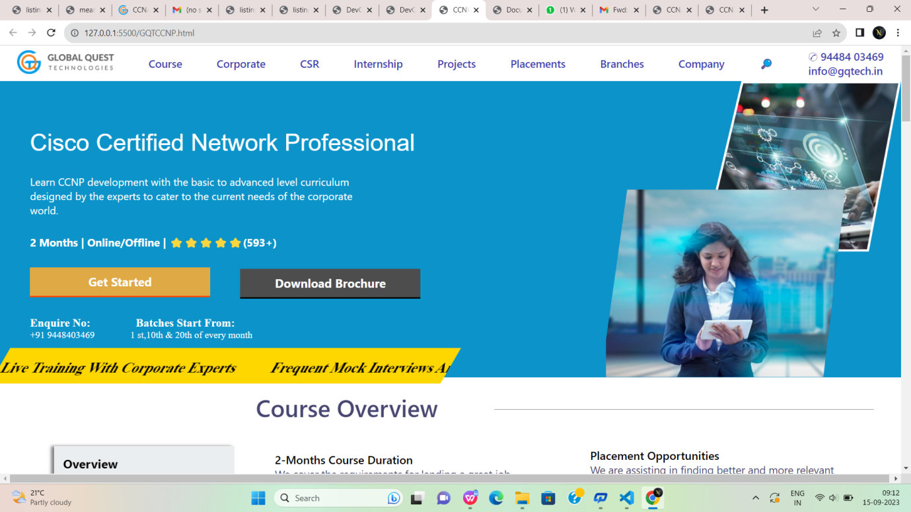

Fig:7

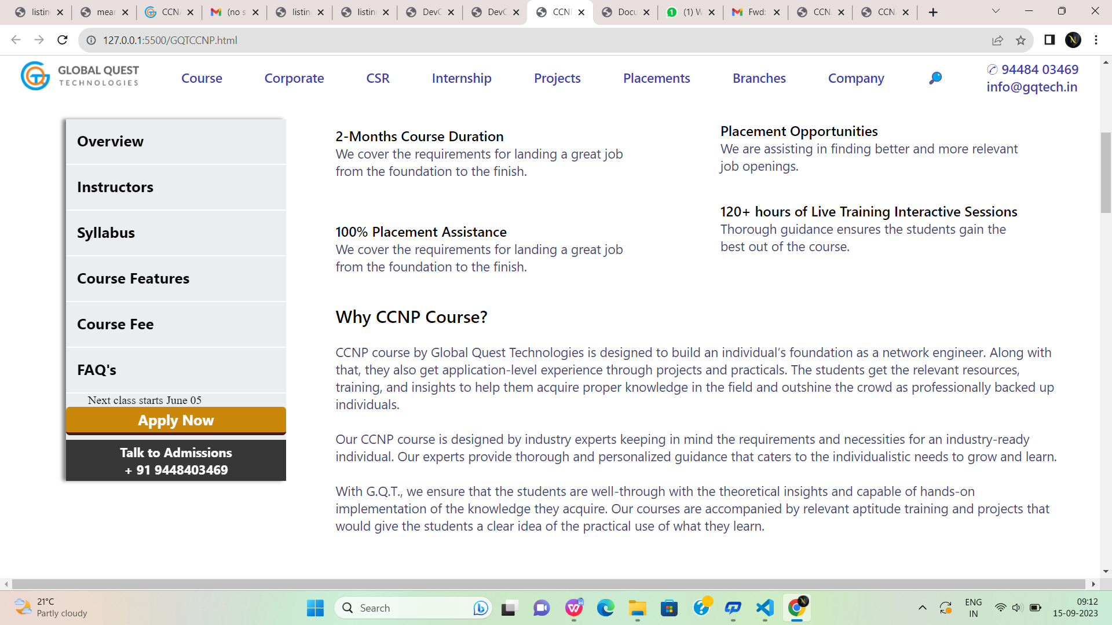

Fig:7.1

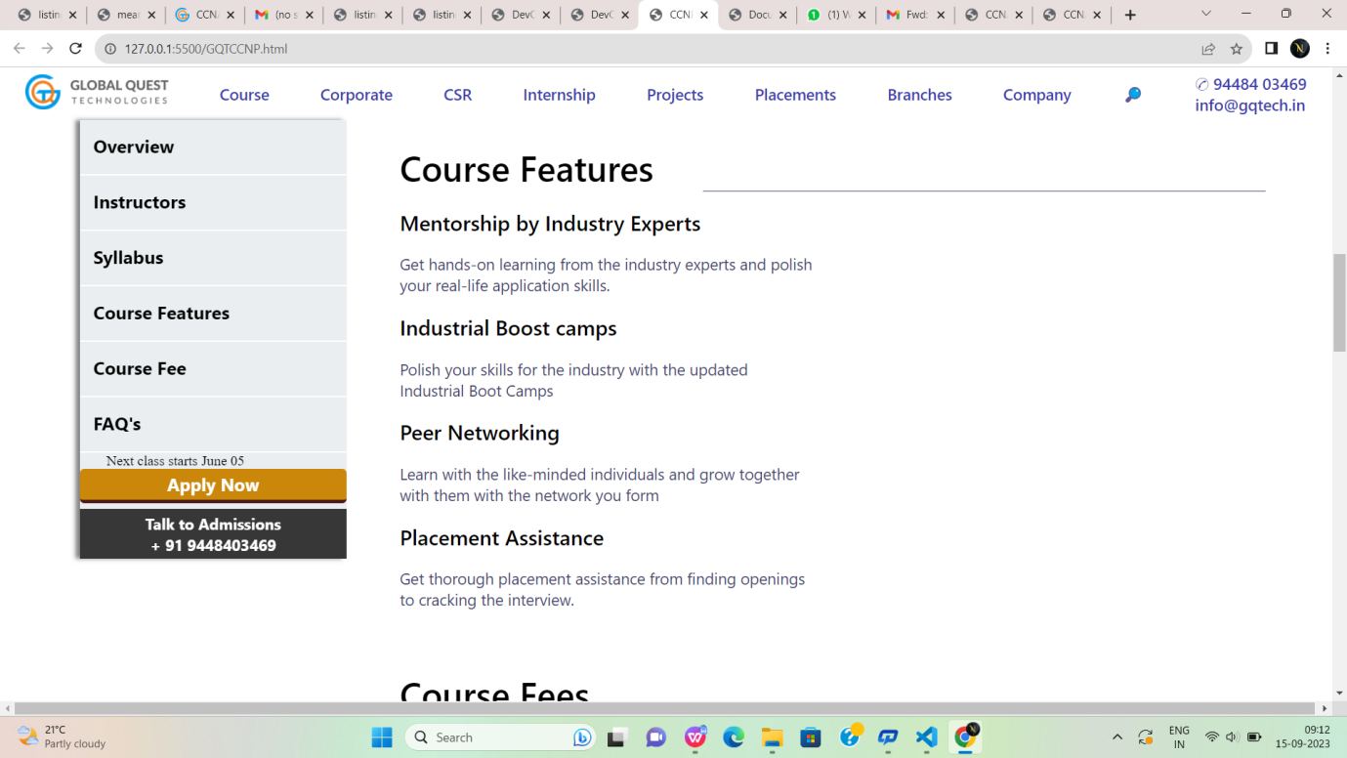

Fig:7.2

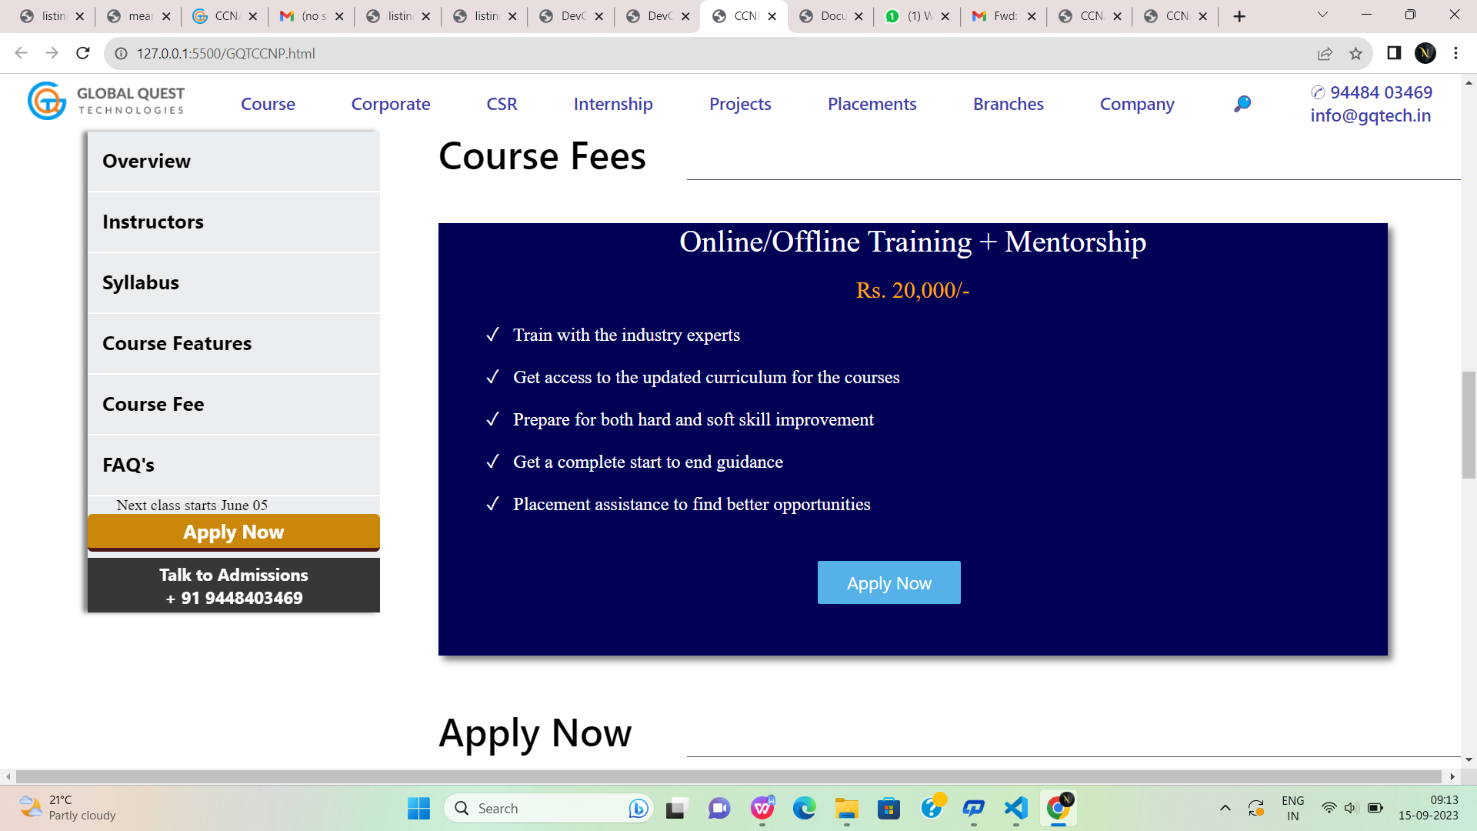

Fig:7.3

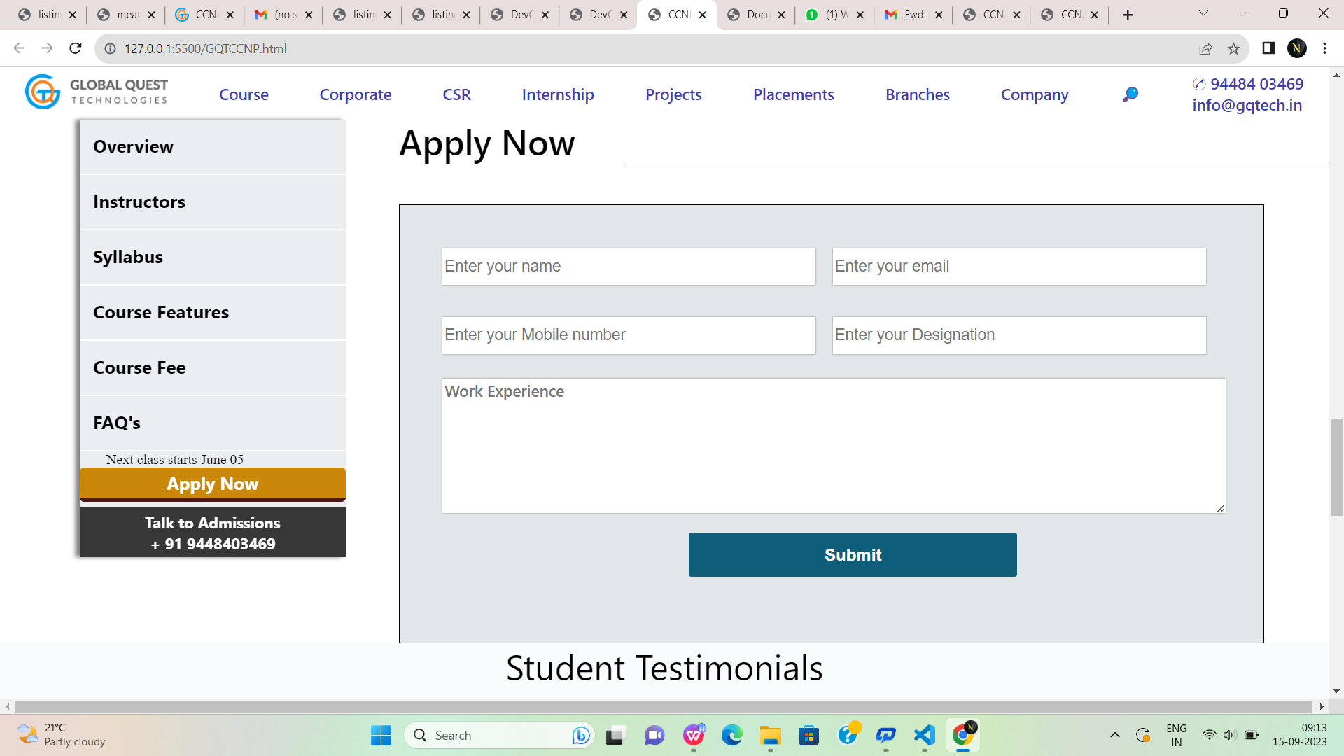

Fig:7.4

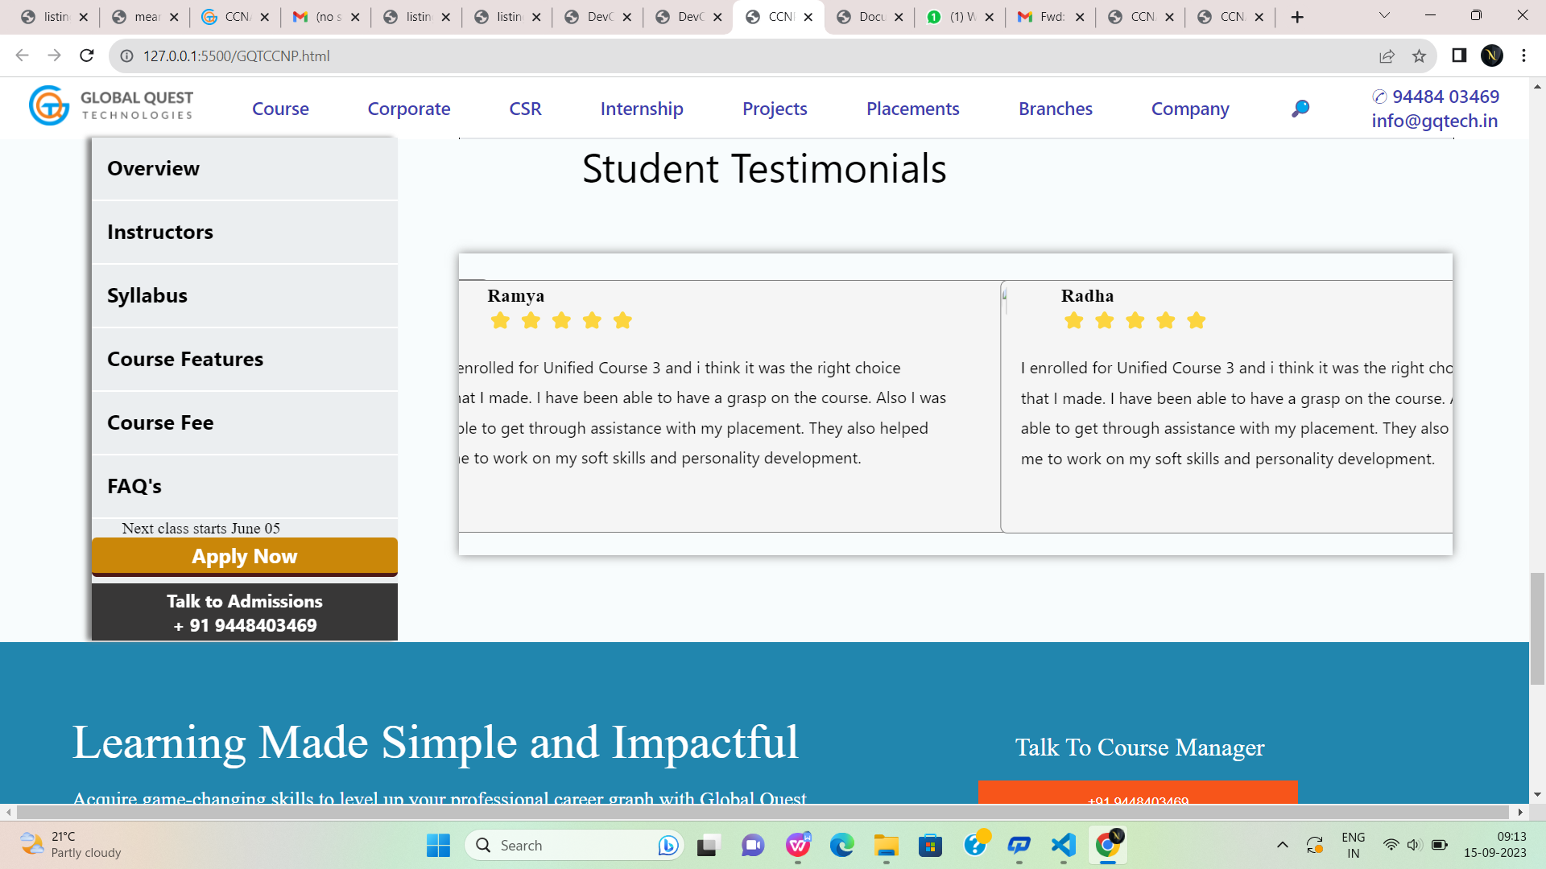

Fig:7.5

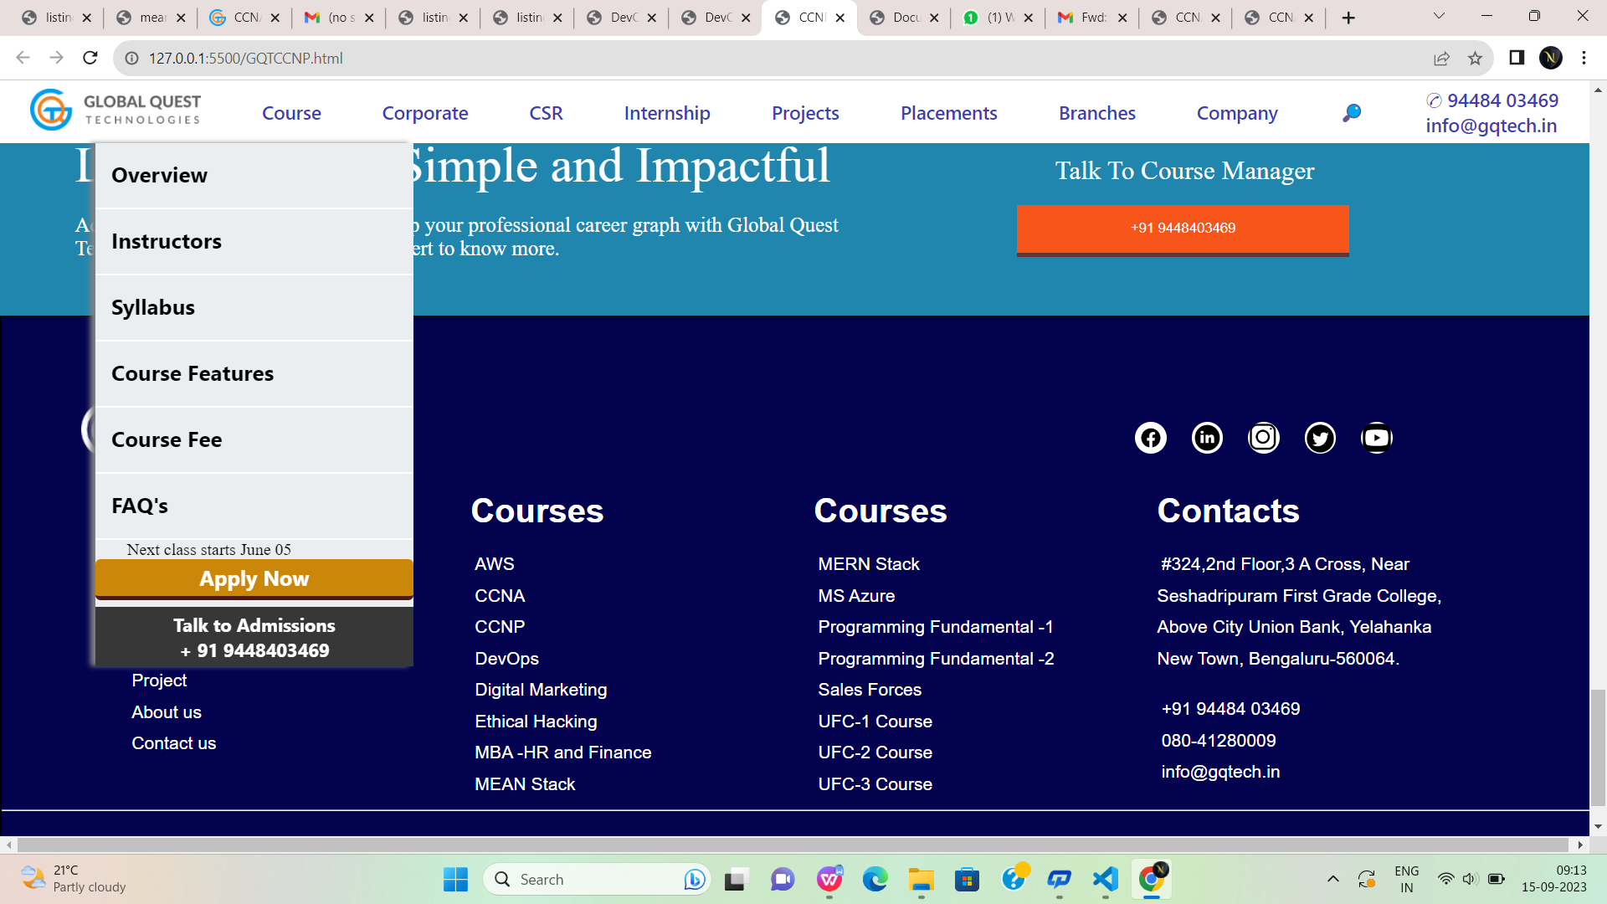

Fig:7.6

**GQTDevops.html:**

<!DOCTYPE html>

<html lang="en">

<head>

<meta charset="UTF-8">

<meta name="viewport" content="width=device-width, initial-scale=1.0">

<title>DevOps</title>

<link rel="stylesheet" href="meanstack.css">

</head>

<body>

<!--first div-->

<div id="div1">

<a href="#"><img style="height: 40px;" src="https://gqtech.in/wp-content/uploads/2022/04/cropped-GQT_Logo_H_.png"></a>

<a href="#">Course</a>

<a href="#">Corporate</a>

<a href="#">CSR</a>

<a href="#">Internship</a>

<a href="#">Projects</a>

<a href="#">Placements</a>

<a href="#">Branches</a>

<a href="#">Company</a>

<a href="#">&#x1F50E;</a>

<a href="#">&#9990; 94484 03469<br>

info@gqtech.in</a>

</div>

<!--second div-->

<div id="div2">

<div style="height:100%;width:80%;display:flex;flex-direction:column;">

<p style="margin-top:5%; margin-left:5%;margin-top:8%; font-family: 'Segoe UI', Tahoma,

Geneva, Verdana, sans-serif;font-size:250%;color:white;font-weight: 500;font-family: sans-serif;">

Development & Operations</p>

<p style="margin-top:3%; margin-left:5%; font-family:'Segoe UI', Tahoma, Geneva, Verdana, sansserif;font-size: 110%;color:white;">

Learn DevOPs with the basic to an advanced level curriculum designed by<br>

the experts to cater to the current needs of the corporate world.</p>

<p style="margin-top:3%; margin-left:5%; font-family:'Segoe UI', Tahoma, Geneva, Verdana,

sans-serif;font-size: 113%;color:white;font-weight:bold;">

2 Months | Online/Offline | ⭐⭐⭐⭐⭐(593+)</p>

<button id="button1">Get Started</button>

<button id="button2">Download Brochure</button>

<p style="margin-top:3%; margin-left:5%; color:white;font-size:medium;">

<a href="#" style="text-decoration: none;color:white;font-size: larger;font-weight:bold;">

Enquire

No:&nbsp;&nbsp;&nbsp;&nbsp;&nbsp;&nbsp;&nbsp;&nbsp;&nbsp;&nbsp;&nbsp;&nbsp;&nbsp;

&nbsp;&nbsp;Batches Start From:</a><br>+91 9448403469

&nbsp;&nbsp;&nbsp;&nbsp;&nbsp;&nbsp;&nbsp;&nbsp;&nbsp;&nbsp;&nbsp;&nbsp;&nbsp;&nbsp;1

st,10th & 20th of every month</p>

</div>

<div style="height:500px;width:40%;">

<img style="height:100%;width:100%;" src="https://gqtech.in/wp-content/uploads/2022/05/DevOps.png">

</div>

</div>

<div style="background-color: gold; height:60px;width:50%;transform:skew(-30deg);margin-left:-

50px;margin-top:-50px;"><marquee style="padding-top:20px;font-size:x-large;font-weight: bold;" >

Live Training With Corporate Experts

&nbsp;&nbsp; &nbsp;&nbsp; &nbsp;&nbsp;

Frequent Mock Interviews And Tests

&nbsp;&nbsp; &nbsp;&nbsp; &nbsp;&nbsp;

700+ Hiring Partners

&nbsp;&nbsp; &nbsp;&nbsp; &nbsp;&nbsp;

Curriculum Designed For Industrial Applications

</marquee>

</div>

<!--sticky div-->

<div id="stickydiv">

<a href="#">Overview</a>

<br>

<hr>

<a href="#">Instructors</a>

<br>

<hr>

<a href="#">Syllabus</a>

<br>

<hr>

<a href="#">Course Features</a>

<br>

<hr>

<a href="#">Course Fee</a>

<br>

<hr>

<a href="#">FAQ's</a>

<br>

<hr>

<p style="margin-left:10%;">Next class starts June 05</p>

<button id="button3">Apply Now</button>

<button style="margin-top: 2%;" id="button4">Talk to Admissions<br>

+ 91 9448403469</button>

</div>

<!--third div-->

<div id="div3">

<div style="display:flex;justify-content: space-between;">

<p style="margin-left:2%; color:rgb(70, 70, 112);font-size:250%;font-family:'Segoe UI', Tahoma,

Geneva, Verdana, sans-serif;font-weight:600;">

Course Overview</p>

<hr style="background-color:rgb(70, 70, 112); width:60%;height:0.2%;margin-top:2.8%;">

</div>

<div style="display:flex;flex-direction:column;width:50%;height:40%;">

<p style="margin-left:10%;margin-top:9%; font-weight:600;color:black;font-size: larger;font-family: 'Segoe UI', Tahoma, Geneva, Verdana, sans-serif;">

2-Months Course Duration</p>

<p style="margin-left:10%; color:rgb(70, 70, 112);font-size: large;font-family: 'Segoe UI', Tahoma,

Geneva, Verdana, sans-serif;">

We cover the requirements for landing a great job <br>from the foundation to the finish.</p><p style="margin-left:10%;margin-top:11%; font-weight:600;color:black;font-size: larger;font-family: 'Segoe UI', Tahoma, Geneva, Verdana, sans-serif;">

100% Placement Assistance</p>

<p style="margin-left:10%; color:rgb(70, 70, 112);font-size: large;font-family: 'Segoe UI',

Tahoma, Geneva, Verdana, sans-serif;">

We cover the requirements for landing a great job <br>from the foundation to the finish.</p>

</div>

<div style="margin-left:50%;margin-top:-40%; display:flex;flex-direction:column;width:50%;height:40%;">

<p style="margin-left:10%;margin-top:9%; font-weight:600;color:black;font-size: larger;font-family: 'Segoe UI', Tahoma, Geneva, Verdana, sans-serif;">

Placement Opportunities</p>

<p style="margin-left:10%; color:rgb(70, 70, 112);font-size: large;font-family: 'Segoe UI', Tahoma,

Geneva, Verdana, sans-serif;">

We are assisting in finding better and more relevant <br>job openings.</p>

<p style="margin-left:10%;margin-top:7%; font-weight:600;color:black;font-size: larger;font-family: 'Segoe UI', Tahoma, Geneva, Verdana, sans-serif;">

120+ hours of Live Training Interactive Sessions</p>

<p style="margin-left:10%; color:rgb(70, 70, 112);font-size: large;font-family: 'Segoe UI',

Tahoma, Geneva, Verdana, sans-serif;">

Thorough guidance ensures the students gain the<br> best out of the course.</p>

</div>

<div>

<p style="margin-left:5%; color:black;font-family: 'Segoe UI', Tahoma, Geneva, Verdana, sansserif;font-weight:500;font-size:x-large;">

Why DevOps Course?</p>

<p style="margin-left:5%;margin-top:2%; color:rgb(70, 70, 112); font-family: 'Segoe UI', Tahoma,

Geneva, Verdana, sans-serif;font-size:large;">

The DevOps course by Global Quest Technologies is designed to build the foundation of an individual as a DevOps professional and expert for various roles. Along with that, they also get application-level experience through projects and practicals. The students get the relevant resources, training, and insights to help them acquire proper knowledge in the field and outshine the crowd as professionally backed up individuals.<br><br>

Our DevOps course is designed by industry experts keeping in mind the requirements and necessities for an industry-ready individual. Our experts provide thorough and personalized guidance that caters to the individualistic needs to grow and learn.<br><br>

With G.Q.T., we ensure that the students are well-through with the theoretical insights and capable of hands-on implementation of the knowledge they acquire. Our courses are accompanied by relevant aptitude training and projects that would give the students a clear idea of the practical use of what they learn.

</p>

</div>

</div>

<br><br><br><br><br><br><br><br><br><br>

<!--course features-->

<div id="course">

<p style="font-family: 'Segoe UI', Tahoma, Geneva, Verdana, sans-serif;

font-size:40px;font-weight:500;color:black;">

Course Features</p>

<hr style="background-color:rgb(70, 70, 112); width:65%;height:0.05%;margin-top:-

3%;float:right;border:none;">

<p class="cls1">Mentorship by Industry Experts</p>

<p class="cls2">Get hands-on learning from the industry experts and polish <br> your real-life

application skills.</p>

<p class="cls1">Industrial Boost camps</p>

<p class="cls2">Polish your skills for the industry with the updated<br> Industrial Boot Camps</p>

<p class="cls1">Peer Networking</p><p class="cls2">Learn with the like-minded individuals and grow together<br> with them with the

network you form</p>

<p class="cls1">Placement Assistance</p>

<p class="cls2">Get thorough placement assistance from finding openings<br> to cracking the

interview.</p>

</div>

<!--course fees div-->

<div style="margin-top:-5%;height:600px;">

<p style="font-family: 'Segoe UI', Tahoma, Geneva, Verdana, sans-serif;

font-size:40px;font-weight:500;color:black;margin-left:30%;">Course Fees</p>

<hr style="background-color:rgb(70, 70, 112); width:53%;height:0.05%;margin-top:-

2%;float:right;border:none;">

<div style="box-shadow: 5px 5px 7px grey;

height:450px;width:65%;margin-left:30%;

margin-top:3%;background-color:rgb(0, 0, 85) ;color:white;">

<p style="font-size:xx-large;text-align: center;">Online/Offline Training + Mentorship</p>

<br>

<p style="font-size:x-large;color:orange;text-align:center;">Rs. 25,000/-</p>

<br>

<p style="font-size: larger;margin-left:5%;">&#x2713;&nbsp;&nbsp; Train with the industry

experts</p>

<br>

<p style="font-size: larger;margin-left:5%;">&#x2713;&nbsp;&nbsp; Get access to the updated

curriculum for the courses</p>

<br>

<p style="font-size: larger;margin-left:5%;">&#x2713;&nbsp;&nbsp; Prepare for both hard and soft

skill improvement</p>

<br>

<p style="font-size: larger;margin-left:5%;">&#x2713;&nbsp;&nbsp; Get a complete start to end

guidance</p>

<br>

<p style="font-size: larger;margin-left:5%;">&#x2713;&nbsp;&nbsp; Placement assistance to find

better opportunities</p>

<br>

<button style="height:10%;width:15%;margin-left:40%;margin-top:3%;

background-color: rgb(86, 177, 233);color:white;font-size:large;border-radius:2px;

font-family:'Segoe UI', Tahoma, Geneva, Verdana, sans-serif;border:none;">Apply Now</button>

</div>

</div>

<!--Apply now div-->

<div style="height:600px;">

<p style="font-family: 'Segoe UI', Tahoma, Geneva, Verdana, sans-serif;

font-size:40px;font-weight:500;color:black;margin-left:30%;">Apply Now</p>

<hr style="background-color:rgb(70, 70, 112); width:53%;height:0.05%;margin-top:-

2%;float:right;border:none;">

<div id="formdiv">

<div style="margin-top:5%;margin-left:5%;">

<form>

<input type="text" id="name" placeholder="Enter your name"

style="border:none;box-shadow:0px 0px 2px grey ; height:40px;width:45%;color:rgb(135,

135, 182);font-size:large;">

&nbsp;&nbsp;&nbsp;

<input type="email" id="name" placeholder="Enter your email"

style="border:none;box-shadow:0px 0px 2px grey ; height:40px;width:45%; color:rgb(135,

135, 182);font-size:large;">

<br><br><br><input type="tel" id="name" placeholder="Enter your Mobile number"

style="border:none;box-shadow:0px 0px 2px grey ; height:40px;width:45%;color:rgb(135,

135, 182);font-size:large;">

&nbsp;&nbsp;&nbsp;

<input type="text" id="name" placeholder="Enter your Designation"

style="border:none;box-shadow:0px 0px 2px grey ; height:40px;width:45%;color:rgb(135,

135, 182);font-size:large;">

<textarea rows="4" cols="50" placeholder="Work Experience"

style="border:none;box-shadow:0px 0px 2px grey ; height:150px;width:95%;font-size:18px;margin-top:3%;

font-weight:500; font-family:'Segoe UI', Tahoma, Geneva, Verdana, sans-serif;"></textarea>

<br><br>

<input type="submit" value="Submit" style="background-color:rgb(76, 172, 204);

height:50px;width:40%;border:none;color:white;font-size: larger;font-weight: 600;

border-radius: 3px;margin-left:30%;">

</form>

</div>

</div>

</div>

<!--students div-->

<div style="height:500px;background-color: rgb(248, 252, 253);">

<p style="font-family:'Segoe UI', Tahoma, Geneva, Verdana, sans-serif;font-size:40px;text-align:center;">Student Testimonials</p>

<!--parent div for student testimonial-->

<div style="height:300px;width:65%;margin-top:60px;margin-left:30%;overflow:hidden;box-shadow: 0px 0px 10px grey;">

<!--child div for student testimonial-->

<marquee>

<div style="border:1px solid grey; height:250px;width:64%;background-color:whitesmoke;border-radius:7px;margin-top:25px;">

<img style="height:40px;width:10%;border-radius:30px;" src="https://gqtech.in/wpcontent/uploads/2022/05/students4.jpg">

<h3 style="margin-left:60px;margin-top:-40px;">james<br>&#11088 &#11088 &#11088 &#11088

&#11088</h3>

<p style="font-family:'Segoe UI', Tahoma, Geneva, Verdana, sans-serif;line-height: 30px;font-size:

medium;margin-left:20px;margin-top:20px;">I enrolled for Unified Course 3 and i think it was the

right choice<br> that I made.

I have been able to have a grasp on the course.

Also I was<br> able to get through assistance with my placement.

They also helped<br> me to work on my soft skills and personality development.</p>

</div>

<div style="border:1px solid grey; margin-left:570px;margin-top:-251px;

height:250px;width:64%;background-color:whitesmoke;border-radius:7px;">

<img style="height:40px;width:10%;border-radius:30px;" src="https://gqtech.in/wpcontent/uploads/2022/05/students3.jpg">

<h3 style="margin-left:60px;margin-top:-40px;">Priyanka<br>&#11088 &#11088 &#11088

&#11088 &#11088</h3>

<p style="font-family:'Segoe UI', Tahoma, Geneva, Verdana, sans-serif;line-height: 30px;font-size: medium;margin-left:20px;margin-top:20px;">I enrolled for Unified Course 3 and i think it was

the right choice<br> that I made.

I have been able to have a grasp on the course.

Also I was<br> able to get through assistance with my placement.

They also helped<br> me to work on my soft skills and personality development.</p>

</div>

<div style="border:1px solid grey; margin-left:1140px;margin-top:-251px;

height:250px;width:64%;background-color:whitesmoke;border-radius:7px;"><img style="height:40px;width:10%;border-radius:30px;" src="https://gqtech.in/wpcontent/uploads/2022/05/students2.jpg">

<h3 style="margin-left:60px;margin-top:-40px;">Ramya<br>&#11088 &#11088 &#11088

&#11088 &#11088</h3>

<p style="font-family:'Segoe UI', Tahoma, Geneva, Verdana, sans-serif;line-height: 30px;font-size: medium;margin-left:20px;margin-top:20px;">I enrolled for Unified Course 3 and i think it was

the right choice<br> that I made.

I have been able to have a grasp on the course.

Also I was<br> able to get through assistance with my placement.

They also helped<br> me to work on my soft skills and personality development.</p>

</div>

<div style="border:1px solid grey; margin-left:1710px;margin-top:-251px;

height:250px;width:64%;background-color: whitesmoke; border-radius:7px;">

<img style="height:40px;width:10%;border-radius:30px;" src="https://gqtech.in/wpcontent/uploads/2022/05/students1.jpg">

<h3 style="margin-left:60px;margin-top:-40px;">Radha<br>&#11088 &#11088 &#11088

&#11088 &#11088</h3>

<p style="font-family:'Segoe UI', Tahoma, Geneva, Verdana, sans-serif;line-height: 30px;font-size: medium;margin-left:20px;margin-top:20px;">I enrolled for Unified Course 3 and i think it was

the right choice<br> that I made.

I have been able to have a grasp on the course.

Also I was<br> able to get through assistance with my placement.

They also helped<br> me to work on my soft skills and personality development.</p>

</div>

</marquee>

</div>

</div>

<!--course manager div-->

<div style="height:240px;background-color:skyblue;">

<h2 style="font-size:48px;color:white;padding-top:70px;padding-left:70px;font-weight:200;">Learning Made Simple and Impactful</h2>

<br>

<p style="padding-left:70px;font-size:20px;color:white;">Acquire game-changing skills to level up

your professional career graph with Global Quest <br>Technologies.

Get in touch with our expert to know more.</p>

<div style="height:70px;width:30%;margin-left:800px;margin-top:-100px;">

<p style="font-size:25px;color:white;text-align:right;">Talk To Course Manager</p><br>

<button id="button10" style="border:none;margin-left:134px;font-size:xlarge;height:50px;width:70%;background-color: rgb(247, 85, 26);color:white;

border-bottom:4px solid rgb(95, 55, 55);">+91 9448403469</button>

</div>

</div>

<!--last footer div-->

<div id="p1">

<img id="p2" src="https://gqtech.in/wp-content/uploads/2022/04/GQT_Logo_H_@2x.png">

<div id="p3">

<img class="z" src="https://encrypted-tbn0.gstatic.com/images?q=tbn:ANd9GcS9QIwGkz33neLbjfP6seN6ycBchzciwXS_KQ&usqp=CAU">

<img class="z" src="https://encrypted-tbn0.gstatic.com/images?q=tbn:ANd9GcS7bVv7wzhQtvTMoZPTJkYcIrN-EFfbQiCPFg&usqp=CAU">

<img class="z" src="https://encrypted-tbn0.gstatic.com/images?q=tbn:ANd9GcTFcnDLO5SGDO2_G_iygk8dxEQAS2c0cVXXEQ&usqp=CAU" >

<img class="z" src="https://encrypted-tbn0.gstatic.com/images?q=tbn:ANd9GcTnKjujHfPrr6WD2lrbzkCBwmzPIKTj02_BJg&usqp=CAU">

<img class="z" src="https://encrypted-tbn0.gstatic.com/images?q=tbn:ANd9GcTVJeTWM--_ulJr2AdOEQ7WyrAfx3qFmdv7ZQ&usqp=CAU">

</div>

<div style="width: 90%;height: 330px;margin-left: 7%;display: flex;">

<div class="u" style="margin-left: 1%;">

<h1 style="color: white;font-family: sans-serif;font-size: x-large;">Quick Links</h1>

<br>

<a href=""class="g" > Home</a><br>

<a href="" class="g">CSR</a><br>

<a href="" class="g">Placements</a><br>

<a href="" class="g">Internship</a><br>

<a href="" class="g">Project</a><br>

<a href=""class="g">About us</a><br>

<a href="" class="g">Contact us</a>

</div>

<div class="u">

<h1 style="color: white;font-family: sans-serif;font-size: xx-large;">Courses</h1>

<br>

<a href=""class="g" > AWS</a><br>

<a href="" class="g">CCNA</a><br>

<a href="" class="g">CCNP</a><br>

<a href="" class="g">DevOps</a><br>

<a href="" class="g">Digital Marketing</a><br>

<a href=""class="g">Ethical Hacking</a><br>

<a href="" class="g">MBA -HR and Finance</a><br>

<a href="" class="g">MEAN Stack</a>

</div>

<div class="u">

<h1 style="color: white;font-family: sans-serif;font-size: xx-large;">Courses</h1>

<br>

<a href=""class="g" >MERN Stack </a><br>

<a href="" class="g">MS Azure</a><br>

<a href="" class="g">Programming Fundamental -1</a><br>

<a href="" class="g">Programming Fundamental -2</a><br>

<a href="" class="g">Sales Forces</a><br>

<a href=""class="g">UFC-1 Course</a><br>

<a href="" class="g">UFC-2 Course</a><br>

<a href="" class="g">UFC-3 Course</a>

</div>

<div class="u">

<h1 style="color: white;font-family: sans-serif;font-size: xx-large;">Contacts</h1>

<br>

<a href="" class="g">#324,2nd Floor,3 A Cross, Near Seshadripuram First Grade College, Above City Union Bank, Yelahanka New Town, Bengaluru-560064.</a><br><br>

<a href="" class="g">+91 94484 03469</a><br>

<a href="" class="g">080-41280009</a><br>

<a href="" class="g">info@gqtech.in</a><br>

</div>

</div>

<hr>

<h1 style="color: white;font-family: sans-serif;font-size: small;margin-left: 29%;margin-top: 30px;">GQT | Copyright © 2022 Global Quest Technologies, Training & Placements. All Rights Reserved.</h1>

</div>

</body>

</html>

**Output:**

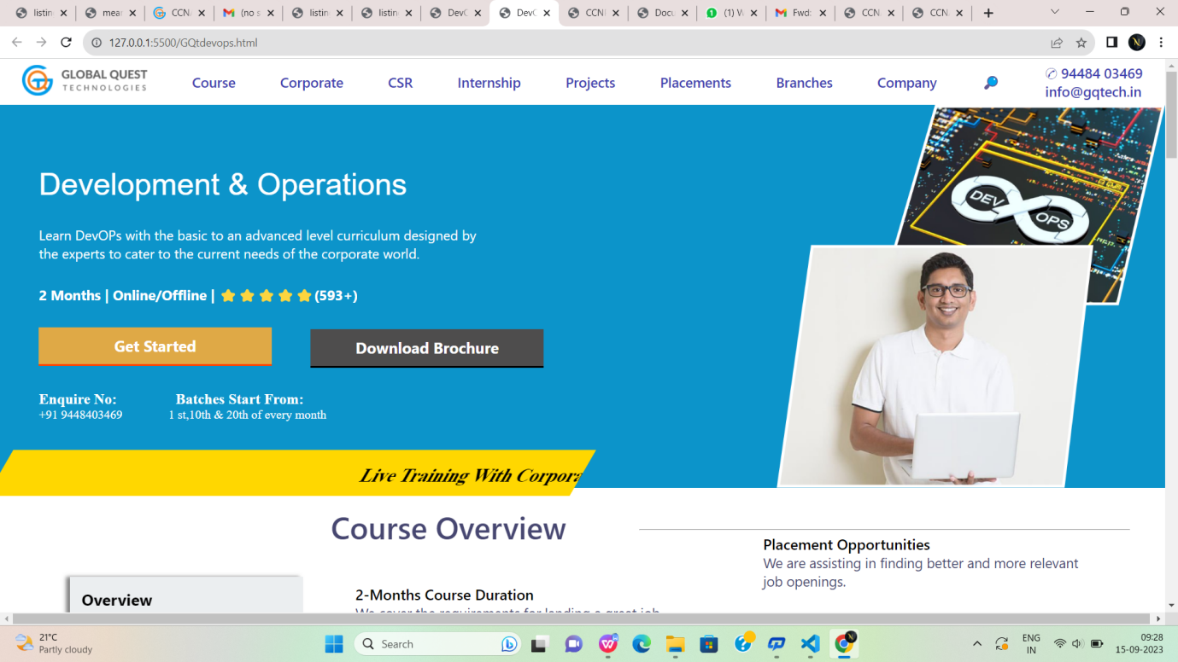

Fig:8

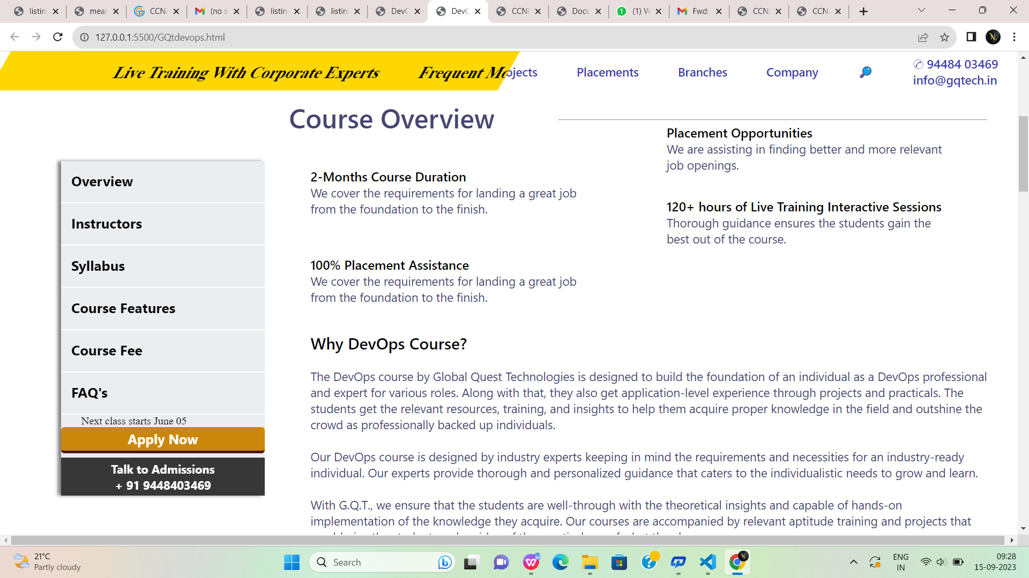

Fig:8.1

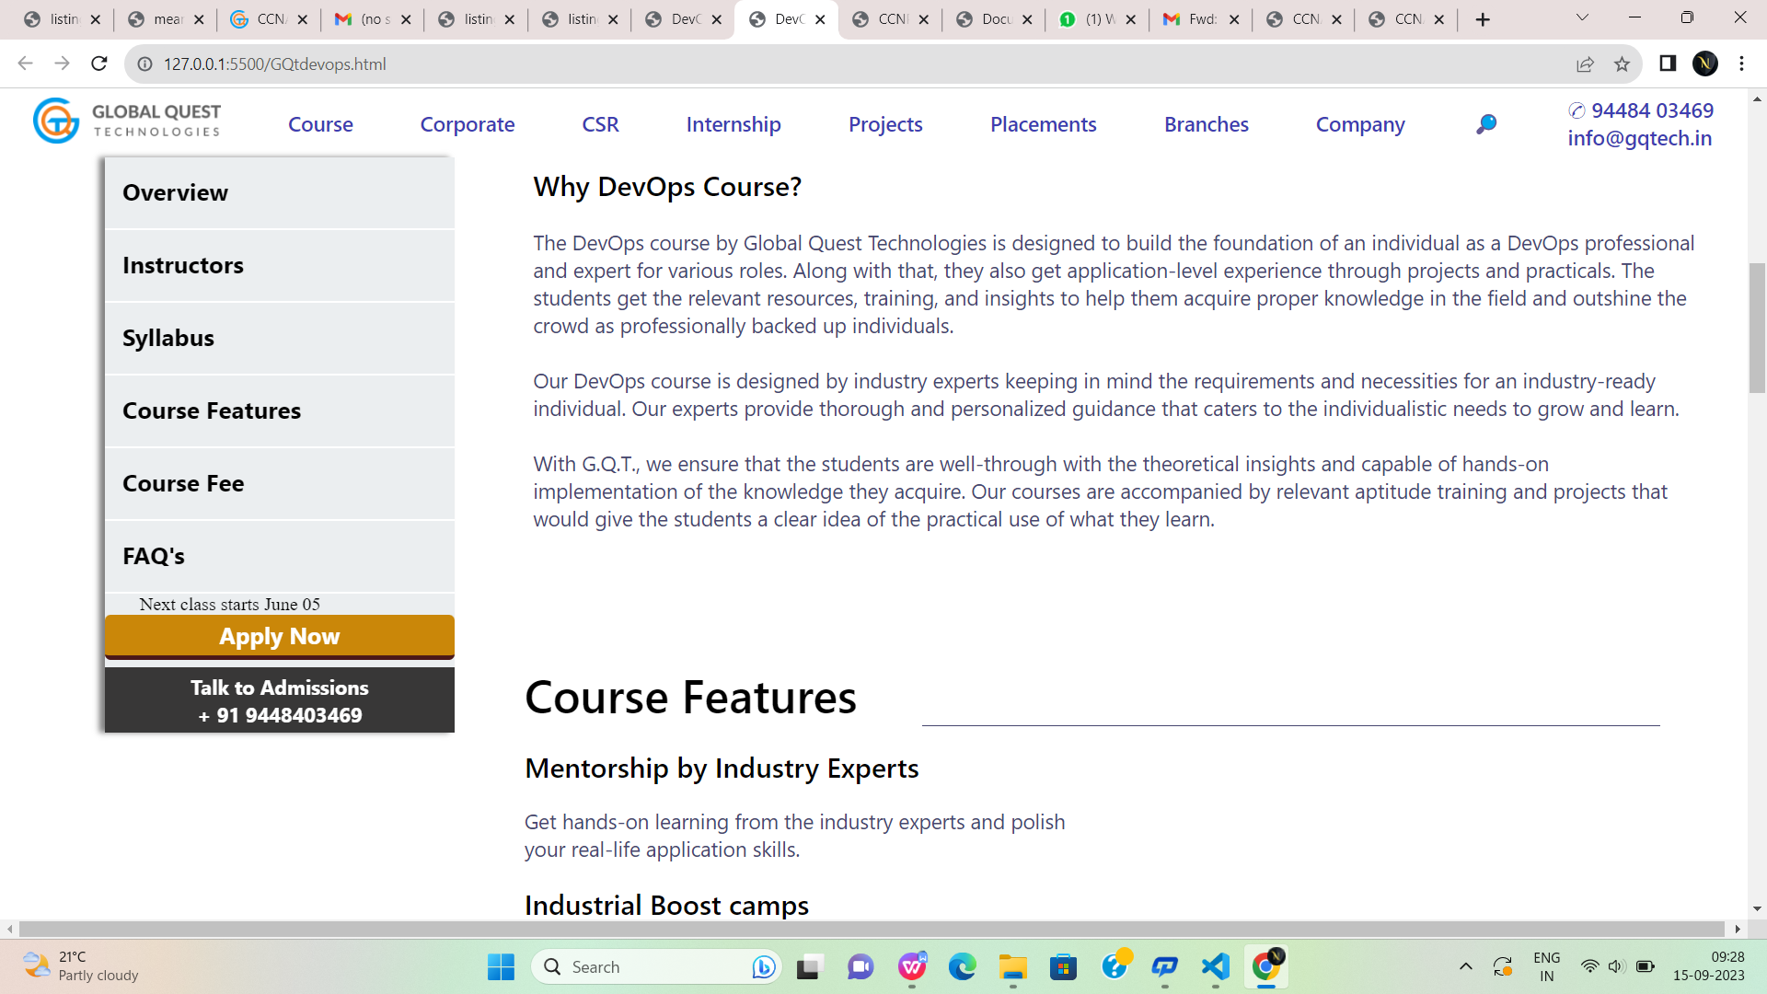

Fig:8.2

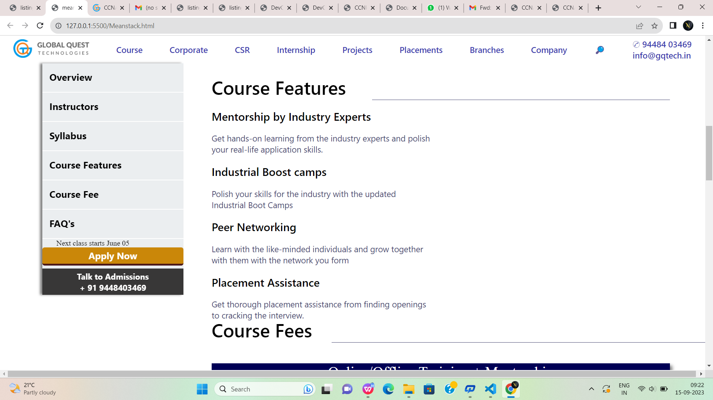

Fig:8.3



Fig:8.4



Fig:8.5



Fig:8.6



Fig:8.7

**Meanstack.html:**

<!DOCTYPE html>

<html lang="en">

<head>

<meta charset="UTF-8">

<meta name="viewport" content="width=device-width, initial-scale=1.0">

<title>CCNP</title>

<link rel="stylesheet" href="meanstack.css">

</head>

<body>

<!--first div-->

<div id="div1">

<a href="#"><img style="height: 40px;" src="https://gqtech.in/wp-content/uploads/2022/04/cropped-GQT_Logo_H_.png"></a>

<a href="#">Course</a>

<a href="#">Corporate</a>

<a href="#">CSR</a>

<a href="#">Internship</a>

<a href="#">Projects</a>

<a href="#">Placements</a>

<a href="#">Branches</a>

<a href="#">Company</a>

<a href="#">&#x1F50E;</a>

<a href="#">&#9990; 94484 03469<br>

info@gqtech.in</a>

</div>

<!--second div-->

<div id="div2">

<div style="height:100%;width:80%;display:flex;flex-direction:column;">

<p style="margin-top:5%; margin-left:5%;margin-top:8%; font-family: 'Segoe UI', Tahoma,

Geneva, Verdana, sans-serif;font-size:250%;color:white;font-weight: 500;font-family: sans-serif;">

Cisco Certified Network Professional</p>

<p style="margin-top:3%; margin-left:5%; font-family:'Segoe UI', Tahoma, Geneva, Verdana, sansserif;font-size: 110%;color:white;">

Learn CCNP development with the basic to advanced level curriculum <br>designed by the experts to cater to the current needs of the corporate<br> world.</p>

<p style="margin-top:3%; margin-left:5%; font-family:'Segoe UI', Tahoma, Geneva, Verdana,

sans-serif;font-size: 113%;color:white;font-weight:bold;">

2 Months | Online/Offline | ⭐⭐⭐⭐⭐(593+)</p>

<button id="button1">Get Started</button>

<button id="button2">Download Brochure</button>

<p style="margin-top:3%; margin-left:5%; color:white;font-size:medium;">

<a href="#" style="text-decoration: none;color:white;font-size: larger;font-weight:bold;">

Enquire

No:&nbsp;&nbsp;&nbsp;&nbsp;&nbsp;&nbsp;&nbsp;&nbsp;&nbsp;&nbsp;&nbsp;&nbsp;&nbsp;

&nbsp;&nbsp;Batches Start From:</a><br>+91 9448403469

&nbsp;&nbsp;&nbsp;&nbsp;&nbsp;&nbsp;&nbsp;&nbsp;&nbsp;&nbsp;&nbsp;&nbsp;&nbsp;&nbsp;1

st,10th & 20th of every month</p>

</div>

<div style="height:500px;width:40%;">

<img style="height:100%;width:100%;" src="https://gqtech.in/wp-content/uploads/2022/05/CCNP.png">

</div>

</div>

<div style="background-color: gold; height:60px;width:50%;transform:skew(-30deg);margin-left:-

50px;margin-top:-50px;"><marquee style="padding-top:20px;font-size:x-large;font-weight: bold;" >

Live Training With Corporate Experts

&nbsp;&nbsp; &nbsp;&nbsp; &nbsp;&nbsp;

Frequent Mock Interviews And Tests

&nbsp;&nbsp; &nbsp;&nbsp; &nbsp;&nbsp;

700+ Hiring Partners

&nbsp;&nbsp; &nbsp;&nbsp; &nbsp;&nbsp;

Curriculum Designed For Industrial Applications

</marquee>

</div>

<!--sticky div-->

<div id="stickydiv">

<a href="#">Overview</a>

<br>

<hr>

<a href="#">Instructors</a>

<br>

<hr>

<a href="#">Syllabus</a>

<br>

<hr>

<a href="#">Course Features</a>

<br>

<hr>

<a href="#">Course Fee</a>

<br>

<hr>

<a href="#">FAQ's</a>

<br>

<hr>

<p style="margin-left:10%;">Next class starts June 05</p>

<button id="button3">Apply Now</button>

<button style="margin-top: 2%;" id="button4">Talk to Admissions<br>

+ 91 9448403469</button>

</div>

<!--third div-->

<div id="div3">

<div style="display:flex;justify-content: space-between;">

<p style="margin-left:2%; color:rgb(70, 70, 112);font-size:250%;font-family:'Segoe UI', Tahoma,

Geneva, Verdana, sans-serif;font-weight:600;">

Course Overview</p>

<hr style="background-color:rgb(70, 70, 112); width:60%;height:0.2%;margin-top:2.8%;">

</div>

<div style="display:flex;flex-direction:column;width:50%;height:40%;">

<p style="margin-left:10%;margin-top:9%; font-weight:600;color:black;font-size: larger;font-family: 'Segoe UI', Tahoma, Geneva, Verdana, sans-serif;">

2-Months Course Duration</p>

<p style="margin-left:10%; color:rgb(70, 70, 112);font-size: large;font-family: 'Segoe UI', Tahoma,

Geneva, Verdana, sans-serif;">

We cover the requirements for landing a great job <br>from the foundation to the finish.</p><p style="margin-left:10%;margin-top:11%; font-weight:600;color:black;font-size: larger;font-family: 'Segoe UI', Tahoma, Geneva, Verdana, sans-serif;">

100% Placement Assistance</p>

<p style="margin-left:10%; color:rgb(70, 70, 112);font-size: large;font-family: 'Segoe UI',

Tahoma, Geneva, Verdana, sans-serif;">

We cover the requirements for landing a great job <br>from the foundation to the finish.</p>

</div>

<div style="margin-left:50%;margin-top:-40%; display:flex;flex-direction:column;width:50%;height:40%;">

<p style="margin-left:10%;margin-top:20%; font-weight:600;color:black;font-size: larger;font-family: 'Segoe UI', Tahoma, Geneva, Verdana, sans-serif;">

Placement Opportunities</p>

<p style="margin-left:10%; color:rgb(70, 70, 112);font-size: large;font-family: 'Segoe UI', Tahoma,

Geneva, Verdana, sans-serif;">

We are assisting in finding better and more relevant <br>job openings.</p>

<p style="margin-left:10%;margin-top:7%; font-weight:600;color:black;font-size: larger;font-family: 'Segoe UI', Tahoma, Geneva, Verdana, sans-serif;">

120+ hours of Live Training Interactive Sessions</p>

<p style="margin-left:10%; color:rgb(70, 70, 112);font-size: large;font-family: 'Segoe UI',

Tahoma, Geneva, Verdana, sans-serif;">

Thorough guidance ensures the students gain the<br> best out of the course.</p>

</div>

<div>

<p style="margin-left:5%; color:black;font-family: 'Segoe UI', Tahoma, Geneva, Verdana, sansserif;font-weight:500;font-size:x-large;">

Why CCNP Course?</p>

<p style="margin-left:5%;margin-top:2%; color:rgb(70, 70, 112); font-family: 'Segoe UI', Tahoma,

Geneva, Verdana, sans-serif;font-size:large;">

CCNP course by Global Quest Technologies is designed to build an individual’s foundation as a network engineer. Along with that, they also get application-level experience through projects and practicals. The students get the relevant resources, training, and insights to help them acquire proper knowledge in the field and outshine the crowd as professionally backed up individuals.<br><br>

Our CCNP course is designed by industry experts keeping in mind the requirements and necessities for an industry-ready individual. Our experts provide thorough and personalized guidance that caters to the individualistic needs to grow and learn.<br><br>

With G.Q.T., we ensure that the students are well-through with the theoretical insights and capable of hands-on implementation of the knowledge they acquire. Our courses are accompanied by relevant aptitude training and projects that would give the students a clear idea of the practical use of what they learn.

</p>

</div>

</div>

<br><br><br><br><br><br><br><br><br><br>

<!--course features-->

<div id="course">

<p style="font-family: 'Segoe UI', Tahoma, Geneva, Verdana, sans-serif;

font-size:40px;font-weight:500;color:black;">

Course Features</p>

<hr style="background-color:rgb(70, 70, 112); width:65%;height:0.05%;margin-top:-

3%;float:right;border:none;">

<p class="cls1">Mentorship by Industry Experts</p>

<p class="cls2">Get hands-on learning from the industry experts and polish <br> your real-life

application skills.</p>

<p class="cls1">Industrial Boost camps</p>

<p class="cls2">Polish your skills for the industry with the updated<br> Industrial Boot Camps</p>

<p class="cls1">Peer Networking</p><p class="cls2">Learn with the like-minded individuals and grow together<br> with them with the

network you form</p>

<p class="cls1">Placement Assistance</p>

<p class="cls2">Get thorough placement assistance from finding openings<br> to cracking the

interview.</p>

</div>

<!--course fees div-->

<div style="margin-top:-5%;height:600px;">

<p style="font-family: 'Segoe UI', Tahoma, Geneva, Verdana, sans-serif;

font-size:40px;font-weight:500;color:black;margin-left:30%;margin-top: 5%;">Course Fees</p>

<hr style="background-color:rgb(70, 70, 112); width:53%;height:0.05%;margin-top:-

10%;float:right;border:none;">

<div style="box-shadow: 5px 5px 7px grey;

height:450px;width:65%;margin-left:30%;

margin-top:3%;background-color:rgb(0, 0, 85) ;color:white;">

<p style="font-size:xx-large;text-align: center;">Online/Offline Training + Mentorship</p>

<br>

<p style="font-size:x-large;color:orange;text-align:center;">Rs. 20,000/-</p>

<br>

<p style="font-size: larger;margin-left:5%;">&#x2713;&nbsp;&nbsp; Train with the industry

experts</p>

<br>

<p style="font-size: larger;margin-left:5%;">&#x2713;&nbsp;&nbsp; Get access to the updated

curriculum for the courses</p>

<br>

<p style="font-size: larger;margin-left:5%;">&#x2713;&nbsp;&nbsp; Prepare for both hard and soft

skill improvement</p>

<br>

<p style="font-size: larger;margin-left:5%;">&#x2713;&nbsp;&nbsp; Get a complete start to end

guidance</p>

<br>

<p style="font-size: larger;margin-left:5%;">&#x2713;&nbsp;&nbsp; Placement assistance to find

better opportunities</p>

<br>

<button style="height:10%;width:15%;margin-left:40%;margin-top:3%;

background-color: rgb(86, 177, 233);color:white;font-size:large;border-radius:2px;

font-family:'Segoe UI', Tahoma, Geneva, Verdana, sans-serif;border:none;">Apply Now</button>

</div>

</div>

<!--Apply now div-->

<div style="height:600px;">

<p style="font-family: 'Segoe UI', Tahoma, Geneva, Verdana, sans-serif;

font-size:40px;font-weight:500;color:black;margin-left:30%;">Apply Now</p>

<hr style="background-color:rgb(70, 70, 112); width:53%;height:0.05%;margin-top:-

2%;float:right;border:none;">

<div id="formdiv">

<div style="margin-top:5%;margin-left:5%;">

<form>

<input type="text" id="name" placeholder="Enter your name"

style="border:none;box-shadow:0px 0px 2px grey ; height:40px;width:45%;color:rgb(135,

135, 182);font-size:large;">

&nbsp;&nbsp;&nbsp;

<input type="email" id="name" placeholder="Enter your email"

style="border:none;box-shadow:0px 0px 2px grey ; height:40px;width:45%; color:rgb(135,

135, 182);font-size:large;">

<br><br><br><input type="tel" id="name" placeholder="Enter your Mobile number"

style="border:none;box-shadow:0px 0px 2px grey ; height:40px;width:45%;color:rgb(135,

135, 182);font-size:large;">

&nbsp;&nbsp;&nbsp;

<input type="text" id="name" placeholder="Enter your Designation"

style="border:none;box-shadow:0px 0px 2px grey ; height:40px;width:45%;color:rgb(135,

135, 182);font-size:large;">

<textarea rows="4" cols="50" placeholder="Work Experience"

style="border:none;box-shadow:0px 0px 2px grey ; height:150px;width:95%;font-size:18px;margin-top:3%;

font-weight:500; font-family:'Segoe UI', Tahoma, Geneva, Verdana, sans-serif;"></textarea>

<br><br>

<input type="submit" value="Submit" style="background-color:rgb(15, 94, 121);

height:50px;width:40%;border:none;color:white;font-size: larger;font-weight: 600;

border-radius: 3px;margin-left:30%;">

</form>

</div>

</div>

</div>

<!--students div-->

<div style="height:500px;background-color: rgb(248, 252, 253);">

<p style="font-family:'Segoe UI', Tahoma, Geneva, Verdana, sans-serif;font-size:40px;text-align:center;">Student Testimonials</p>

<!--parent div for student testimonial-->

<div style="height:300px;width:65%;margin-top:60px;margin-left:30%;overflow:hidden;box-shadow: 0px 0px 10px grey;">

<!--child div for student testimonial-->

<marquee>

<div style="border:1px solid grey; height:250px;width:64%;background-color:whitesmoke;border-radius:7px;margin-top:25px;">

<img style="height:40px;width:10%;border-radius:30px;" src="https://gqtech.in/wpcontent/uploads/2022/05/students4.jpg">

<h3 style="margin-left:60px;margin-top:-40px;">james<br>&#11088 &#11088 &#11088 &#11088

&#11088</h3>

<p style="font-family:'Segoe UI', Tahoma, Geneva, Verdana, sans-serif;line-height: 30px;font-size:

medium;margin-left:20px;margin-top:20px;">I enrolled for Unified Course 3 and i think it was the

right choice<br> that I made.

I have been able to have a grasp on the course.

Also I was<br> able to get through assistance with my placement.

They also helped<br> me to work on my soft skills and personality development.</p>

</div>

<div style="border:1px solid grey; margin-left:570px;margin-top:-251px;

height:250px;width:64%;background-color:whitesmoke;border-radius:7px;">

<img style="height:40px;width:10%;border-radius:30px;" src="https://gqtech.in/wpcontent/uploads/2022/05/students3.jpg">

<h3 style="margin-left:60px;margin-top:-40px;">Priyanka<br>&#11088 &#11088 &#11088

&#11088 &#11088</h3>

<p style="font-family:'Segoe UI', Tahoma, Geneva, Verdana, sans-serif;line-height: 30px;font-size: medium;margin-left:20px;margin-top:20px;">I enrolled for Unified Course 3 and i think it was

the right choice<br> that I made.

I have been able to have a grasp on the course.

Also I was<br> able to get through assistance with my placement.

They also helped<br> me to work on my soft skills and personality development.</p>

</div>

<div style="border:1px solid grey; margin-left:1140px;margin-top:-251px;

height:250px;width:64%;background-color:whitesmoke;border-radius:7px;"><img style="height:40px;width:10%;border-radius:30px;" src="https://gqtech.in/wpcontent/uploads/2022/05/students2.jpg">

<h3 style="margin-left:60px;margin-top:-40px;">Ramya<br>&#11088 &#11088 &#11088

&#11088 &#11088</h3>

<p style="font-family:'Segoe UI', Tahoma, Geneva, Verdana, sans-serif;line-height: 30px;font-size: medium;margin-left:20px;margin-top:20px;">I enrolled for Unified Course 3 and i think it was

the right choice<br> that I made.

I have been able to have a grasp on the course.

Also I was<br> able to get through assistance with my placement.

They also helped<br> me to work on my soft skills and personality development.</p>

</div>

<div style="border:1px solid grey; margin-left:1710px;margin-top:-251px;

height:250px;width:64%;background-color: whitesmoke; border-radius:7px;">

<img style="height:40px;width:10%;border-radius:30px;" src="https://gqtech.in/wpcontent/uploads/2022/05/students1.jpg">

<h3 style="margin-left:60px;margin-top:-40px;">Radha<br>&#11088 &#11088 &#11088

&#11088 &#11088</h3>

<p style="font-family:'Segoe UI', Tahoma, Geneva, Verdana, sans-serif;line-height: 30px;font-size: medium;margin-left:20px;margin-top:20px;">I enrolled for Unified Course 3 and i think it was

the right choice<br> that I made.

I have been able to have a grasp on the course.

Also I was<br> able to get through assistance with my placement.

They also helped<br> me to work on my soft skills and personality development.</p>

</div>

</marquee>

</div>

</div>

<!--course manager div-->

<div style="height:240px;background-color:rgb(33, 134, 174);border: 2px solid rgb(33, 134, 174);">

<h2 style="font-size:48px;color:white;padding-top:70px;padding-left:70px;font-weight:200;">Learning Made Simple and Impactful</h2>

<br>

<p style="padding-left:70px;font-size:20px;color:white;">Acquire game-changing skills to level up

your professional career graph with Global Quest <br>Technologies.

Get in touch with our expert to know more.</p>

<div style="height:70px;width:30%;margin-left:800px;margin-top:-100px;">

<p style="font-size:25px;color:white;text-align:right;">Talk To Course Manager</p><br>

<button id="button10" style="border:none;margin-left:170px;font-size:xlarge;height:50px;width:70%;background-color: rgb(247, 85, 26);color:white;

border-bottom:4px solid rgb(95, 55, 55);">+91 9448403469</button>

</div>

</div>

<!--last footer div-->

<div id="p1">

<img id="p2" src="https://gqtech.in/wp-content/uploads/2022/04/GQT_Logo_H_@2x.png">

<div id="p3">

<img class="z" src="https://encrypted-tbn0.gstatic.com/images?q=tbn:ANd9GcS9QIwGkz33neLbjfP6seN6ycBchzciwXS_KQ&usqp=CAU">

<img class="z" src="https://encrypted-tbn0.gstatic.com/images?q=tbn:ANd9GcS7bVv7wzhQtvTMoZPTJkYcIrN-EFfbQiCPFg&usqp=CAU">

<img class="z" src="https://encrypted-tbn0.gstatic.com/images?q=tbn:ANd9GcTFcnDLO5SGDO2_G_iygk8dxEQAS2c0cVXXEQ&usqp=CAU" >

<img class="z" src="https://encrypted-tbn0.gstatic.com/images?q=tbn:ANd9GcTnKjujHfPrr6WD2lrbzkCBwmzPIKTj02_BJg&usqp=CAU">

<img class="z" src="https://encrypted-tbn0.gstatic.com/images?q=tbn:ANd9GcTVJeTWM--_ulJr2AdOEQ7WyrAfx3qFmdv7ZQ&usqp=CAU">

</div>

<div style="width: 90%;height: 330px;margin-left: 7%;display: flex;">

<div class="u" style="margin-left: 1%;">

<h1 style="color: white;font-family: sans-serif;font-size: x-large;">Quick Links</h1>

<br>

<a href=""class="g" > Home</a><br>

<a href="" class="g">CSR</a><br>

<a href="" class="g">Placements</a><br>

<a href="" class="g">Internship</a><br>

<a href="" class="g">Project</a><br>

<a href=""class="g">About us</a><br>

<a href="" class="g">Contact us</a>

</div>

<div class="u">

<h1 style="color: white;font-family: sans-serif;font-size: xx-large;">Courses</h1>

<br>

<a href=""class="g" > AWS</a><br>

<a href="" class="g">CCNA</a><br>

<a href="" class="g">CCNP</a><br>

<a href="" class="g">DevOps</a><br>

<a href="" class="g">Digital Marketing</a><br>

<a href=""class="g">Ethical Hacking</a><br>

<a href="" class="g">MBA -HR and Finance</a><br>

<a href="" class="g">MEAN Stack</a>

</div>

<div class="u">

<h1 style="color: white;font-family: sans-serif;font-size: xx-large;">Courses</h1>

<br>

<a href=""class="g" >MERN Stack </a><br>

<a href="" class="g">MS Azure</a><br>

<a href="" class="g">Programming Fundamental -1</a><br>

<a href="" class="g">Programming Fundamental -2</a><br>

<a href="" class="g">Sales Forces</a><br>

<a href=""class="g">UFC-1 Course</a><br>

<a href="" class="g">UFC-2 Course</a><br>

<a href="" class="g">UFC-3 Course</a>

</div>

<div class="u">

<h1 style="color: white;font-family: sans-serif;font-size: xx-large;">Contacts</h1>

<br>

<a href="" class="g">#324,2nd Floor,3 A Cross, Near Seshadripuram First Grade College, Above City Union Bank, Yelahanka New Town, Bengaluru-560064.</a><br><br>

<a href="" class="g">+91 94484 03469</a><br>

<a href="" class="g">080-41280009</a><br>

<a href="" class="g">info@gqtech.in</a><br>

</div>

</div>

<hr>

<h1 style="color: white;font-family: sans-serif;font-size: small;margin-left: 29%;margin-top: 30px;">GQT | Copyright © 2022 Global Quest Technologies, Training & Placements. All Rights Reserved.</h1>

</div>

</body>

[9:17 am, 15/09/2023] Noshitha..: <!DOCTYPE html>

<html lang="en">

<head>

<meta charset="UTF-8">

<meta name="viewport" content="width=device-width, initial-scale=1.0">

<title>mean stack</title>

<link rel="stylesheet" href="meanstack.css">

</head>

<body>

<!--first div-->

<div id="div1">

<a href="#"><img style="height: 40px;" src="https://gqtech.in/wp-content/uploads/2022/04/cropped-GQT_Logo_H_.png"></a>

<a href="#">Course</a>

<a href="#">Corporate</a>

<a href="#">CSR</a>

<a href="#">Internship</a>

<a href="#">Projects</a>

<a href="#">Placements</a>

<a href="#">Branches</a>

<a href="#">Company</a>

<a href="#">&#x1F50E;</a>

<a href="#">&#9990; 94484 03469<br>

info@gqtech.in</a>

</div>

<!--second div-->

<div id="div2">

<div style="height:100%;width:80%;display:flex;flex-direction:column;">

<p style="margin-top:5%; margin-left:5%;margin-top:8%; font-family: 'Segoe UI', Tahoma,

Geneva, Verdana, sans-serif;font-size:250%;color:white;font-weight: 500;">

MEAN stack</p>

<p style="margin-top:3%; margin-left:5%; font-family:'Segoe UI', Tahoma, Geneva, Verdana, sansserif;font-size: 110%;color:white;">

Learn MEAN Stack development with the basic to advanced level<br>

curriculum designed by the experts to cater to the current needs

of the<br> corporate world.</p>

<p style="margin-top:3%; margin-left:5%; font-family:'Segoe UI', Tahoma, Geneva, Verdana,

sans-serif;font-size: 113%;color:white;font-weight:bold;">

4 Months | Online/Offline | ⭐⭐⭐⭐⭐(593+)</p>

<button id="button1">Get Started</button>

<button id="button2">Download Brochure</button>

<p style="margin-top:3%; margin-left:5%; color:white;font-size:medium;">

<a href="#" style="text-decoration: none;color:white;font-size: larger;font-weight:bold;">

Enquire

No:&nbsp;&nbsp;&nbsp;&nbsp;&nbsp;&nbsp;&nbsp;&nbsp;&nbsp;&nbsp;&nbsp;&nbsp;&nbsp;&nbsp;&nbsp;Batches Start From:</a><br>+91 9448403469

&nbsp;&nbsp;&nbsp;&nbsp;&nbsp;&nbsp;&nbsp;&nbsp;&nbsp;&nbsp;&nbsp;&nbsp;&nbsp;&nbsp;1

st,10th & 20th of every month</p>

</div>

<div style="height:500px;width:40%;">

<img style="height:100%;width:100%;" src="https://gqtech.in/wp-content/uploads/2022/05/MERN-Stack.png">

</div>

</div>

<div style="background-color: gold; height:60px;width:50%;transform:skew(-30deg);margin-left:-

50px;margin-top:-50px;"><marquee style="padding-top:20px;font-size:x-large;font-weight: bold;" >

Live Training With Corporate Experts

&nbsp;&nbsp; &nbsp;&nbsp; &nbsp;&nbsp;

Frequent Mock Interviews And Tests

&nbsp;&nbsp; &nbsp;&nbsp; &nbsp;&nbsp;

700+ Hiring Partners

&nbsp;&nbsp; &nbsp;&nbsp; &nbsp;&nbsp;

Curriculum Designed For Industrial Applications

</marquee>

</div>

<!--sticky div-->

<div id="stickydiv">

<a href="#">Overview</a>

<br>

<hr>

<a href="#">Instructors</a>

<br>

<hr>

<a href="#">Syllabus</a>

<br>

<hr>

<a href="#">Course Features</a>

<br>

<hr>

<a href="#">Course Fee</a>

<br>

<hr>

<a href="#">FAQ's</a>

<br>

<hr>

<p style="margin-left:10%;">Next class starts June 05</p>

<button id="button3">Apply Now</button>

<button style="margin-top: 2%;" id="button4">Talk to Admissions<br>

+ 91 9448403469</button>

</div>

<!--third div-->

<div id="div3">

<div style="display:flex;justify-content: space-between;">

<p style="margin-left:2%; color:rgb(70, 70, 112);font-size:250%;font-family:'Segoe UI', Tahoma,

Geneva, Verdana, sans-serif;font-weight:600;">

Course Overview</p>

<hr style="background-color:rgb(70, 70, 112); width:60%;height:0.2%;margin-top:2.8%;">

</div>

<div style="display:flex;flex-direction:column;width:50%;height:40%;">

<p style="margin-left:10%;margin-top:9%; font-weight:600;color:black;font-size: larger;font-family: 'Segoe UI', Tahoma, Geneva, Verdana, sans-serif;">

4-Months Course Duration</p>

<p style="margin-left:10%; color:rgb(70, 70, 112);font-size: large;font-family: 'Segoe UI', Tahoma,

Geneva, Verdana, sans-serif;">

We cover the requirements for landing a great job <br>from the foundation to the finish.</p><p style="margin-left:10%;margin-top:11%; font-weight:600;color:black;font-size: larger;font-family: 'Segoe UI', Tahoma, Geneva, Verdana, sans-serif;">

100% Placement Assistance</p>

<p style="margin-left:10%; color:rgb(70, 70, 112);font-size: large;font-family: 'Segoe UI',

Tahoma, Geneva, Verdana, sans-serif;">

We cover the requirements for landing a great job <br>from the foundation to the finish.</p>

</div>

<div style="margin-left:50%;margin-top:-40%; display:flex;flex-direction:column;width:50%;height:40%;">

<p style="margin-left:10%;margin-top:9%; font-weight:600;color:black;font-size: larger;font-family: 'Segoe UI', Tahoma, Geneva, Verdana, sans-serif;">

Placement Opportunities</p>

<p style="margin-left:10%; color:rgb(70, 70, 112);font-size: large;font-family: 'Segoe UI', Tahoma,

Geneva, Verdana, sans-serif;">

We are assisting in finding better and more relevant <br>job openings.</p>

<p style="margin-left:10%;margin-top:7%; font-weight:600;color:black;font-size: larger;font-family: 'Segoe UI', Tahoma, Geneva, Verdana, sans-serif;">

320+ hours of Live Training Interactive Sessions</p>

<p style="margin-left:10%; color:rgb(70, 70, 112);font-size: large;font-family: 'Segoe UI',

Tahoma, Geneva, Verdana, sans-serif;">

Thorough guidance ensures the students gain the<br> best out of the course.</p>

</div>

<div>

<p style="margin-left:5%; color:black;font-family: 'Segoe UI', Tahoma, Geneva, Verdana, sansserif;font-weight:500;font-size:x-large;">

Why MEAN Stack Course?</p>

<p style="margin-left:5%;margin-top:2%; color:rgb(70, 70, 112); font-family: 'Segoe UI', Tahoma,

Geneva, Verdana, sans-serif;font-size:large;">

In the MEAN Stack course, the candidates will be

exposed to the backend database called MongoDB.

Students would also be learning and working on

Express.js and Angular.js. Along with it, they

would get experience working with Node.js, a

potential top-notch technology being used by

the UI/UX developer in the present day. The

developers training in the MERN Stack course

would be able to give the beautification factor

for the web pages and also create interactive

windows for the users to work with</p>

</div>

</div>

<!--course features-->

<div id="course">

<p style="font-family: 'Segoe UI', Tahoma, Geneva, Verdana, sans-serif;

font-size:40px;font-weight:500;color:black;">

Course Features</p>

<hr style="background-color:rgb(70, 70, 112); width:65%;height:0.05%;margin-top:-

3%;float:right;border:none;">

<p class="cls1">Mentorship by Industry Experts</p>

<p class="cls2">Get hands-on learning from the industry experts and polish <br> your real-life

application skills.</p>

<p class="cls1">Industrial Boost camps</p>

<p class="cls2">Polish your skills for the industry with the updated<br> Industrial Boot Camps</p>

<p class="cls1">Peer Networking</p><p class="cls2">Learn with the like-minded individuals and grow together<br> with them with the

network you form</p>

<p class="cls1">Placement Assistance</p>

<p class="cls2">Get thorough placement assistance from finding openings<br> to cracking the

interview.</p>

</div>

<!--course fees div-->

<div style="margin-top:-5%;height:600px;">

<p style="font-family: 'Segoe UI', Tahoma, Geneva, Verdana, sans-serif;

font-size:40px;font-weight:500;color:black;margin-left:30%;">Course Fees</p>

<hr style="background-color:rgb(70, 70, 112); width:53%;height:0.05%;margin-top:-

2%;float:right;border:none;">

<div style="box-shadow: 5px 5px 7px grey;

height:450px;width:65%;margin-left:30%;

margin-top:3%;background-color:rgb(0, 0, 85) ;color:white;">

<p style="font-size:xx-large;text-align: center;">Online/Offline Training + Mentorship</p>

<br>

<p style="font-size:x-large;color:orange;text-align:center;">Rs. 25,000/-</p>

<br>

<p style="font-size: larger;margin-left:5%;">&#x2713;&nbsp;&nbsp; Train with the industry

experts</p>

<br>

<p style="font-size: larger;margin-left:5%;">&#x2713;&nbsp;&nbsp; Get access to the updated

curriculum for the courses</p>

<br>

<p style="font-size: larger;margin-left:5%;">&#x2713;&nbsp;&nbsp; Prepare for both hard and soft

skill improvement</p>

<br>

<p style="font-size: larger;margin-left:5%;">&#x2713;&nbsp;&nbsp; Get a complete start to end

guidance</p>

<br>

<p style="font-size: larger;margin-left:5%;">&#x2713;&nbsp;&nbsp; Placement assistance to find

better opportunities</p>

<br>

<button style="height:10%;width:15%;margin-left:40%;margin-top:3%;

background-color: rgb(86, 177, 233);color:white;font-size:large;border-radius:2px;

font-family:'Segoe UI', Tahoma, Geneva, Verdana, sans-serif;border:none;">Apply Now</button>

</div>

</div>

<!--Apply now div-->

<div style="height:600px;">

<p style="font-family: 'Segoe UI', Tahoma, Geneva, Verdana, sans-serif;

font-size:40px;font-weight:500;color:black;margin-left:30%;">Apply Now</p>

<hr style="background-color:rgb(70, 70, 112); width:53%;height:0.05%;margin-top:-

2%;float:right;border:none;">

<div id="formdiv">

<div style="margin-top:5%;margin-left:5%;">

<form>

<input type="text" id="name" placeholder="Enter your name"

style="border:none;box-shadow:0px 0px 2px grey ; height:40px;width:45%;color:rgb(135,

135, 182);font-size:large;">

&nbsp;&nbsp;&nbsp;

<input type="email" id="name" placeholder="Enter your email"

style="border:none;box-shadow:0px 0px 2px grey ; height:40px;width:45%; color:rgb(135,

135, 182);font-size:large;">

<br><br><br><input type="tel" id="name" placeholder="Enter your Mobile number"

style="border:none;box-shadow:0px 0px 2px grey ; height:40px;width:45%;color:rgb(135,

135, 182);font-size:large;">

&nbsp;&nbsp;&nbsp;

<input type="text" id="name" placeholder="Enter your Designation"

style="border:none;box-shadow:0px 0px 2px grey ; height:40px;width:45%;color:rgb(135,

135, 182);font-size:large;">

<textarea rows="4" cols="50" placeholder="Work Experience"

style="border:none;box-shadow:0px 0px 2px grey ; height:150px;width:95%;font-size:18px;margin-top:3%;

font-weight:500; font-family:'Segoe UI', Tahoma, Geneva, Verdana, sans-serif;"></textarea>

<br><br>

<input type="submit" value="Submit" style="background-color:rgb(76, 172, 204);

height:50px;width:40%;border:none;color:white;font-size: larger;font-weight: 600;

border-radius: 3px;margin-left:30%;">

</form>

</div>

</div>

</div>

<!--students div-->

<div style="height:500px;background-color: rgb(248, 252, 253);">

<p style="font-family:'Segoe UI', Tahoma, Geneva, Verdana, sans-serif;font-size:40px;text-align:center;">Student Testimonials</p>

<!--parent div for student testimonial-->

<div style="height:300px;width:65%;margin-top:60px;margin-left:30%;overflow:hidden;box-shadow: 0px 0px 10px grey;">

<!--child div for student testimonial-->

<marquee>

<div style="border:1px solid grey; height:250px;width:64%;background-color:whitesmoke;border-radius:7px;margin-top:25px;">

<img style="height:40px;width:10%;border-radius:30px;" src="https://gqtech.in/wpcontent/uploads/2022/05/students4.jpg">

<h3 style="margin-left:60px;margin-top:-40px;">james<br>&#11088 &#11088 &#11088 &#11088

&#11088</h3>

<p style="font-family:'Segoe UI', Tahoma, Geneva, Verdana, sans-serif;line-height: 30px;font-size:

medium;margin-left:20px;margin-top:20px;">I enrolled for Unified Course 3 and i think it was the

right choice<br> that I made.

I have been able to have a grasp on the course.

Also I was<br> able to get through assistance with my placement.

They also helped<br> me to work on my soft skills and personality development.</p>

</div>

<div style="border:1px solid grey; margin-left:570px;margin-top:-251px;

height:250px;width:64%;background-color:whitesmoke;border-radius:7px;">

<img style="height:40px;width:10%;border-radius:30px;" src="https://gqtech.in/wpcontent/uploads/2022/05/students3.jpg">

<h3 style="margin-left:60px;margin-top:-40px;">Priyanka<br>&#11088 &#11088 &#11088

&#11088 &#11088</h3>

<p style="font-family:'Segoe UI', Tahoma, Geneva, Verdana, sans-serif;line-height: 30px;font-size: medium;margin-left:20px;margin-top:20px;">I enrolled for Unified Course 3 and i think it was

the right choice<br> that I made.

I have been able to have a grasp on the course.

Also I was<br> able to get through assistance with my placement.

They also helped<br> me to work on my soft skills and personality development.</p>

</div>

<div style="border:1px solid grey; margin-left:1140px;margin-top:-251px;

height:250px;width:64%;background-color:whitesmoke;border-radius:7px;"><img style="height:40px;width:10%;border-radius:30px;" src="https://gqtech.in/wpcontent/uploads/2022/05/students2.jpg">

<h3 style="margin-left:60px;margin-top:-40px;">Ramya<br>&#11088 &#11088 &#11088

&#11088 &#11088</h3>

<p style="font-family:'Segoe UI', Tahoma, Geneva, Verdana, sans-serif;line-height: 30px;font-size: medium;margin-left:20px;margin-top:20px;">I enrolled for Unified Course 3 and i think it was

the right choice<br> that I made.

I have been able to have a grasp on the course.

Also I was<br> able to get through assistance with my placement.

They also helped<br> me to work on my soft skills and personality development.</p>

</div>

<div style="border:1px solid grey; margin-left:1710px;margin-top:-251px;

height:250px;width:64%;background-color: whitesmoke; border-radius:7px;">

<img style="height:40px;width:10%;border-radius:30px;" src="https://gqtech.in/wpcontent/uploads/2022/05/students1.jpg">

<h3 style="margin-left:60px;margin-top:-40px;">Radha<br>&#11088 &#11088 &#11088

&#11088 &#11088</h3>

<p style="font-family:'Segoe UI', Tahoma, Geneva, Verdana, sans-serif;line-height: 30px;font-size: medium;margin-left:20px;margin-top:20px;">I enrolled for Unified Course 3 and i think it was

the right choice<br> that I made.

I have been able to have a grasp on the course.

Also I was<br> able to get through assistance with my placement.

They also helped<br> me to work on my soft skills and personality development.</p>

</div>

</marquee>

</div>

</div>

<!--course manager div-->

<div style="height:240px;background-color:skyblue;">

<h2 style="font-size:48px;color:white;padding-top:70px;padding-left:70px;font-weight:200;">Learning Made Simple and Impactful</h2>

<br>

<p style="padding-left:70px;font-size:20px;color:white;">Acquire game-changing skills to level up

your professional career graph with Global Quest <br>Technologies.

Get in touch with our expert to know more.</p>

<div style="height:70px;width:30%;margin-left:800px;margin-top:-100px;">

<p style="font-size:25px;color:white;text-align:right;">Talk To Course Manager</p><br>

<button id="button10" style="border:none;margin-left:134px;font-size:xlarge;height:50px;width:70%;background-color: rgb(247, 85, 26);color:white;

border-bottom:4px solid rgb(95, 55, 55);">+91 9448403469</button>

</div>

</div>

<!--last footer div-->

<div id="p1">

<img id="p2" src="https://gqtech.in/wp-content/uploads/2022/04/GQT_Logo_H_@2x.png">

<div id="p3">

<img class="z" src="https://encrypted-tbn0.gstatic.com/images?q=tbn:ANd9GcS9QIwGkz33neLbjfP6seN6ycBchzciwXS_KQ&usqp=CAU">

<img class="z" src="https://encrypted-tbn0.gstatic.com/images?q=tbn:ANd9GcS7bVv7wzhQtvTMoZPTJkYcIrN-EFfbQiCPFg&usqp=CAU">

<img class="z" src="https://encrypted-tbn0.gstatic.com/images?q=tbn:ANd9GcTFcnDLO5SGDO2_G_iygk8dxEQAS2c0cVXXEQ&usqp=CAU" >

<img class="z" src="https://encrypted-tbn0.gstatic.com/images?q=tbn:ANd9GcTnKjujHfPrr6WD2lrbzkCBwmzPIKTj02_BJg&usqp=CAU">

<img class="z" src="https://encrypted-tbn0.gstatic.com/images?q=tbn:ANd9GcTVJeTWM--_ulJr2AdOEQ7WyrAfx3qFmdv7ZQ&usqp=CAU">

</div>

<div style="width: 90%;height: 330px;margin-left: 7%;display: flex;">

<div class="u" style="margin-left: 1%;">

<h1 style="color: white;font-family: sans-serif;font-size: x-large;">Quick Links</h1>

<br>

<a href=""class="g" > Home</a><br>

<a href="" class="g">CSR</a><br>

<a href="" class="g">Placements</a><br>

<a href="" class="g">Internship</a><br>

<a href="" class="g">Project</a><br>

<a href=""class="g">About us</a><br>

<a href="" class="g">Contact us</a>

</div>

<div class="u">

<h1 style="color: white;font-family: sans-serif;font-size: x-large;">Courses</h1>

<br>

<a href=""class="g" > AWS</a><br>

<a href="" class="g">CCNA</a><br>

<a href="" class="g">CCNP</a><br>

<a href="" class="g">DevOps</a><br>

<a href="" class="g">Digital Marketing</a><br>

<a href=""class="g">Ethical Hacking</a><br>

<a href="" class="g">MBA -HR and Finance</a><br>

<a href="" class="g">MEAN Stack</a>

</div>

<div class="u">

<h1 style="color: white;font-family: sans-serif;font-size: x-large;">Courses</h1>

<br>

<a href=""class="g" >MERN Stack </a><br>

<a href="" class="g">MS Azure</a><br>

<a href="" class="g">Programming Fundamental -1</a><br>

<a href="" class="g">Programming Fundamental -2</a><br>

<a href="" class="g">Sales Forces</a><br>

<a href=""class="g">UFC-1 Course</a><br>

<a href="" class="g">UFC-2 Course</a><br>

<a href="" class="g">UFC-3 Course</a>

</div>

<div class="u">

<h1 style="color: white;font-family: sans-serif;font-size: x-large;">Contacts</h1>

<br>

<a href="" class="g">#324,2nd Floor,3 A Cross, Near Seshadripuram First Grade College, Above City Union Bank, Yelahanka New Town, Bengaluru-560064.</a><br><br>

<a href="" class="g">+91 94484 03469</a><br>

<a href="" class="g">080-41280009</a><br>

<a href="" class="g">info@gqtech.in</a><br>

</div>

</div>

<hr>

<h1 style="color: white;font-family: sans-serif;font-size: small;margin-left: 29%;margin-top: 30px;">GQT | Copyright © 2022 Global Quest Technologies, Training & Placements. All Rights Reserved.</h1>

</div>

</body>

</html>

**Output:**

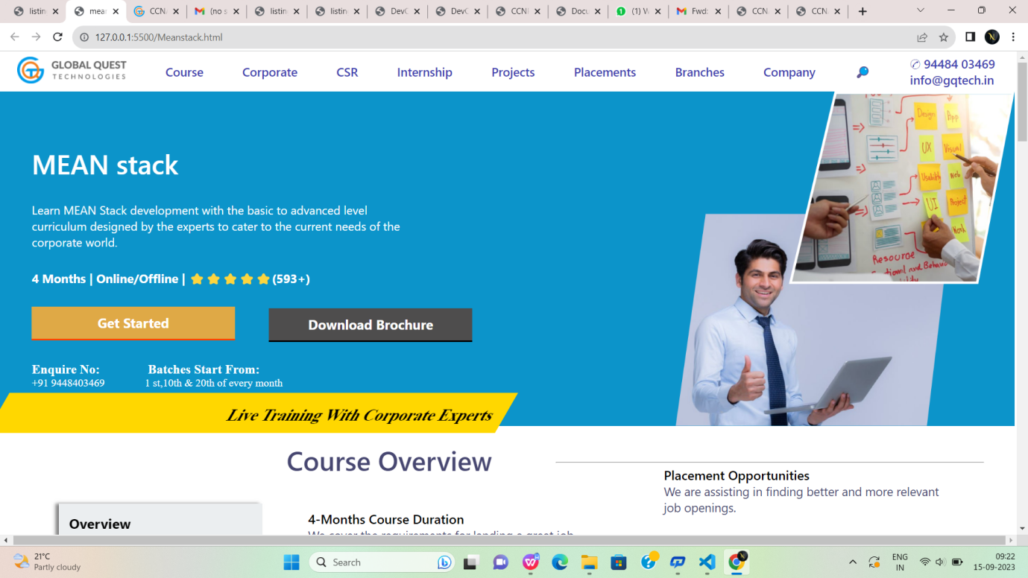

Fig:9

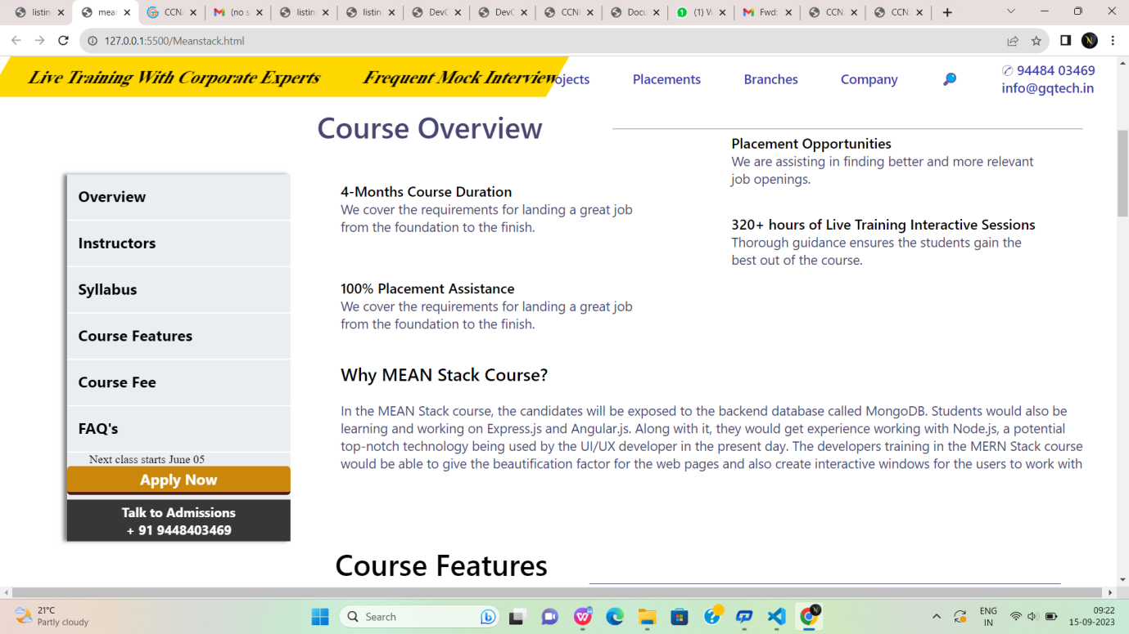

Fig:9.1



Fig:9.2



Fig:9.3



Fig:9.4



Fig:9.5



Fig:9.6

**Conclusion**

In conclusion, Global Quest Technologies (GQT) is envisioned as a dynamic and informative online hub for all things technology. With a commitment to staying at the forefront of technological advancements, GQT aims to empower individuals, businesses, and industries with the knowledge and resources needed to thrive in the digital age. Whether you're a tech enthusiast, a budding developer, or a seasoned professional, GQT is your go-to destination for staying informed, learning, collaborating, and making informed choices in the ever-evolving world of technology.